Modelling

AI/Data Science Project

Zhitan Wu

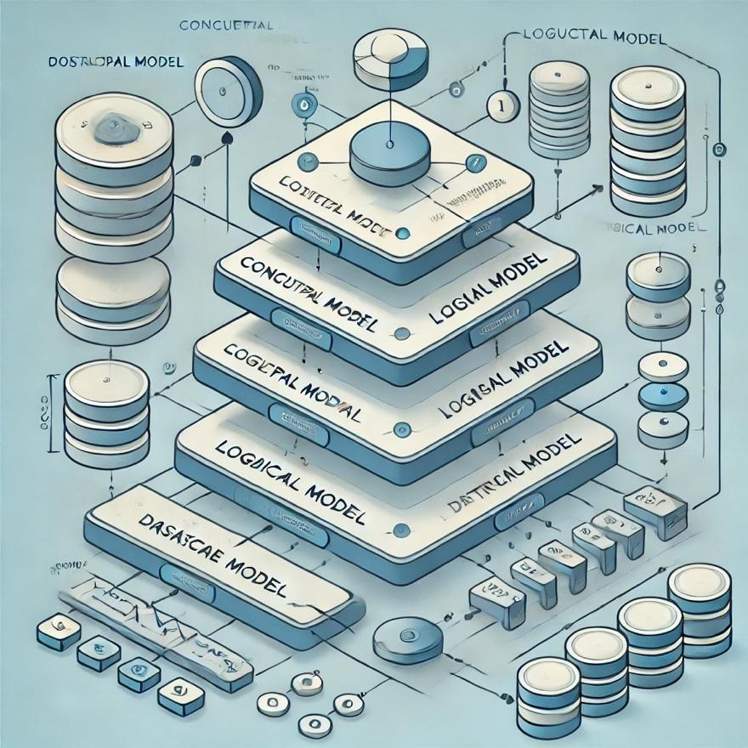

# Abstract

The modelling phase is crucial as it:

* Provides a structured framework for data scientists to better understand, process and analyze data.
* Is the foundation of data analysis and machine learning that sees models being scalable and reliable, for the overall insights to be accurate.

The aim of this stage of the project is to predict time-series target values using sequential models.

Table of Contents

**Abstract 1**

**Data Preprocessing and Preparation 3**

General Processing 3

**Load Dataset 3**

**Drop Irrelevant Columns 3**

**Missing Data 3**

**Date Conversion 4**

**Encoding 4**

**Cyclical Features 4**

**Scaling Of Features 5**

**Group By Year and Trim Sequences 5**

**Removing Commas and Convert to Numeric 6**

LSTM 7

GRU 9

1D – CNN 10

LSTM (with attention layer) 11

**More Details About The Models 12**

**Results 14**

LSTM 14

**CA 14**

**WA 18**

**MI 21**

**PA 25**

GRU 28

**CA 28**

**WA 32**

**MI 36**

**PA 39**

1D-CNN 43

**CA 43**

**WA 47**

**MI 50**

**PA 53**

LSTM (with Attention Layer) 56

**CA 56**

**WA 60**

**MI 64**

**PA 68**

Comparison Table 72

**Accuracies 72**

**Interpretation Of Accuracies, Loss Curves, Prediction Plots and Methods | Future Work 73**

# Data Preprocessing and Preparation

## General Processing

### **Load Dataset**



To alter and process it efficiently, we must first load in the dataset as csv format. This block of code allows for that to happen, for the IDE to have something to work with.

### **Drop Irrelevant Columns**



The focus of this investigation is to predict the yield of apples for airports in 4 key US states of California, Michigan, Pennsylvania and Washington. To ensure that the data is substantially ready for the usage, other attributes that can potentially jeopardize the results would need to be omitted. For this application, the attributes of ‘Name’, ‘Station’, ‘Latitude’, ‘Longitude’ and ‘Elevation’ are the ones chosen to be dropped as they are redundant due to them having the same values.

### **Missing Data**

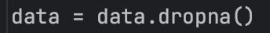

If there is any missing data that has been detected in any of the attributes, this code block will remove it for plotting purposes. Missing data might be a concern for the perceived outcome of the study and may lead to data discrepancies such as outliers and noise.

### **Date Conversion**

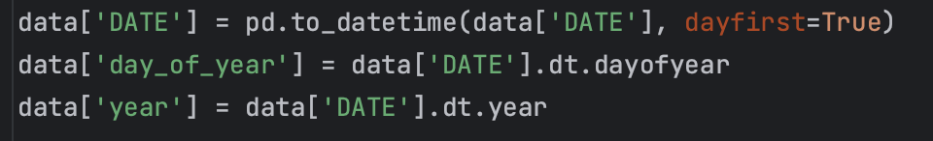

We continue to convert the dates to date-time objects, whereby the day within the entire date is the first element to work with. Then separate columns are created for the day in the year and the year itself, for machine learning models to utilize it more effectively.

### **Encoding**

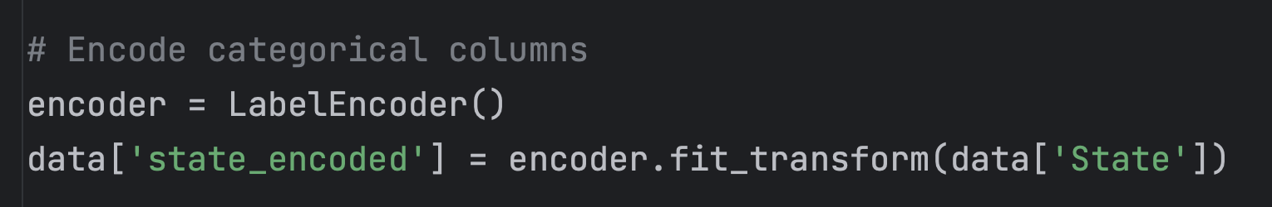

Encoding is used to convert the values in the ‘State’ column to a numerical format so that the model can more appropriately use for predictions. It does not matter too much what type of encoding is done, since for each of the four datasets, the state is the same throughout. The idea is to make it numerical for the model to perform more efficient analysis.

### **Cyclical Features**

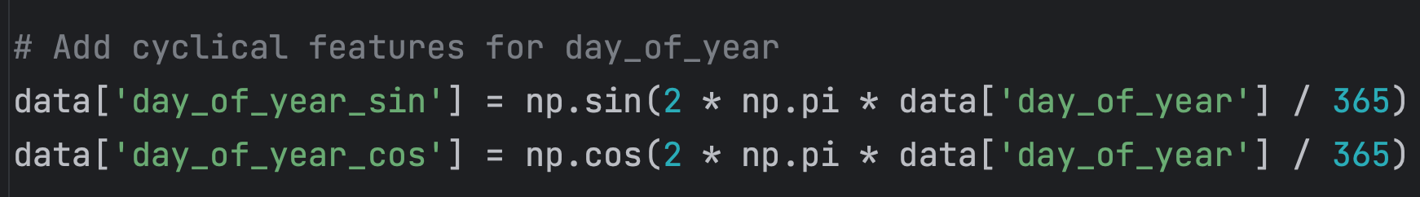

Using the sine and cos functions, the day of year is converted to a cyclical representation. This ensures that similar days have values that are close to each other. It is implemented as machine learning models might incur an inability to capture the true cyclical nature of dates. Transforming into sine and cosine values will also help the models detect seasonality patterns.

### **Scaling Of Features**

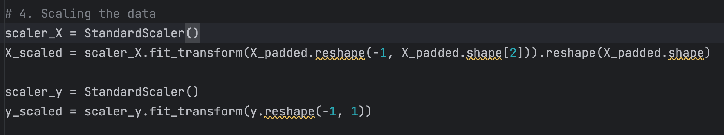

This scales the features by calculating the mean and standard deviation and standardizing them. It reshapes for the x values by changing a 3D array into a 2D shape for standardization, including converting y into a 2D array with shape (n_samples, 1), required by StandardScaler.

### **Group By Year and Trim Sequences**

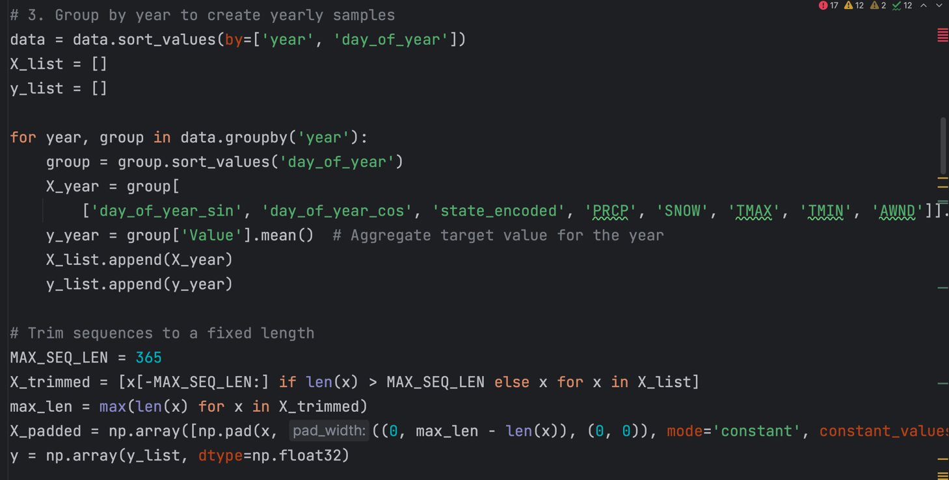

The data is processed by sorting it by year and the day of year to ensure a chronological order is achieved. Next, we group it by the day of year and extract the variables of interest (which include cyclical features). The average of the value column alongside the x_year and y_year are extracted, computed and stored as a list. For the state of PA, we omit ‘Snow’ as a variable to be grouped since the generated final dataset does not have that as an attribute.

If a year has 366 days, only the last 365 are kept for plotting, and if they have less than 365, all of them are kept. They are padded with zeroes to ensure similar sequence lengths and so input sequences have uniform dimensions for deep learning models. Then, a NumPy array is used for all of this to work better with packages such as TensorFlow or PyTorch.

### **Removing Commas and Convert to Numeric**

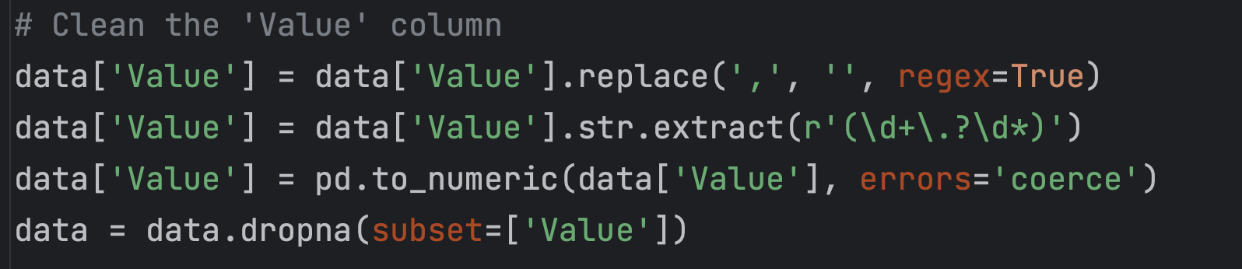

We also must clean the value column, getting rid of any commas that are present. Then, we extract the numeric components of the result and change the data type. If any values are missing or are inconclusive at the end of doing all of this, we remove it completely from the dataset.

## LSTM

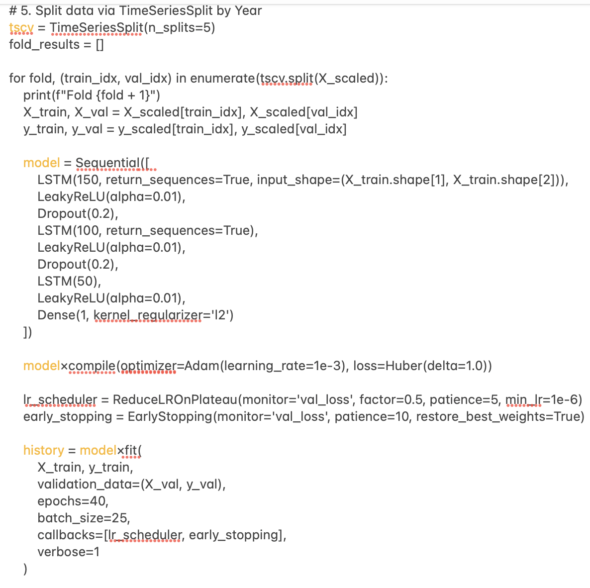

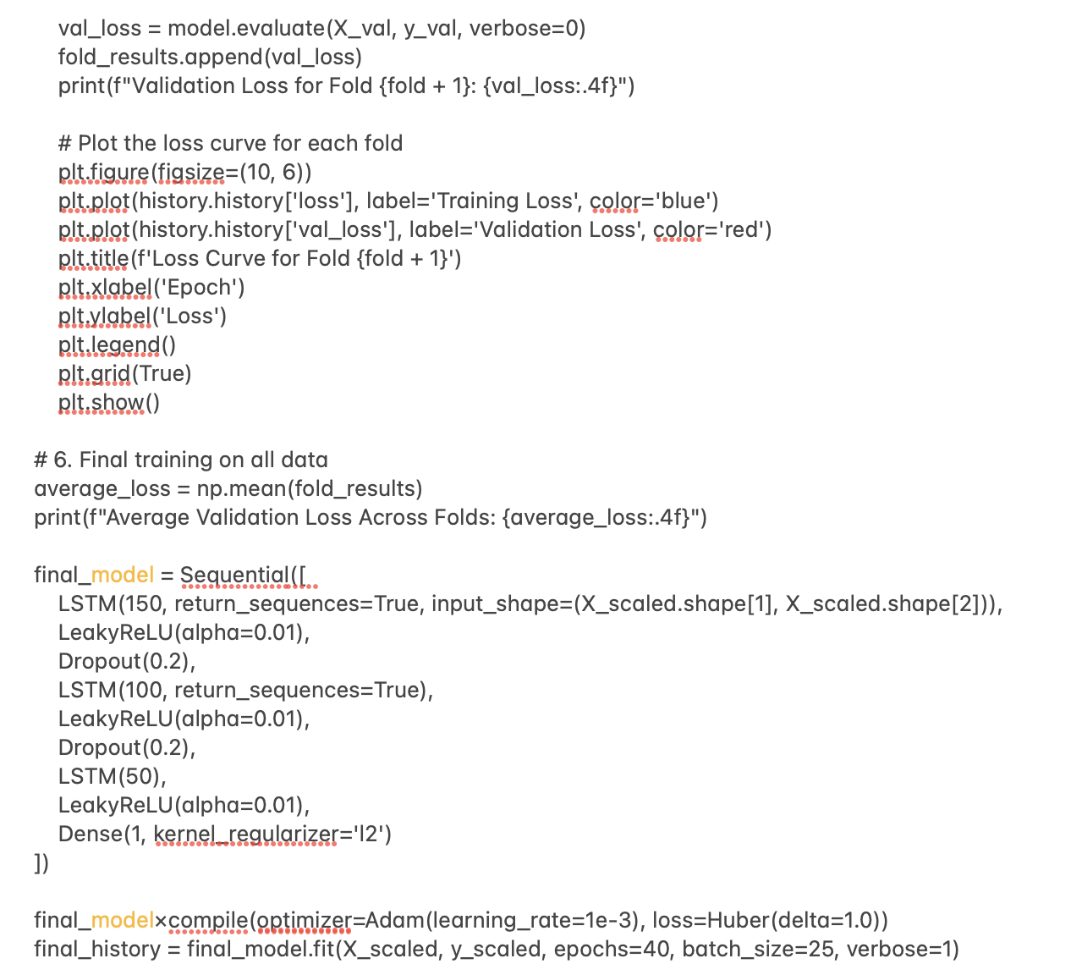

These are some snippets of code that contribute to how the final conventional LSTM model is built. The data is first distributed across 5 ‘folds’ of epochs with the TimeSeriesSplit for the model to properly learn patterns, each with early stopping, dropouts by turning off neurons and mechanisms to reduce the learning rate when the validation loss plateaus. It is implemented like this to avoid overfitting. LeakyReLU is instated for the model to learn complex patterns since it introduces non-linearity and TimeSeriesSplit aims to preserve the temporal order when performing cross-validation on time-series data.

From my testing, at least three LSTM layers alongside a batch size of 25 and epochs of 40 are of the key metrics that produced the best results for the model. Each fold of data that is sorted in terms of epochs are plotted and key metrics such as validation loss are calculated before a final model is fitted. At the end, the model tries to predict values for at least 5 future years based on the patterns that are inherent within the existing data. The accuracies regarding the predicted and actual values, and unseen are both outputted with the relevant corresponding graphs.

## GRU

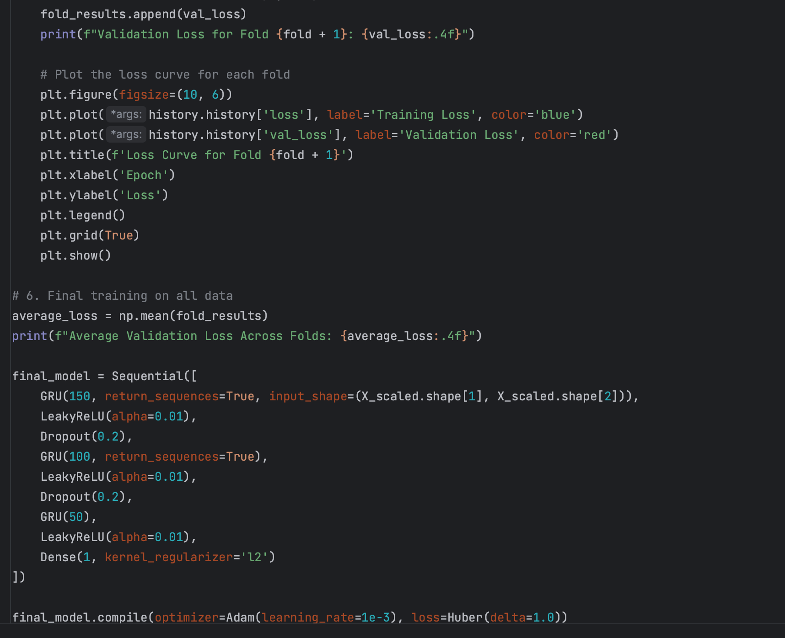

For the GRU model, many of the things that were previously used in other models such as the conventional LSTM model are kept the same. We still divide the data into 5 folds and use the callback functions alongside optimizers such as Adam and Huber to reduce the risk of overfitting and the impact of possible outliers in the dataset. There’s metrics such as validation loss for each epoch of each fold, and a final one which is the average. We also compute the average validation loss across folds to get a broad scope of the capabilities of the model. The only thing that is a variation is that we are now using GRU layers for the model to predict values.

The GRU model works with fewer gates, is simple to interpret, and has a faster training speed with lower memory requirements. It works more efficiently to prevent overfitting on small datasets; however it may struggle with very long sequences.

## 1D – CNN

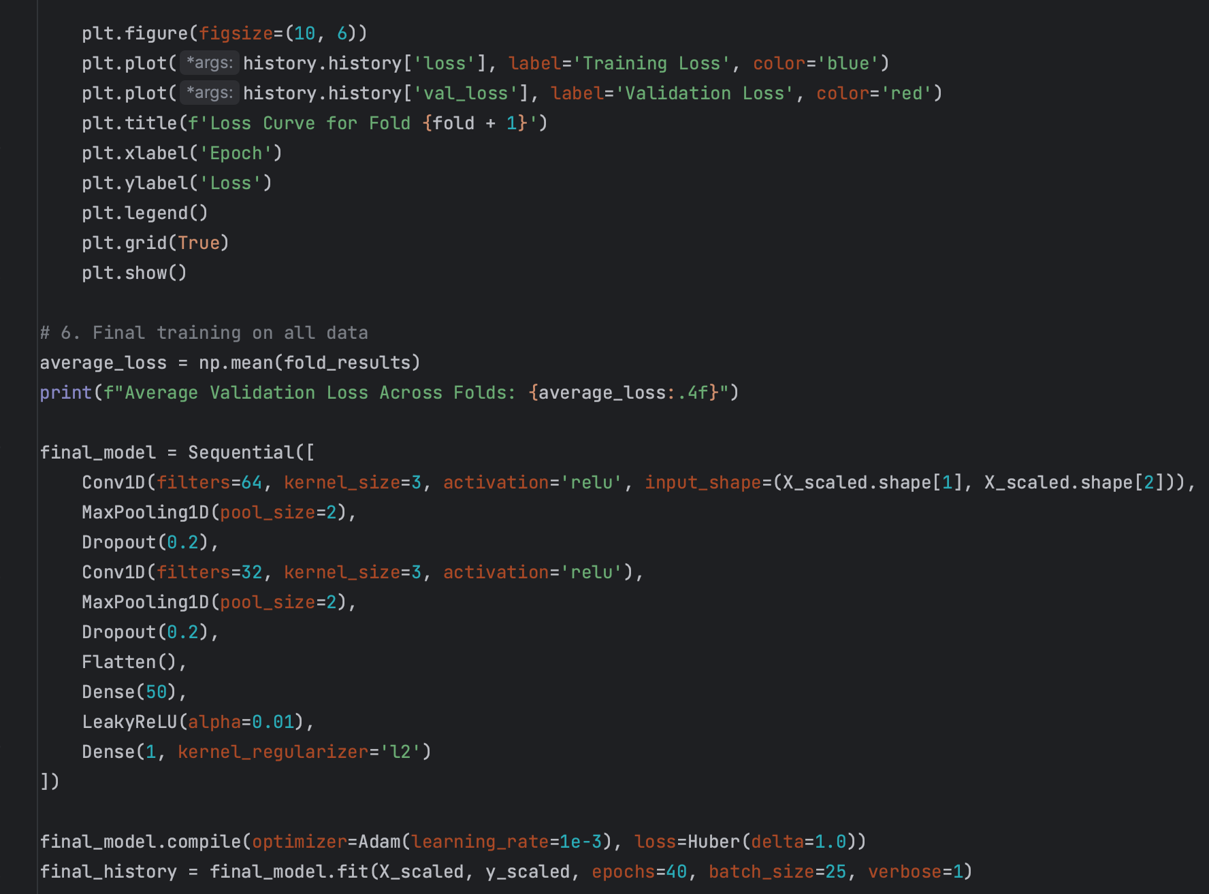

For the 1D-CNN model, most of the elements that were present in the previous ones remain. They include the LeakyReLU and the number of layers used for the model to learn accurate patterns within the data. The first ConvID with 64 filters introduces a 1D convolution with non-linearity and the second ConvID with 32 filters further extracts data attributes in the 1D convolution structure. In each window of size 2, it takes the maximum value that helps with feature extraction and reducing computational load. Dropouts are still used for regularization to avoid overfitting and ‘Dense (50)’ introduces a fully connected layer with 50 neurons in this case to capture complex patterns and relationships with the extracted features from previous layers.

The other mechanisms remain similar as the other models in terms of functions and callbacks such as EarlyStopping, Huber and Adam. The validation loss and conventional loss are still computed, and after each epoch has been run, loss curves are plotted on a graph. Then, a generalized average of the values is computed before the whole repertoire of values are mapped back to the original and the complete graph of the lines for predictions, actual and future predictions are displayed all as one.

## LSTM (with attention layer)

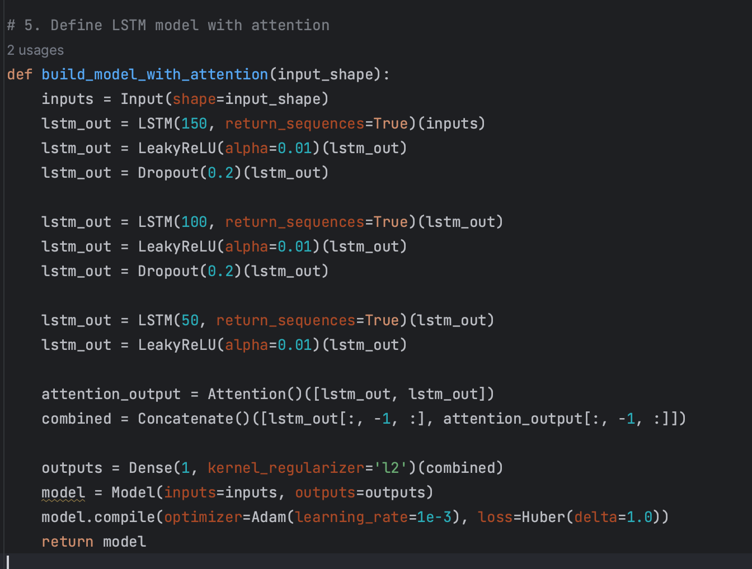

For the LSTM model with attention layer, it learns temporal dependencies from input sequences with decreasing units in each layer. It utilizes an attention mechanism to weigh the most important parts of the sequence and uses them to an advantage. A final representation of the sequence comes from the learnt temporal representation with the attended context that are concatenated with each other. It is combined with a scalar output for regression analysis, while functions such as the Huber and Adam loss and L2 Regularization are combined to combat overfitting issues.

# More Details About The Models

There are many different types of models that can be selected for this phase, ranging from transformers and recurrent neural networks to neural ordinary differential equations. However, to keep things simple, the ones chosen for the task are LSTM, GRU, 1D-CNN and LSTM (with attention layer). All these models can use time-series sequential data to predict future values, while also ensuring that a wide variety has been covered in the investigation.

*“Choosing the optimal model for the task at hand can make or break the final objectives.”*

However, even though they can all be used for time series data, they still have limitations that can make some more applicable than others. This is all listed in the comparison table below, and an overall evaluation will also be conducted at the end of the report.

|  | Advantages | Disadvantages |
| --- | --- | --- |
| LSTM | 1. Can retain information over long sequences, making them ideal for tasks where context from earlier in the sequence is critical (like time-series analysis and language modelling).  2. Can process sequences that involve text with varying lengths.  3. Architecture allows for effective training on long sequences.  4. Noise is reduced as it filters noise and retain only meaningful information. | 1. Can be computationally expensive due to their complex architecture.  2. Can struggle with long sequences due to limitations in memory capacity.  3. Prone to overfitting due to the number of parameters.  4. Training can be slow and there are hyperparameters that need to be fine-tuned. | |
| GRU | 1. It has a simpler architecture that reduces complexity and speeds up training.  2. It is efficient for smaller datasets due to reduced parameters and hence it’s not as prone to overfitting.  3. Achieves a similar or even better performance than a conventional LSTM model.  4. Flexible memory control that has a streamlined mechanism to decide what information to retain or discard. | 1. Less expressive than the generic LSTM model.  2. It has limited control over memory.  3. It is not as popular as conventional LSTMs.  4. Has the potential for over- simplification. |
| 1D-CNN | 1. Very efficient at capturing local patterns such as identifying local features. 2. Training and inference can be parallelized, making them faster. 3. Scales well to large datasets and complex architectures. 4. Easier to debug and implement when compared to recurrent models. | 1. May struggle to model long-term dependencies in sequences. 2. May perform poorly if the input length varies significantly or contains irregular patterns unless preprocessing has been applied. 3. Lacks a mechanism to understand the order of the time dependence in the data beyond local context. |
| LSTM (with attention layer) | 1. Attention layer allows the model to focus on specific time steps that improves interpretability and effectiveness of predictions. 2. Improved performance on long sequences with the attention layer that accesses key parts, regardless of position. 3. Very flexible and can be applied to a variety of tasks such as classification, regression and sequence-to-sequence modelling. | 1. Attention weights introduce complexity as weights must be calculated for each time step in the sequence. 2. Storing attention weights and additional parameters increases memory usage and makes it less efficient for resource-constrained systems. 3. Irrelevant data dominating the sequence may lead to noise amplification rather than focusing on the genuinely important time steps. |

# Results

This section provides the various curves that were generated by using distinctive neural network and machine learning models, such as LSTM and 1D-CNN. Such curves include loss curves after each fold of epochs and a prediction plot for each type of model and US state. For a more concise outlook, it has been decided to omit the graphs generated for the ‘test accuracy’ models. Each US state has about 6209 records in an Excel csv format, and the necessary features are extracted and grouped together to generate the graphs below. The necessary code suites are attached separately.

## LSTM

#### **Actual Model Code**

Refer to the Google Drive.

### CA

#### **Plots (Original LSTM)**

1. Predicted, Actual and Future Predicted (Prediction Plot)

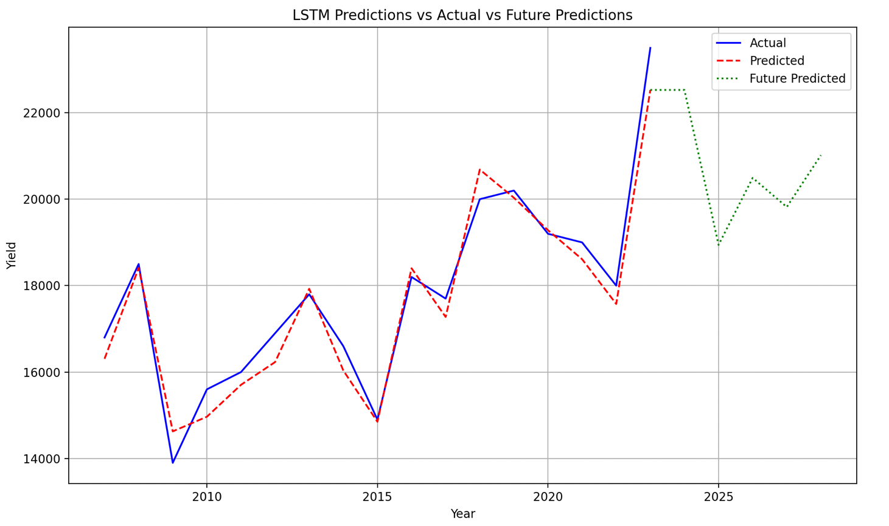

1. Loss Curves (Five Folds)

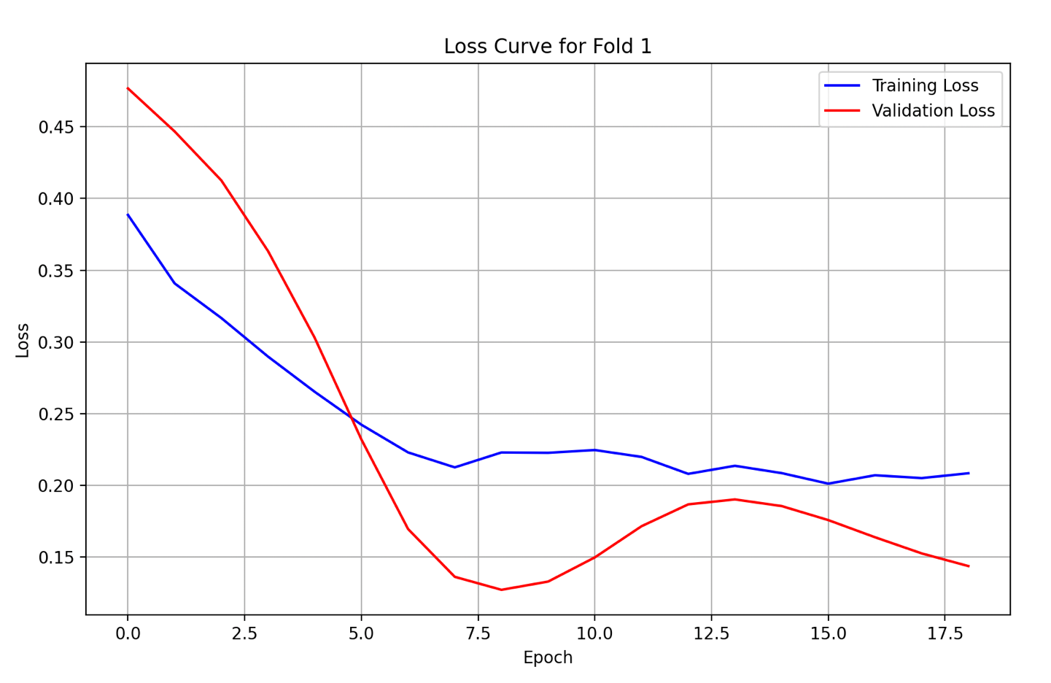

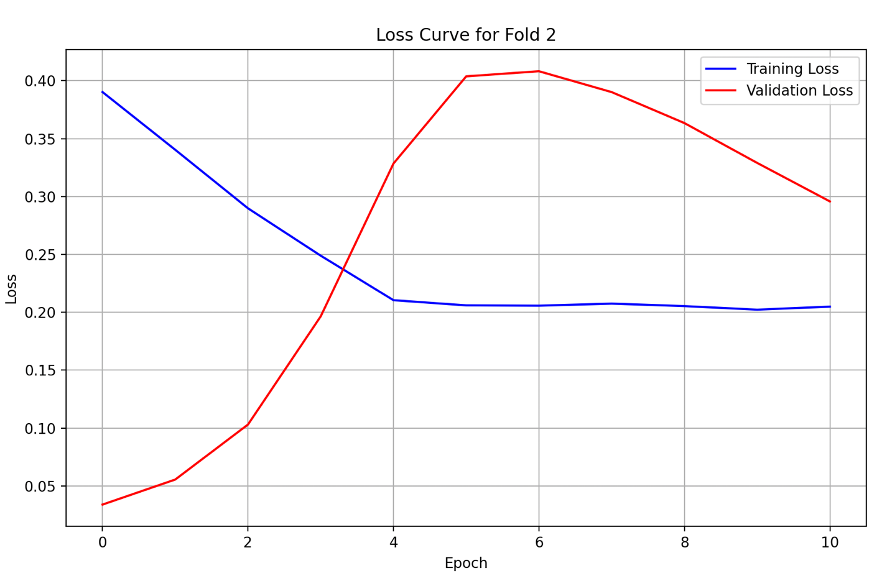

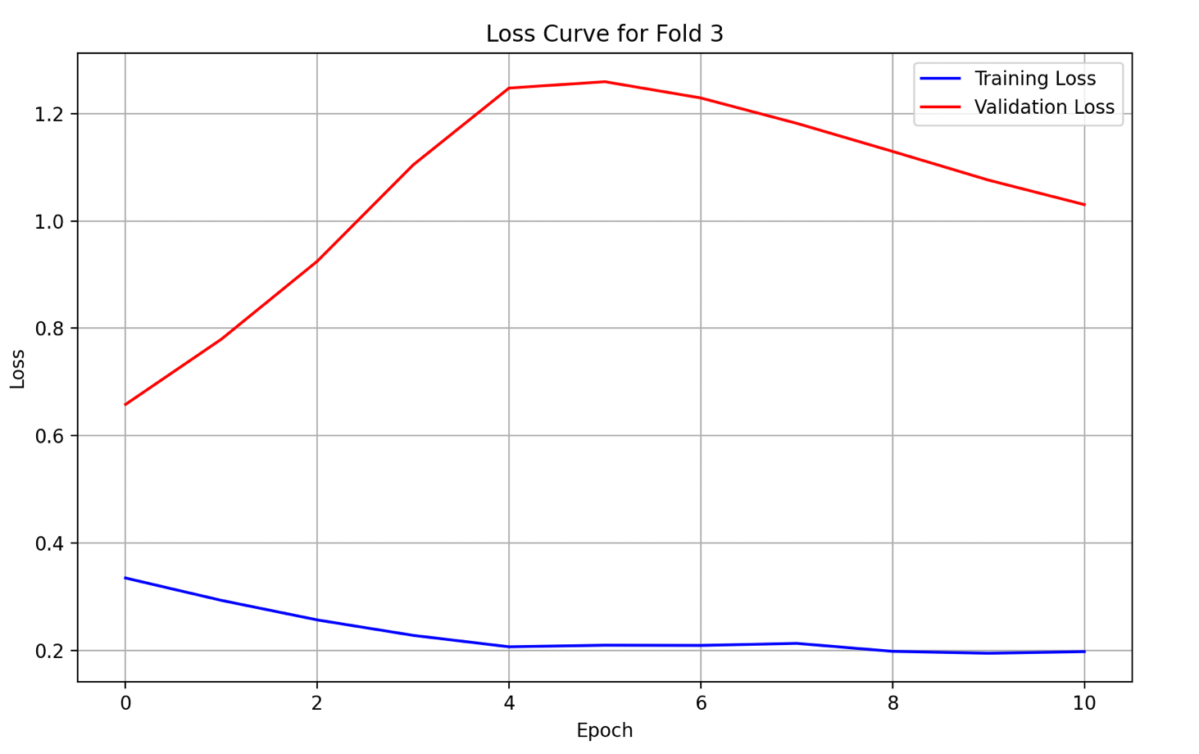

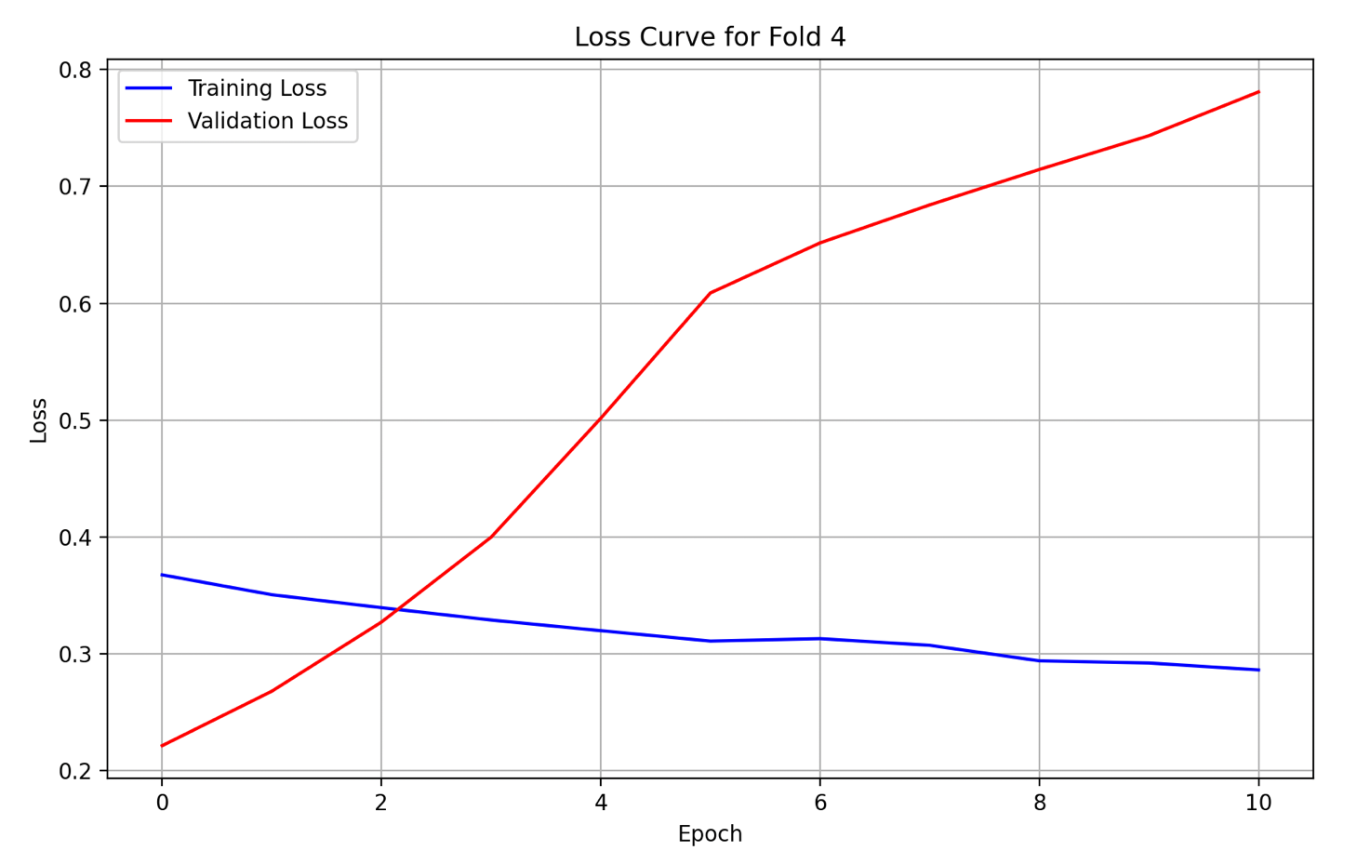

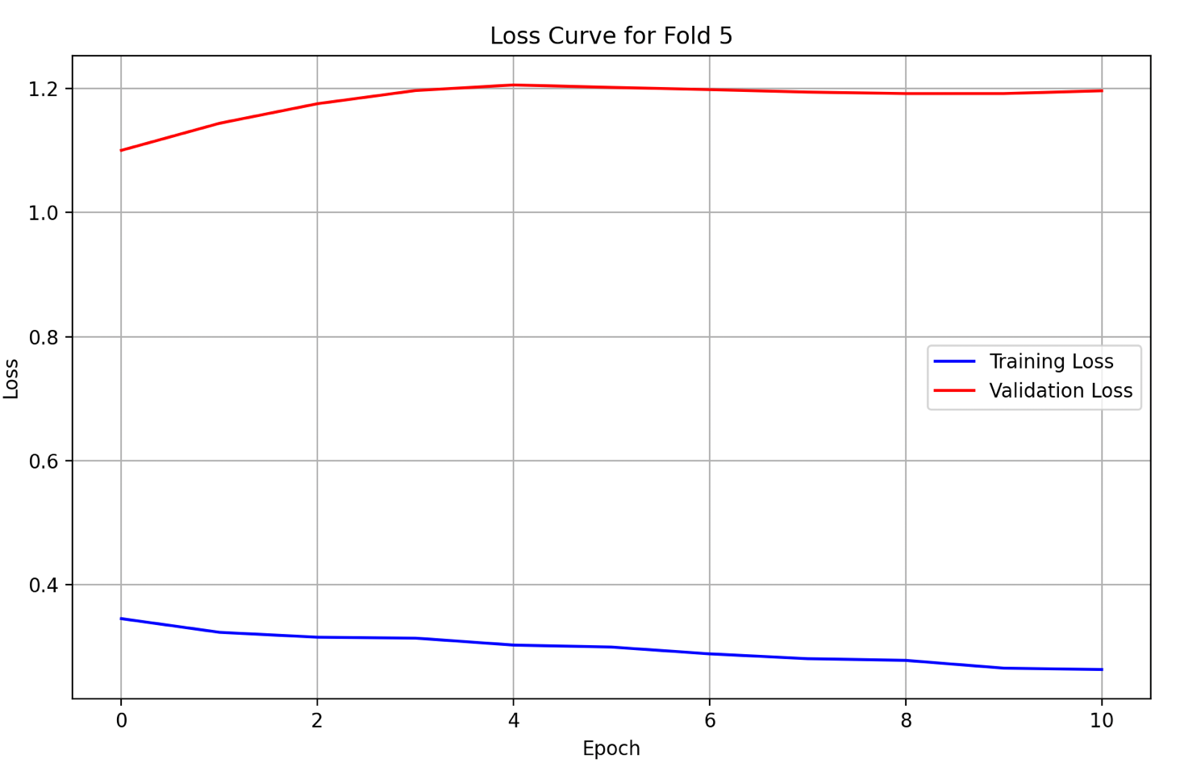

### WA

#### **Plots (Original LSTM)**

1. Predicted, Actual and Future Predicted (Prediction Plot)

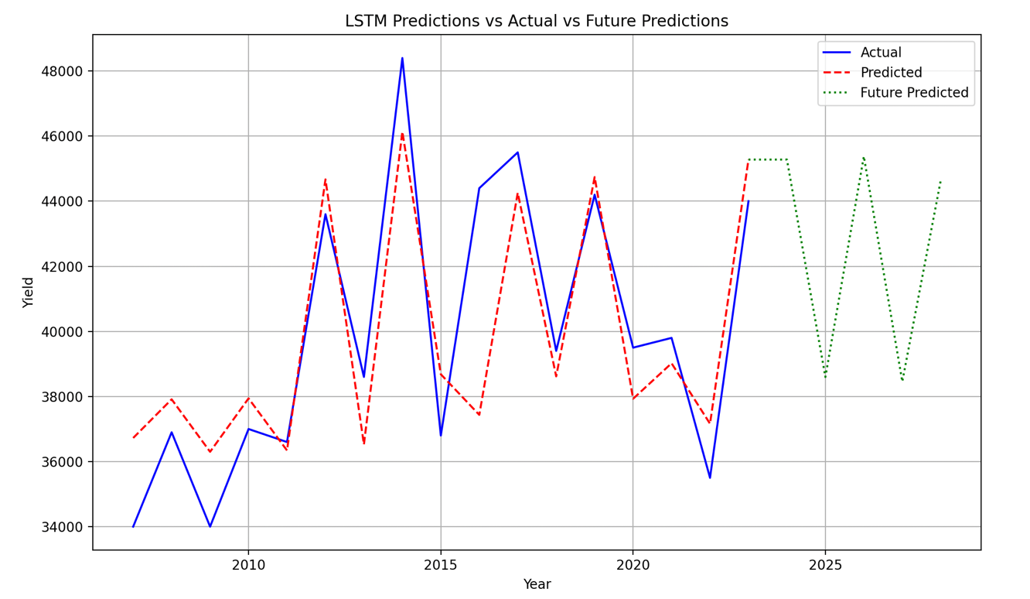

1. Loss Curves

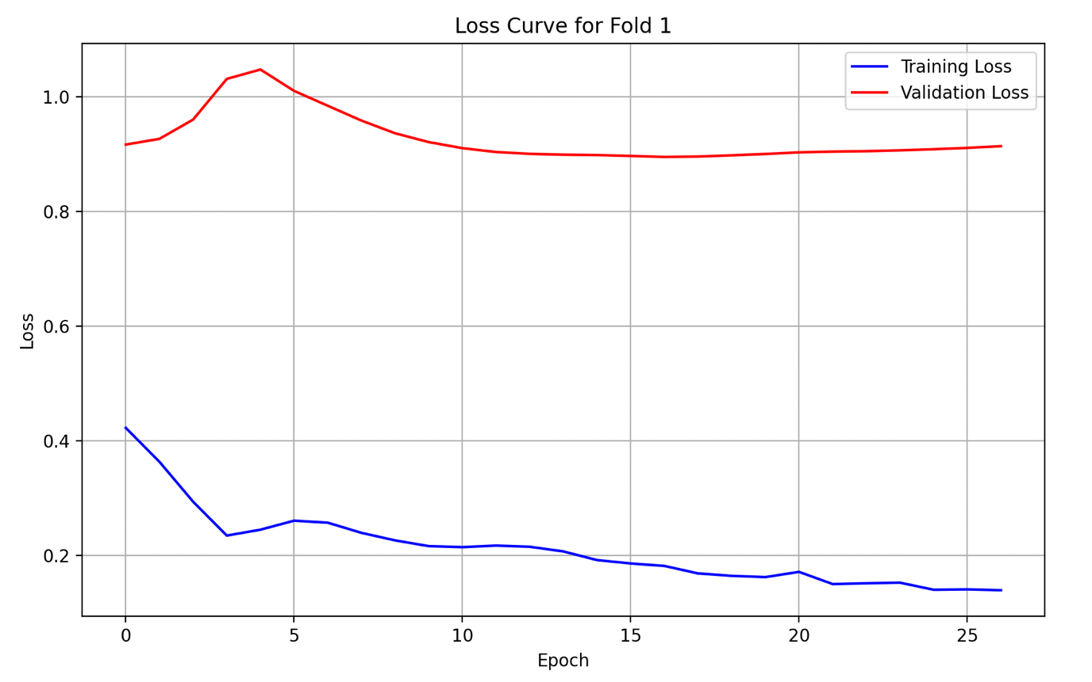

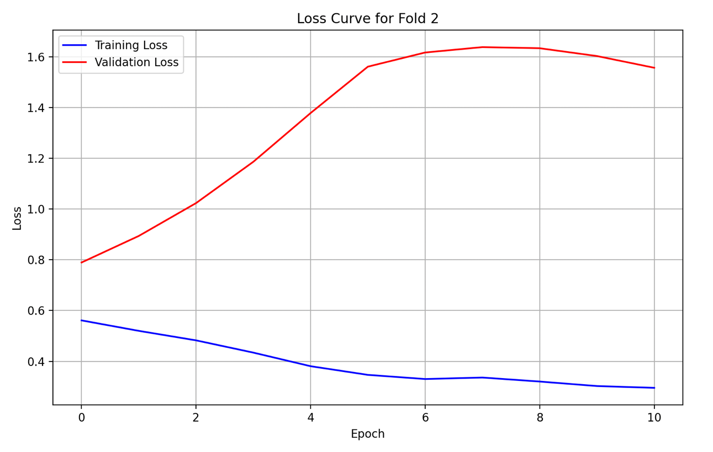

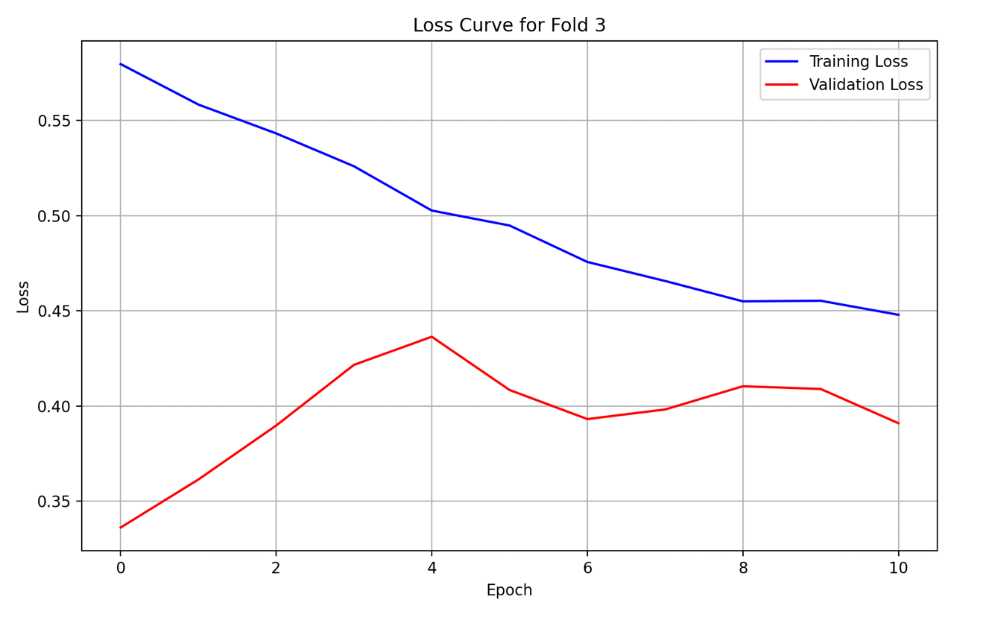

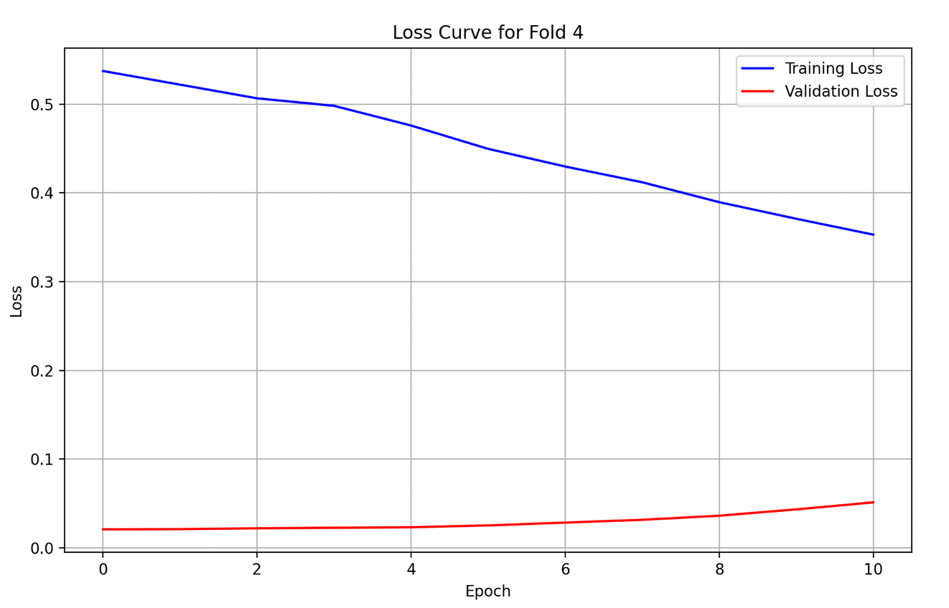

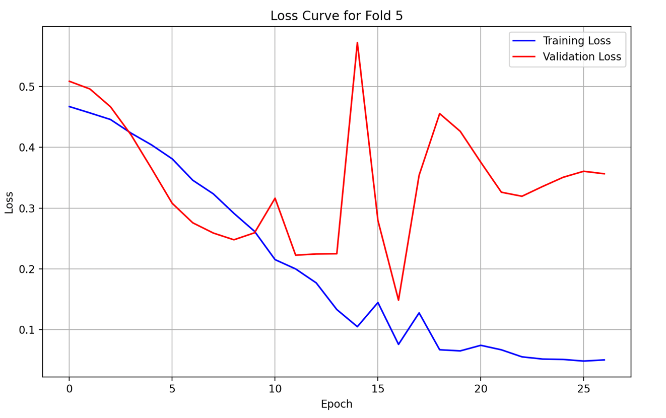

### MI

#### **Plots (Original LSTM)**

1. Predicted, Actual and Future Predicted (Prediction Plot)

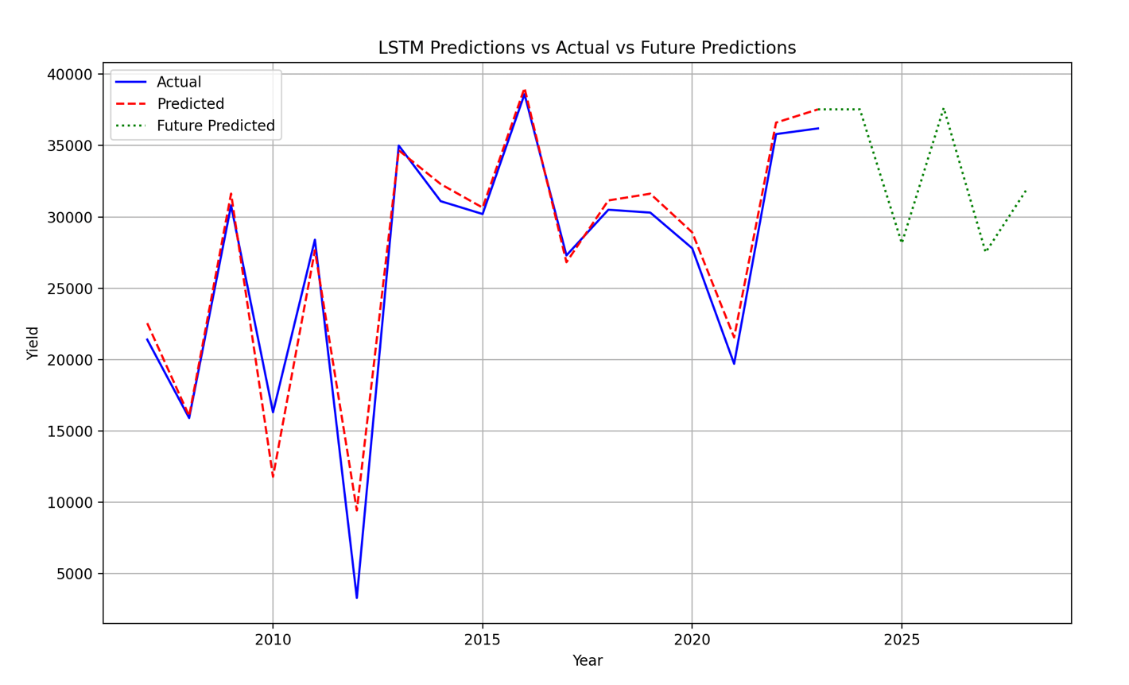

1. Loss Curves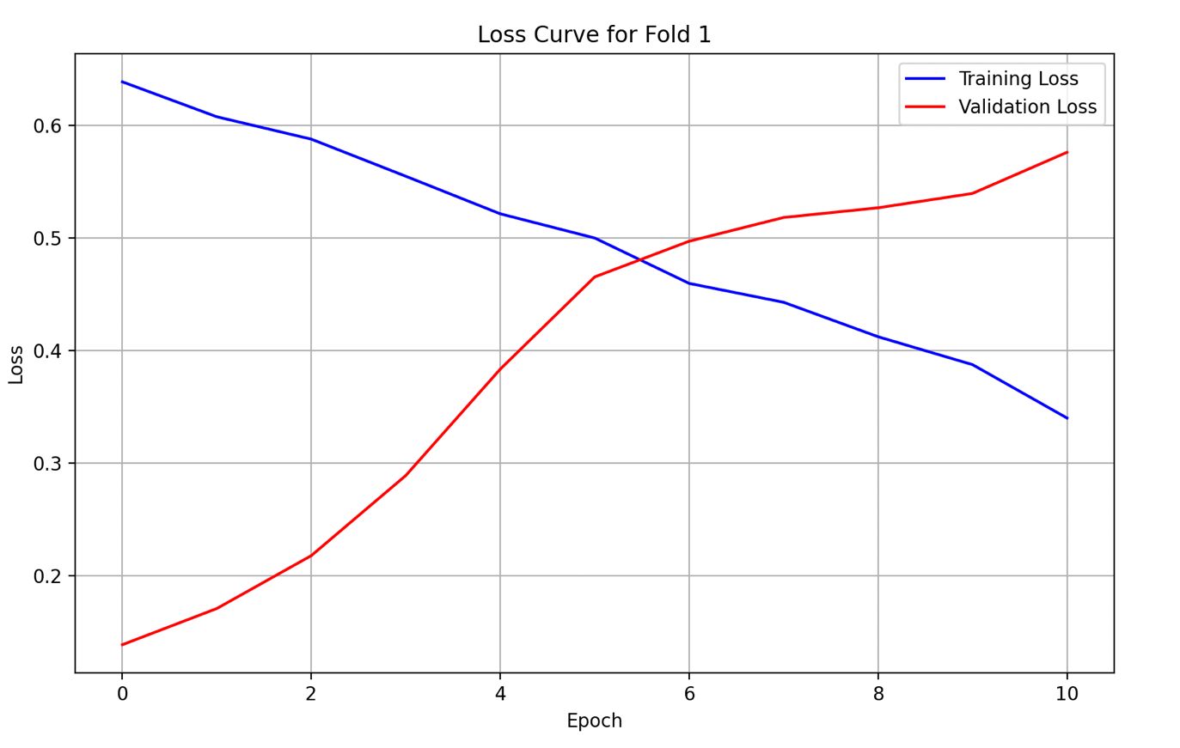

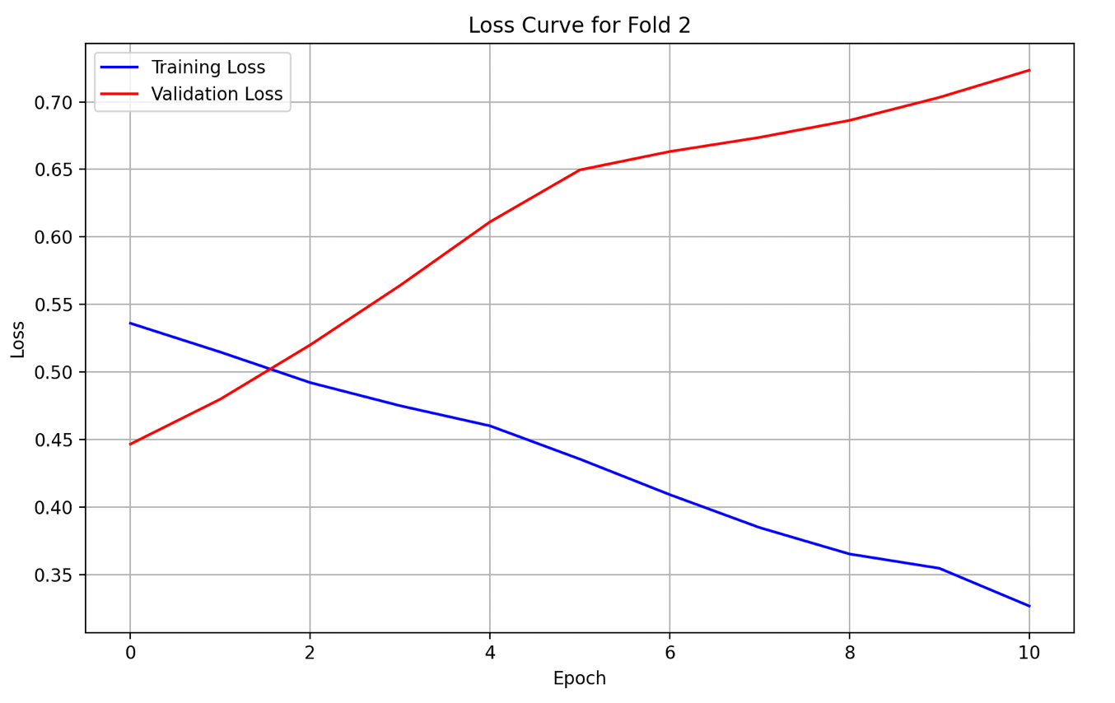

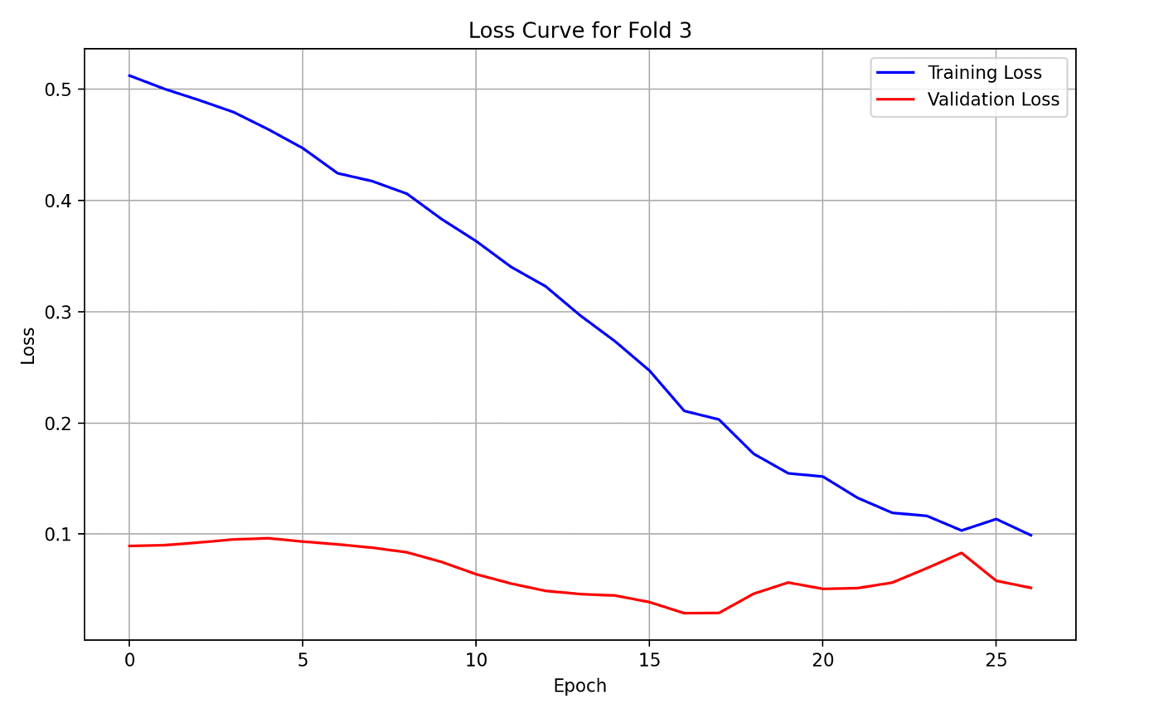

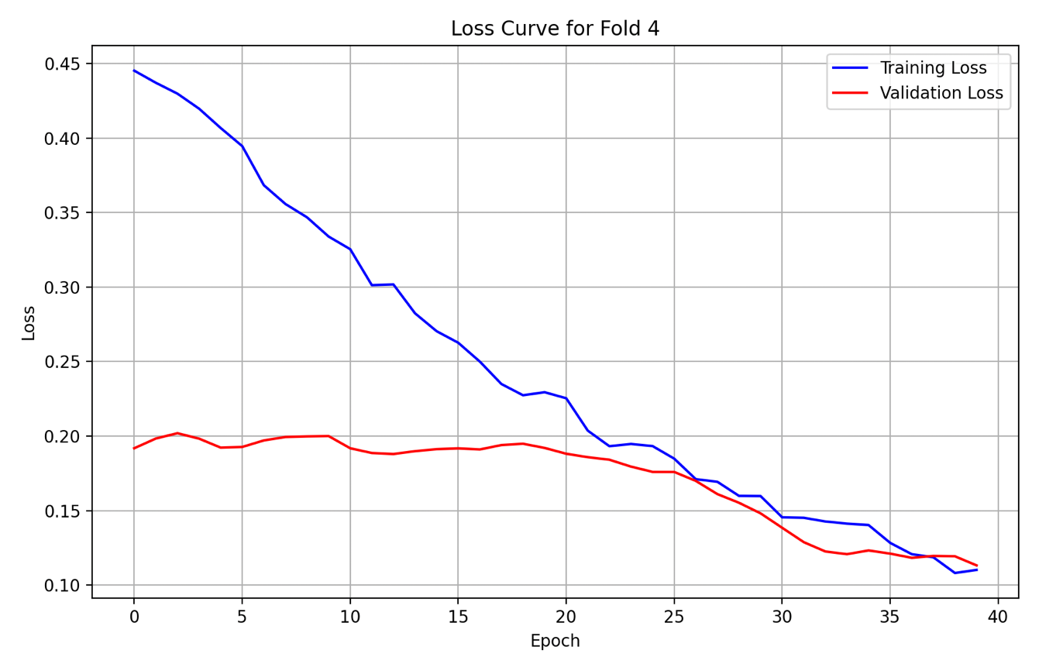

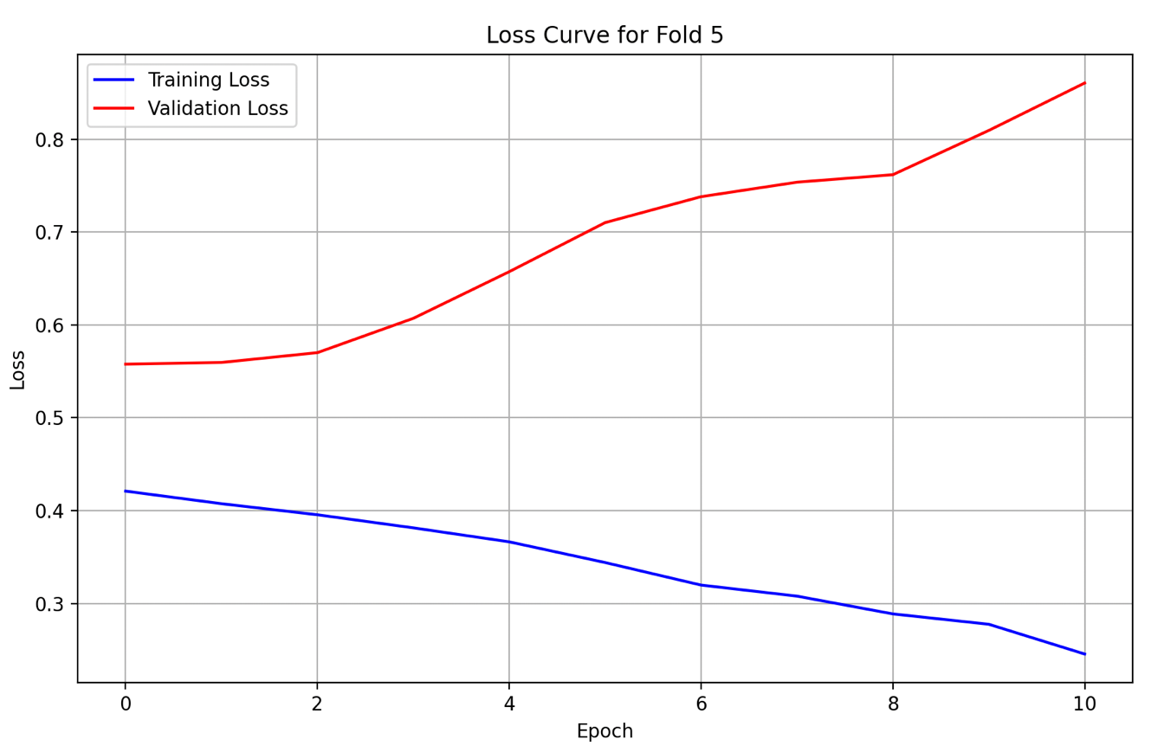

### PA

#### **Plots (Original LSTM)**

1. Predicted, Actual and Future Predicted (Prediction Plot)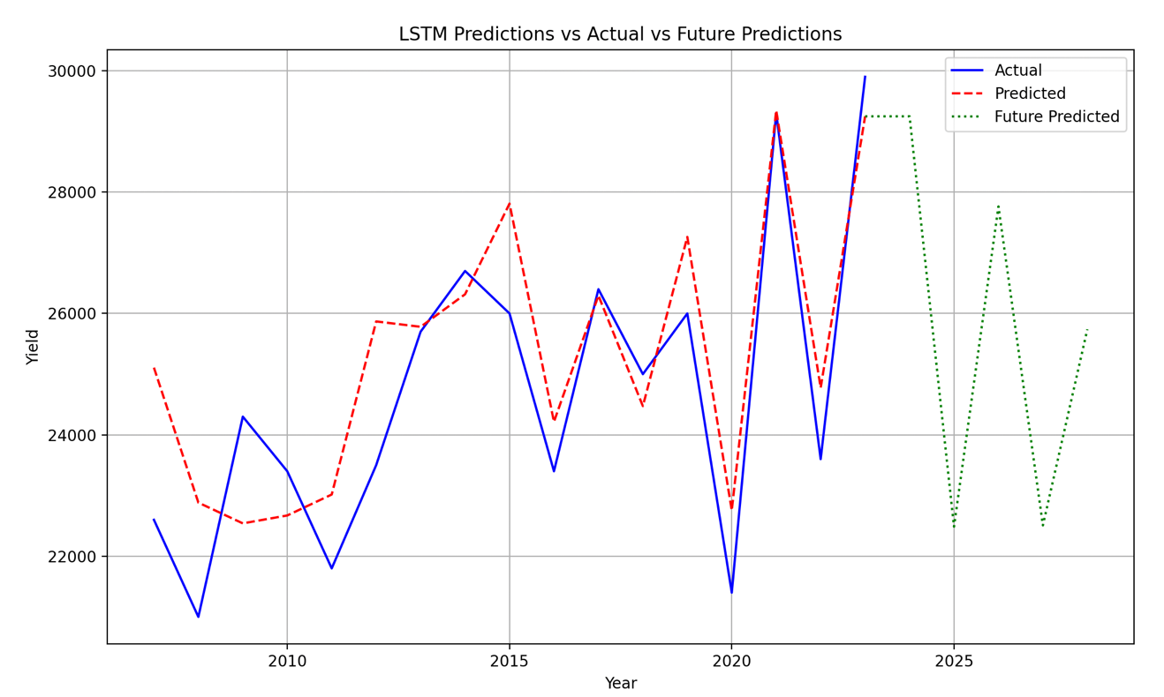
2. Loss Curves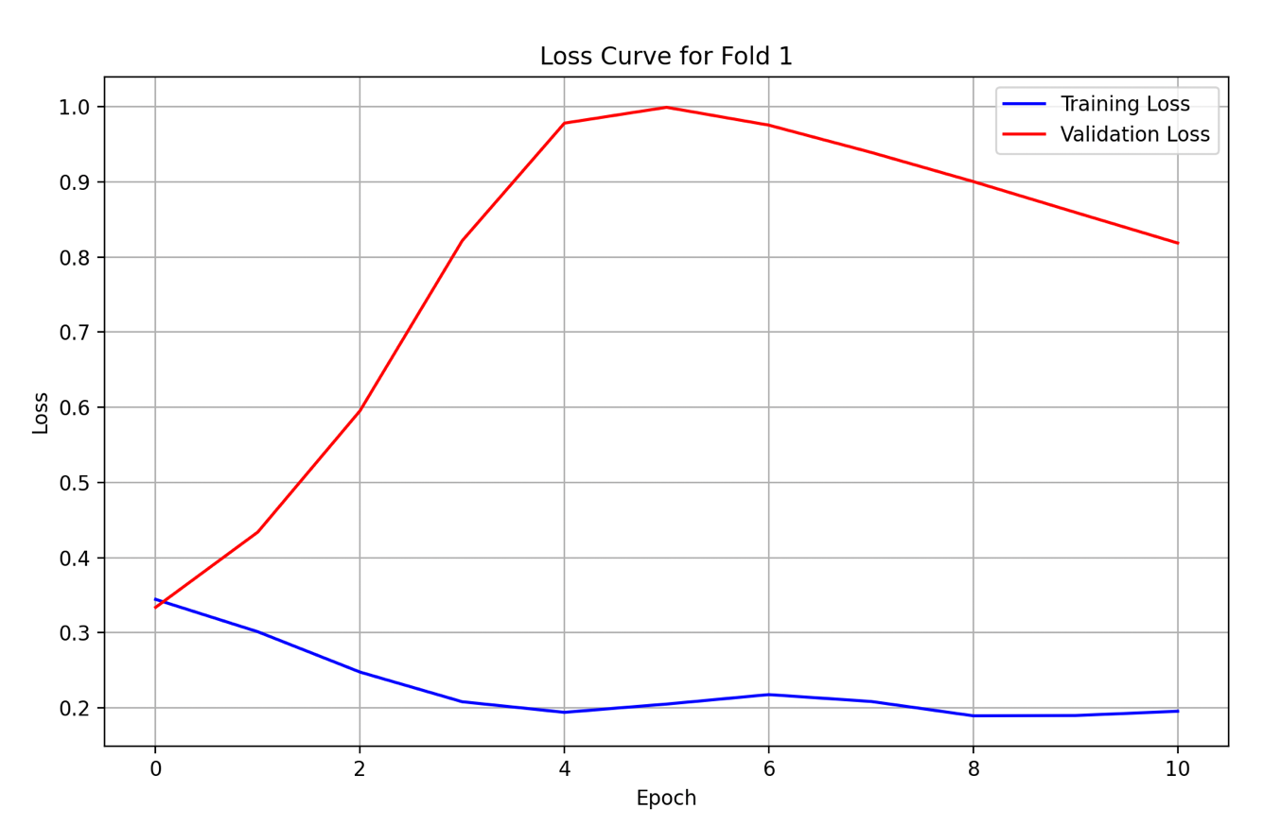

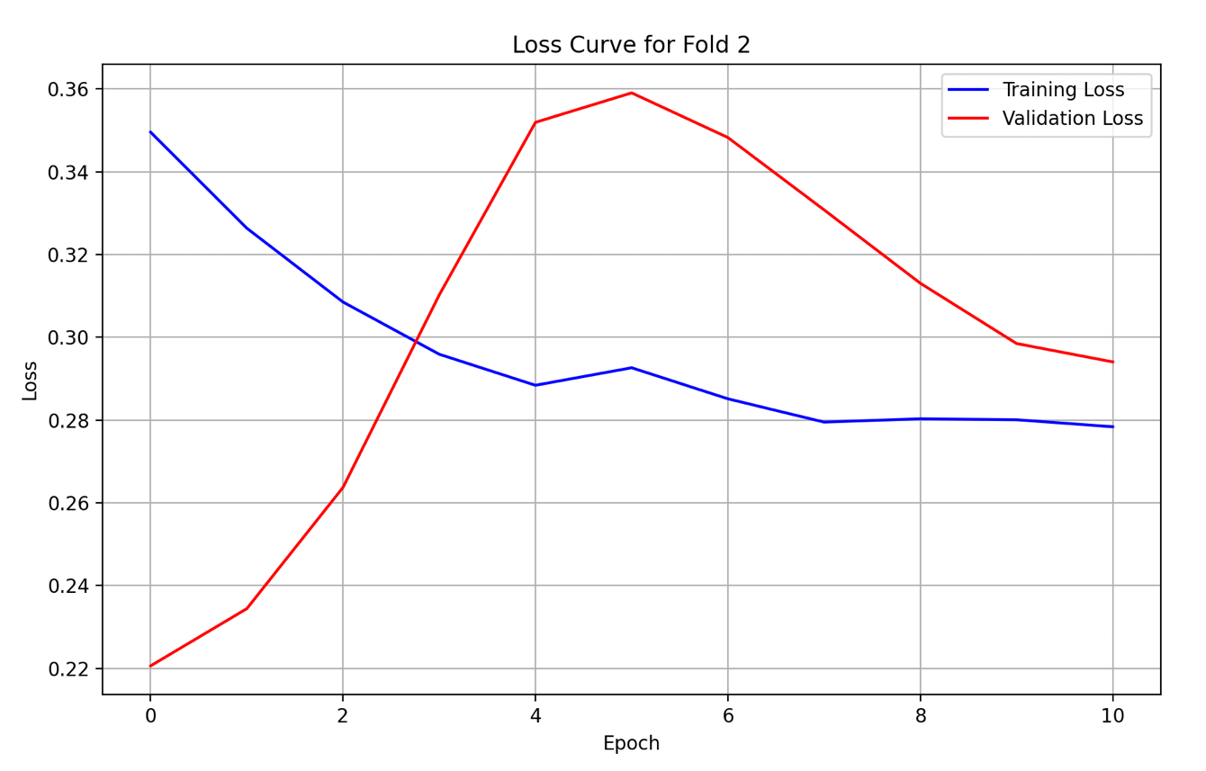

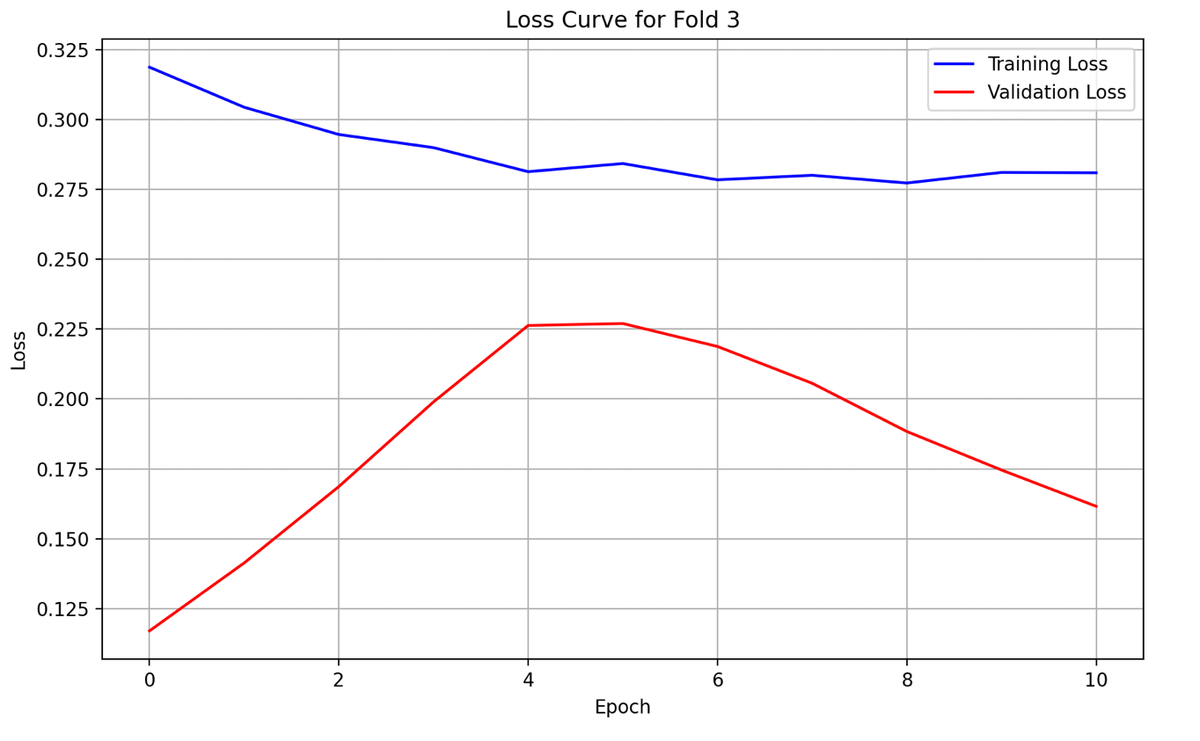

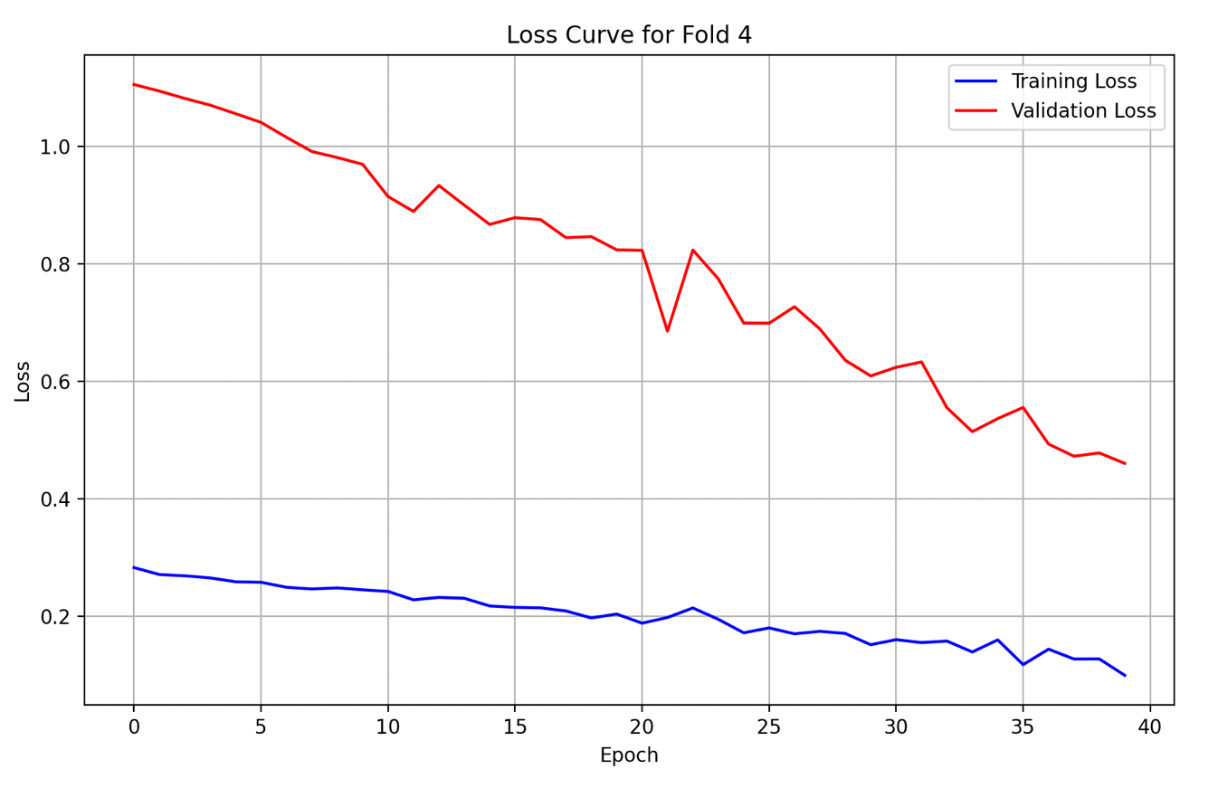

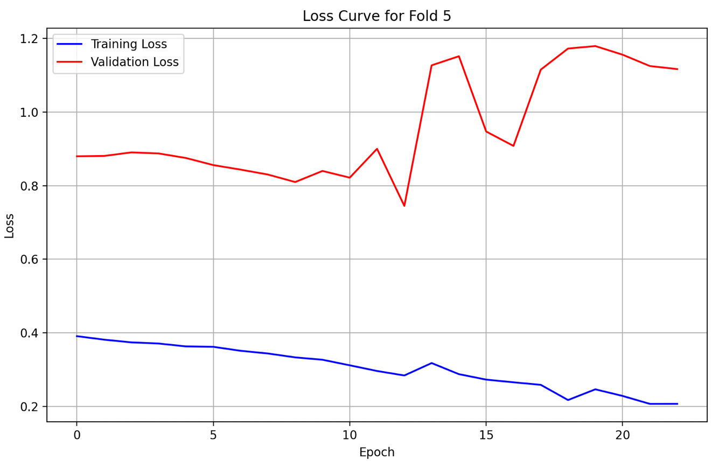

## GRU

#### **Actual Model Code**

Refer to the Google Drive.

### CA

#### **Plots (Original GRU)**

1. Predicted, Actual and Future Predicted (Prediction Plot)

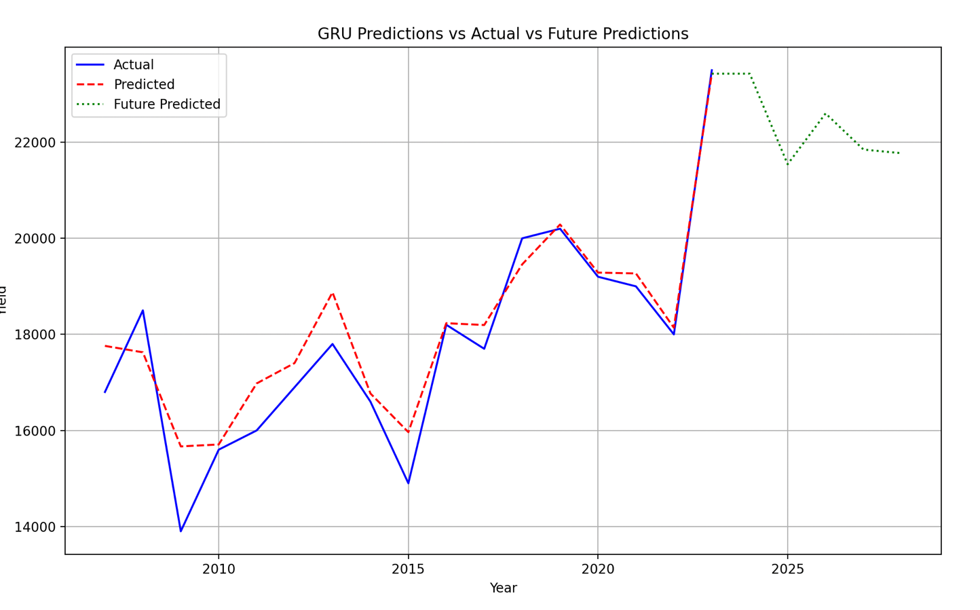

1. Loss Curves

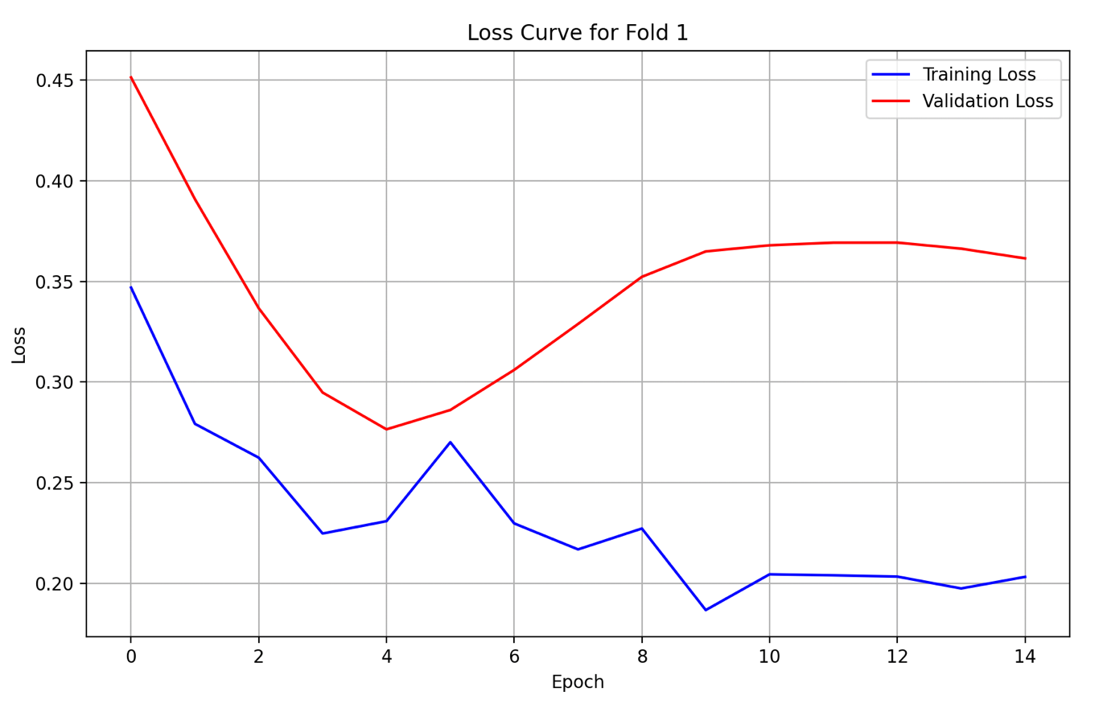

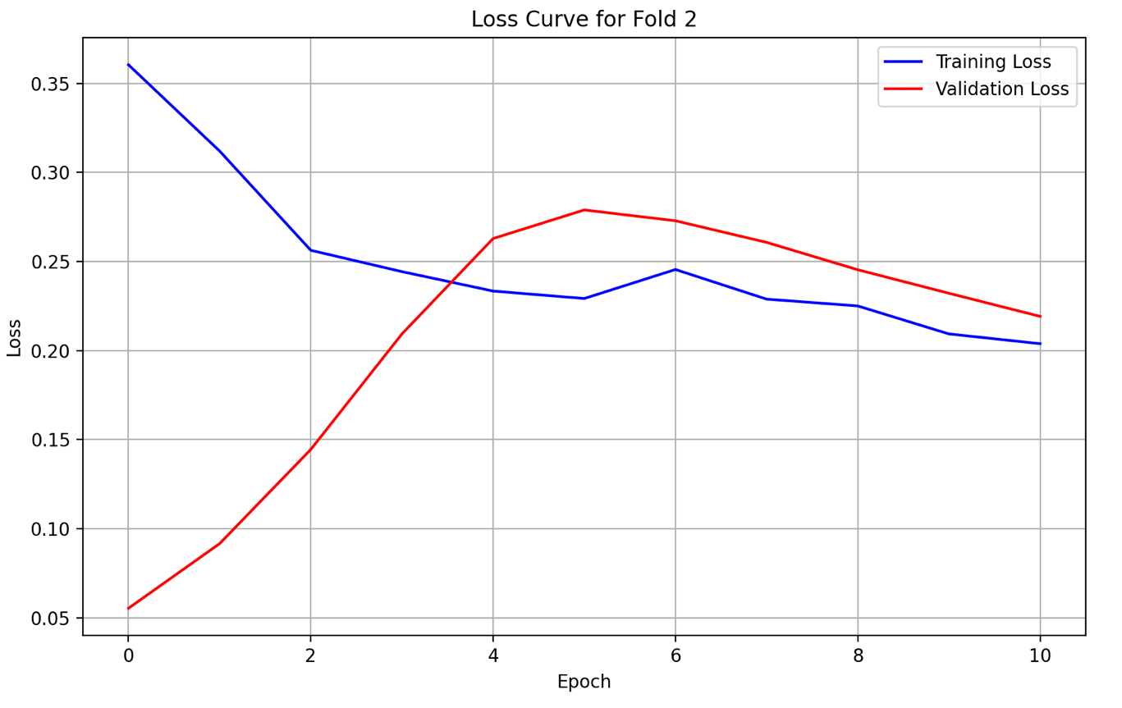

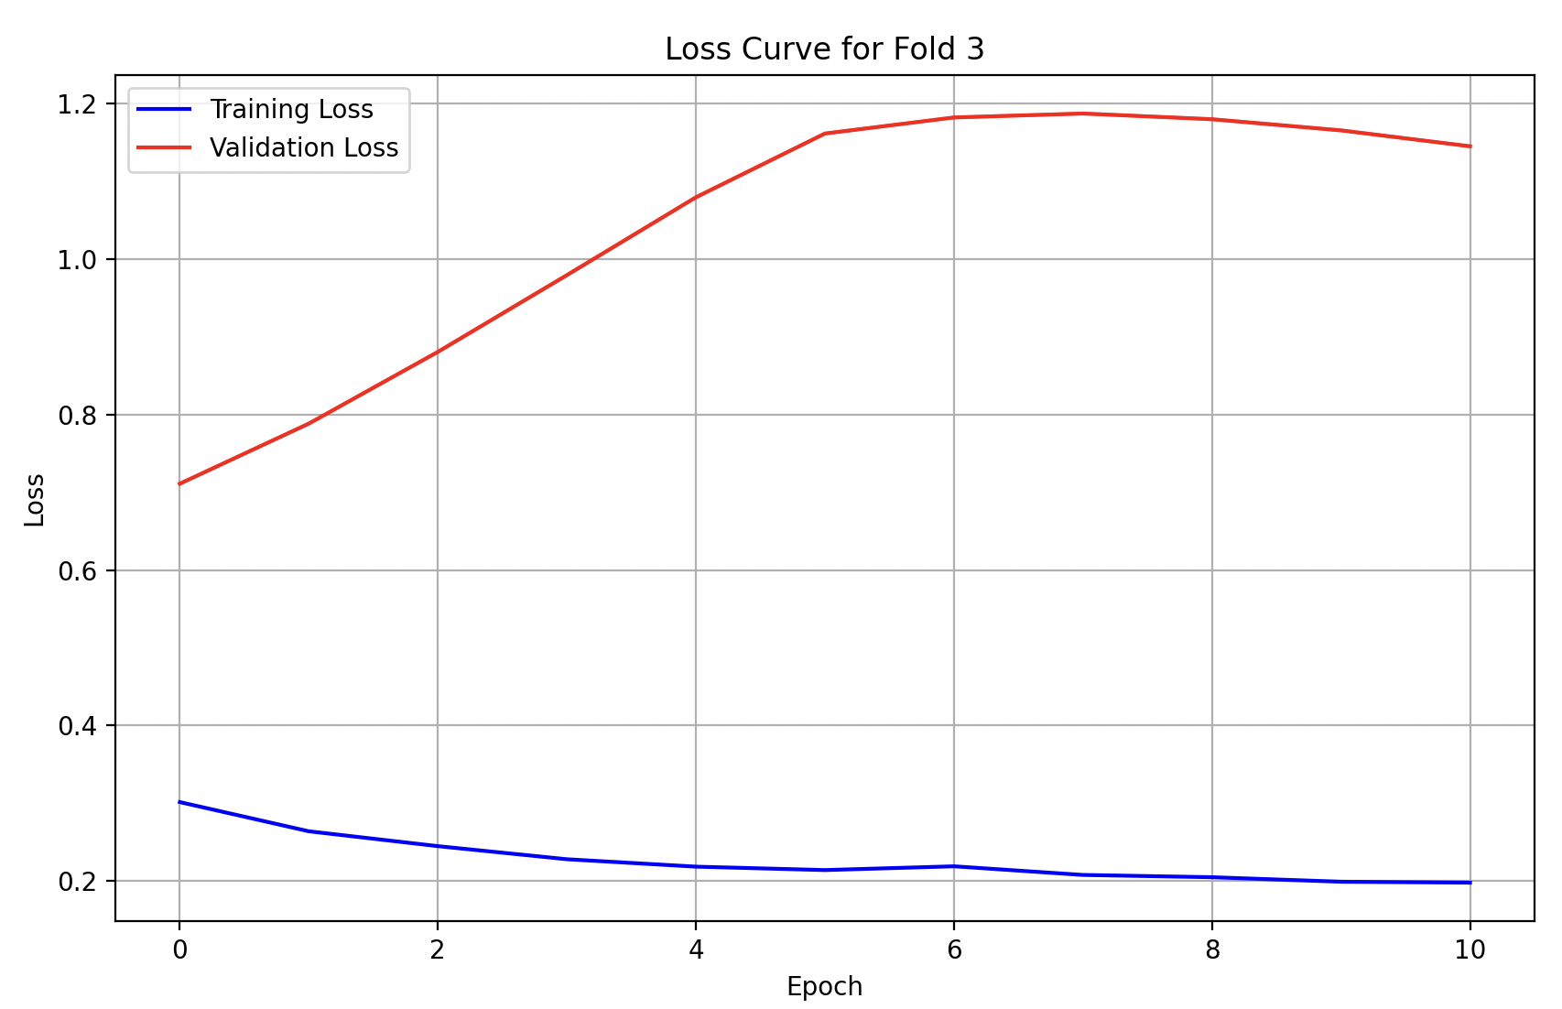

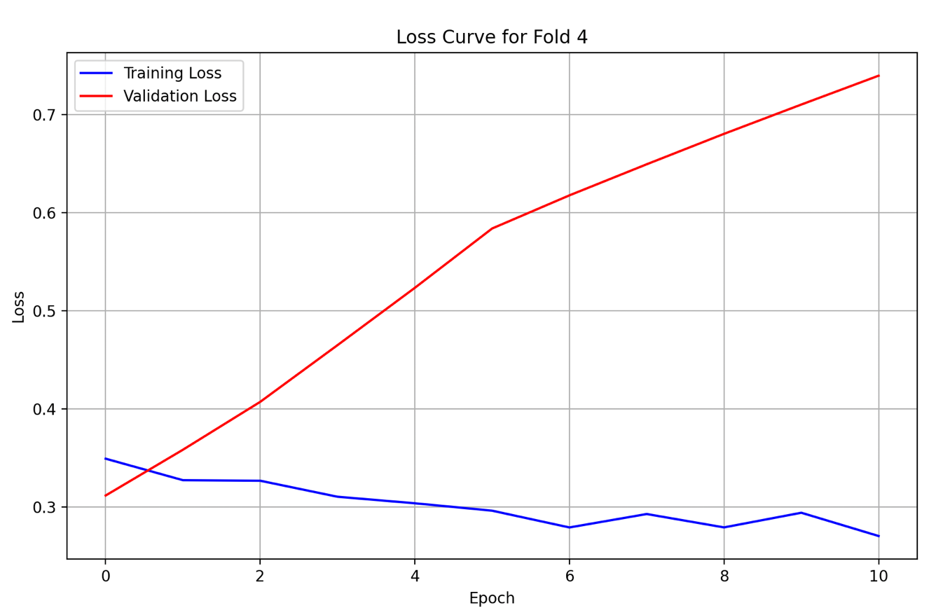

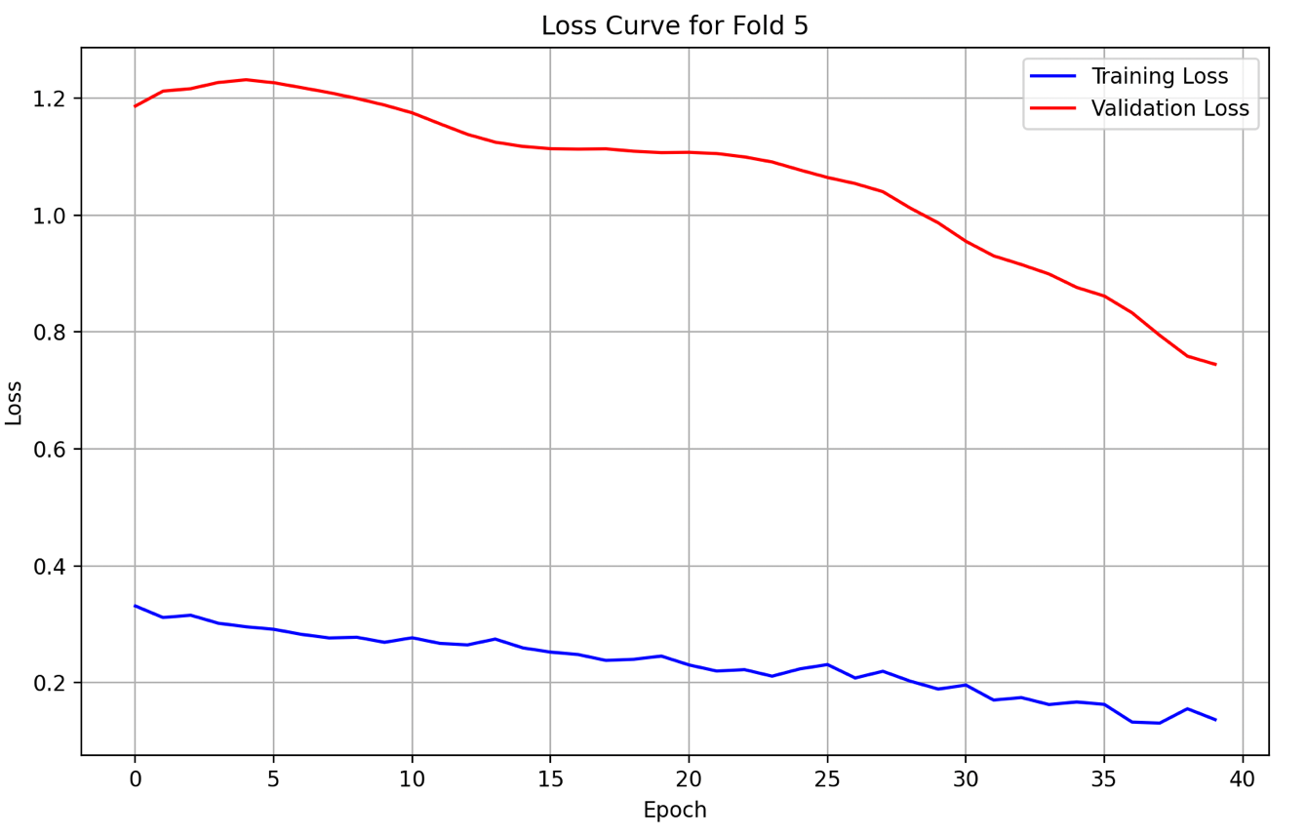

### WA

#### **Plots (Original GRU)**

1. Predicted, Actual and Future Predicted (Prediction Plot)

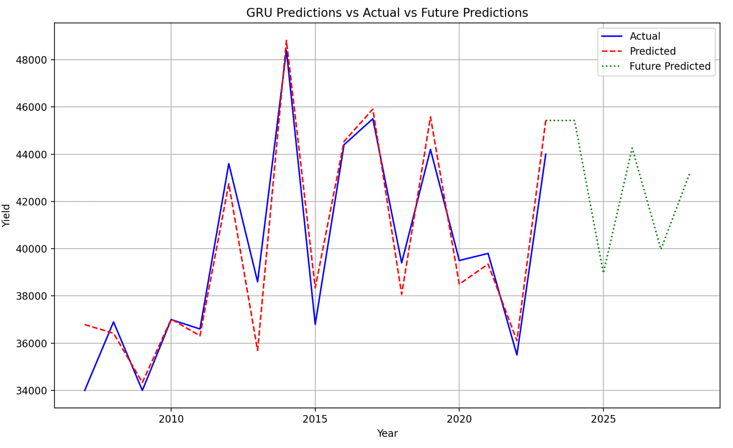

1. Loss Curves

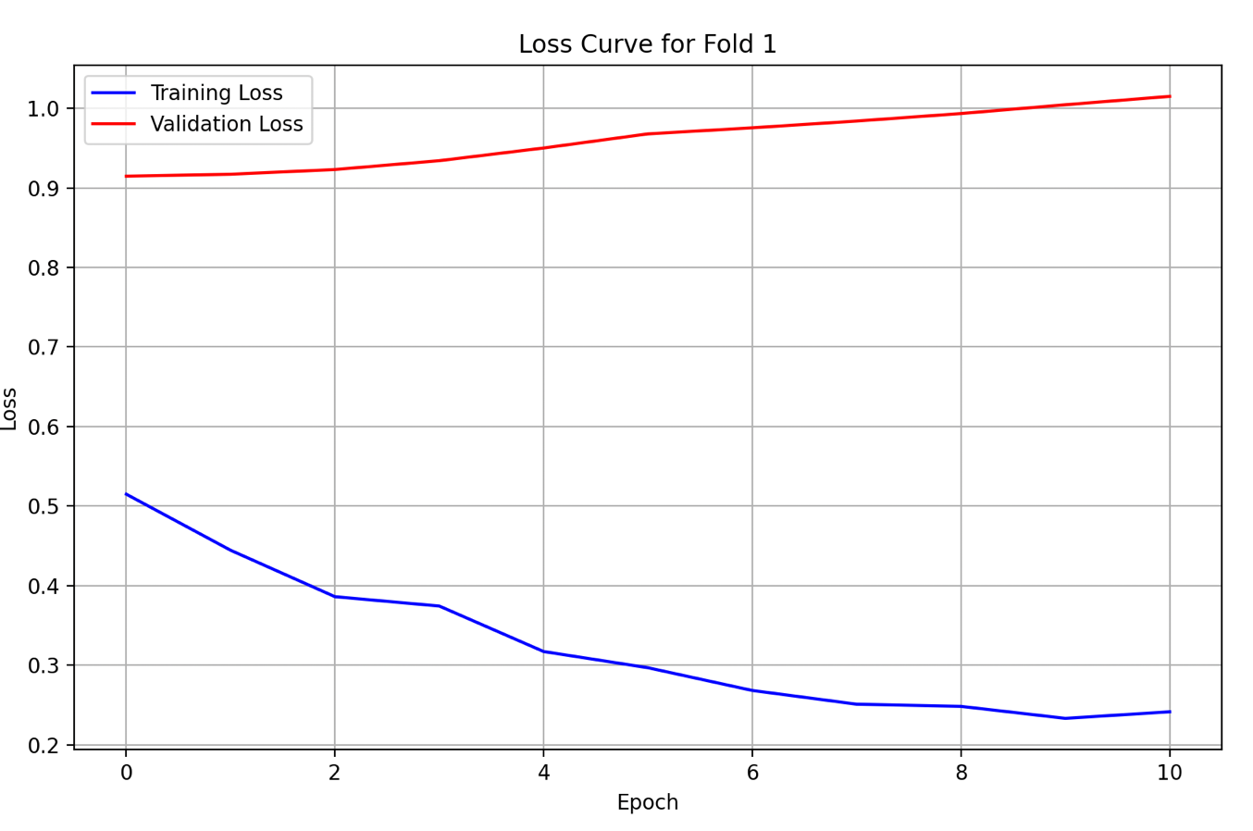

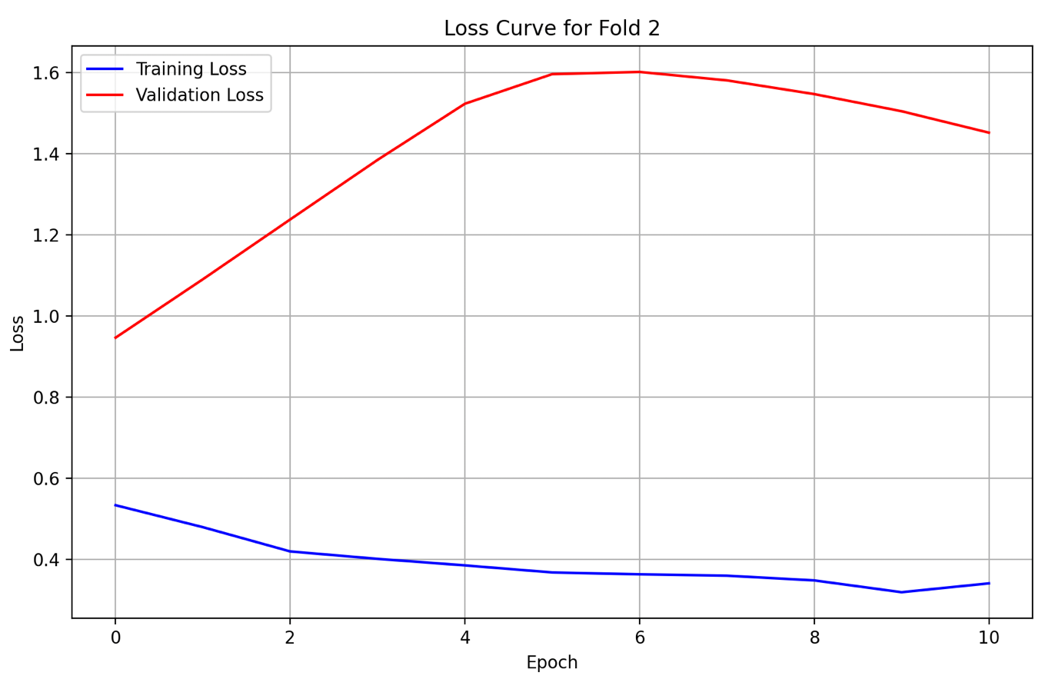

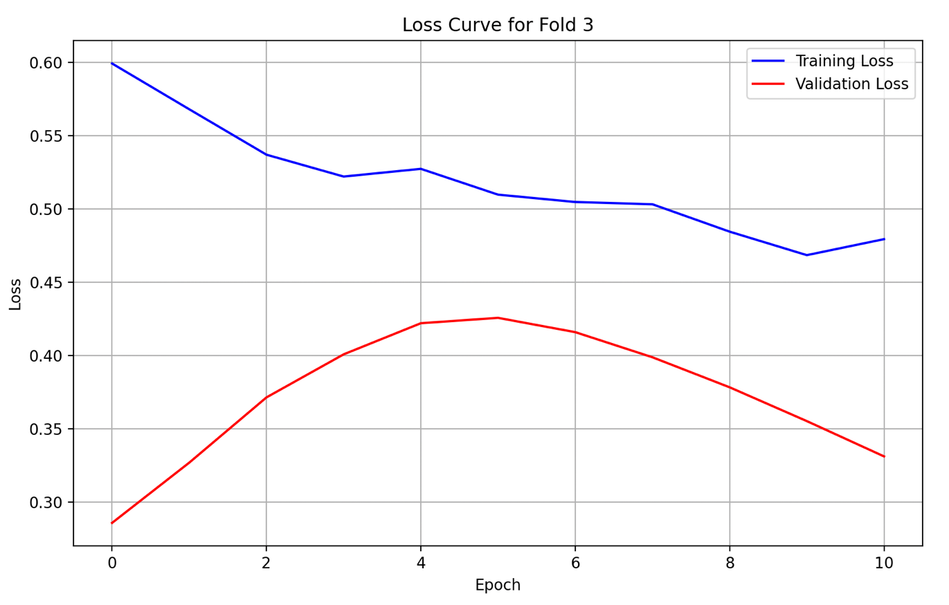

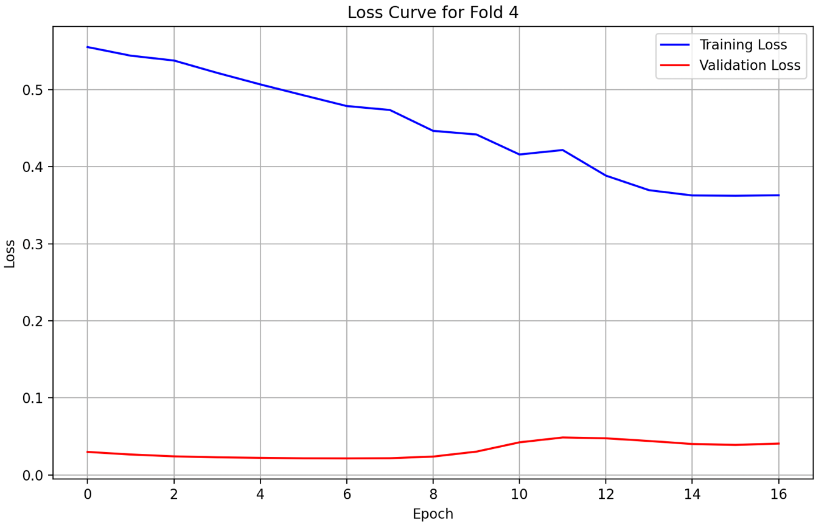

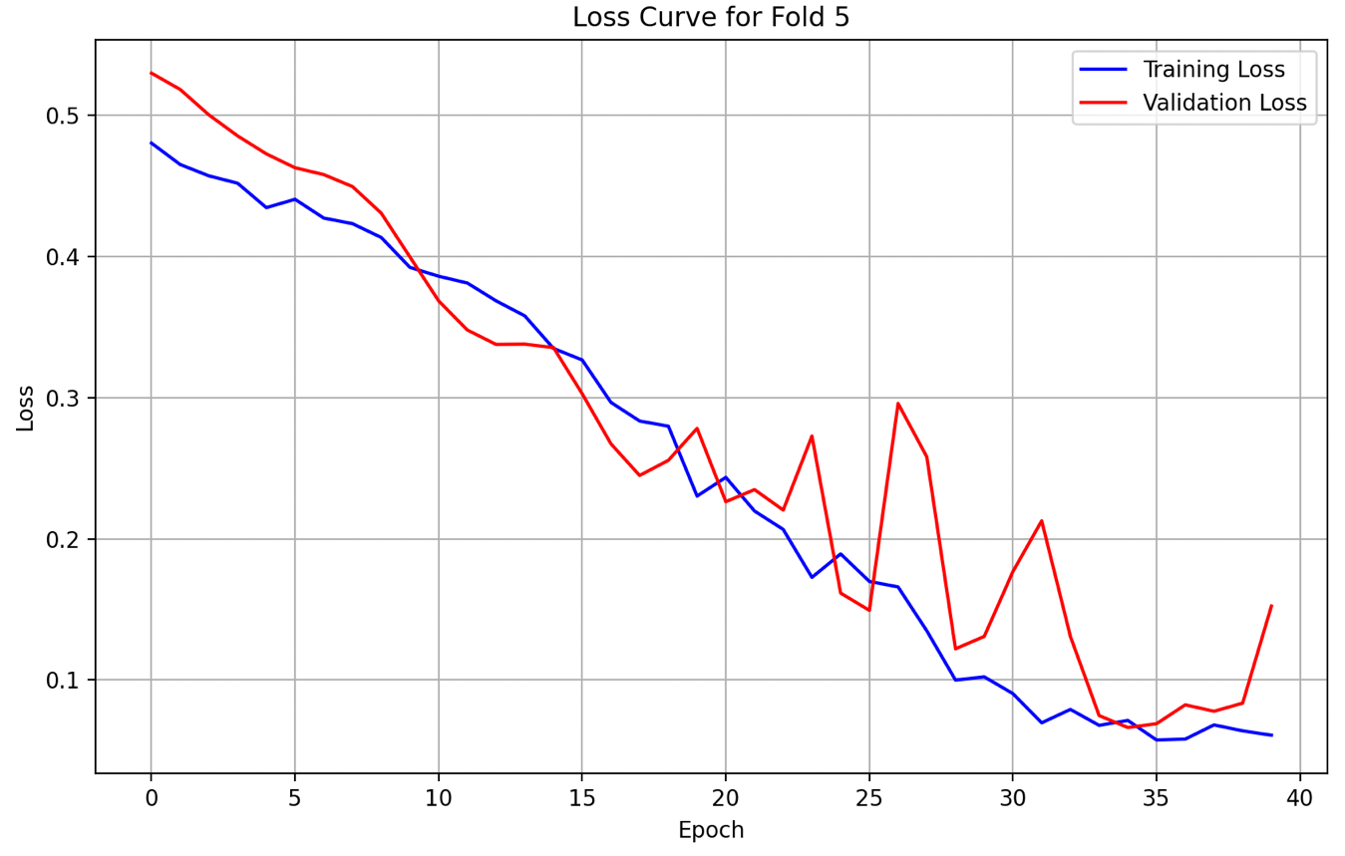

### MI

#### **Plots (Original GRU)**

1. Predicted, Actual and Future Predicted (Prediction Plot)

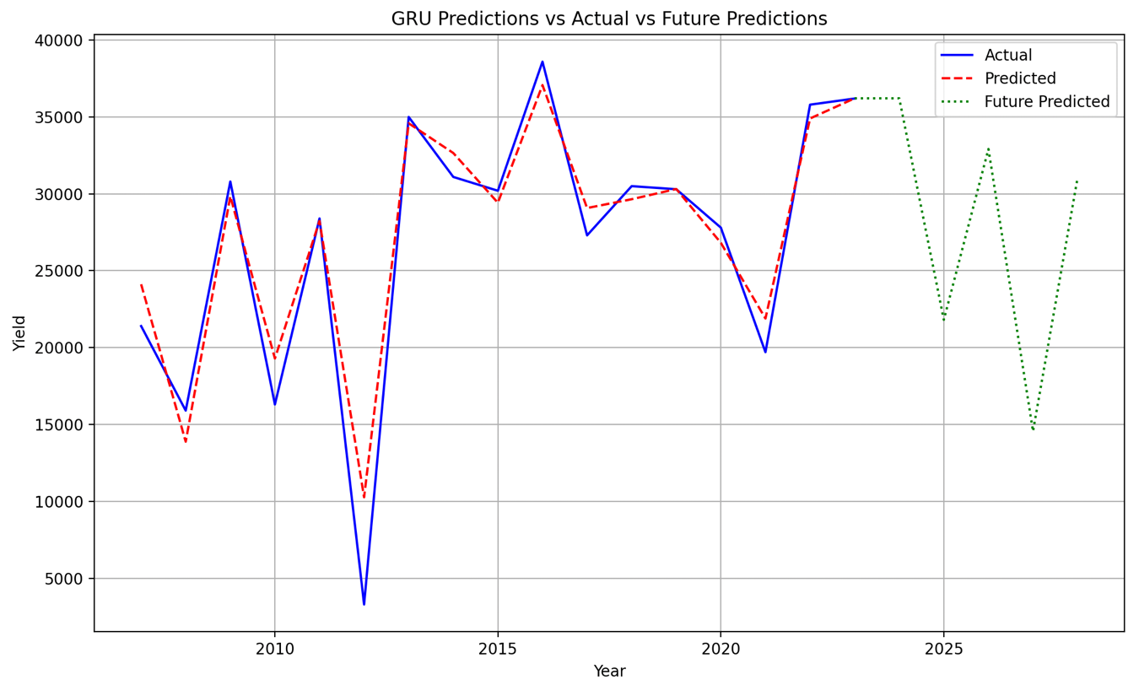

1. Loss Curves

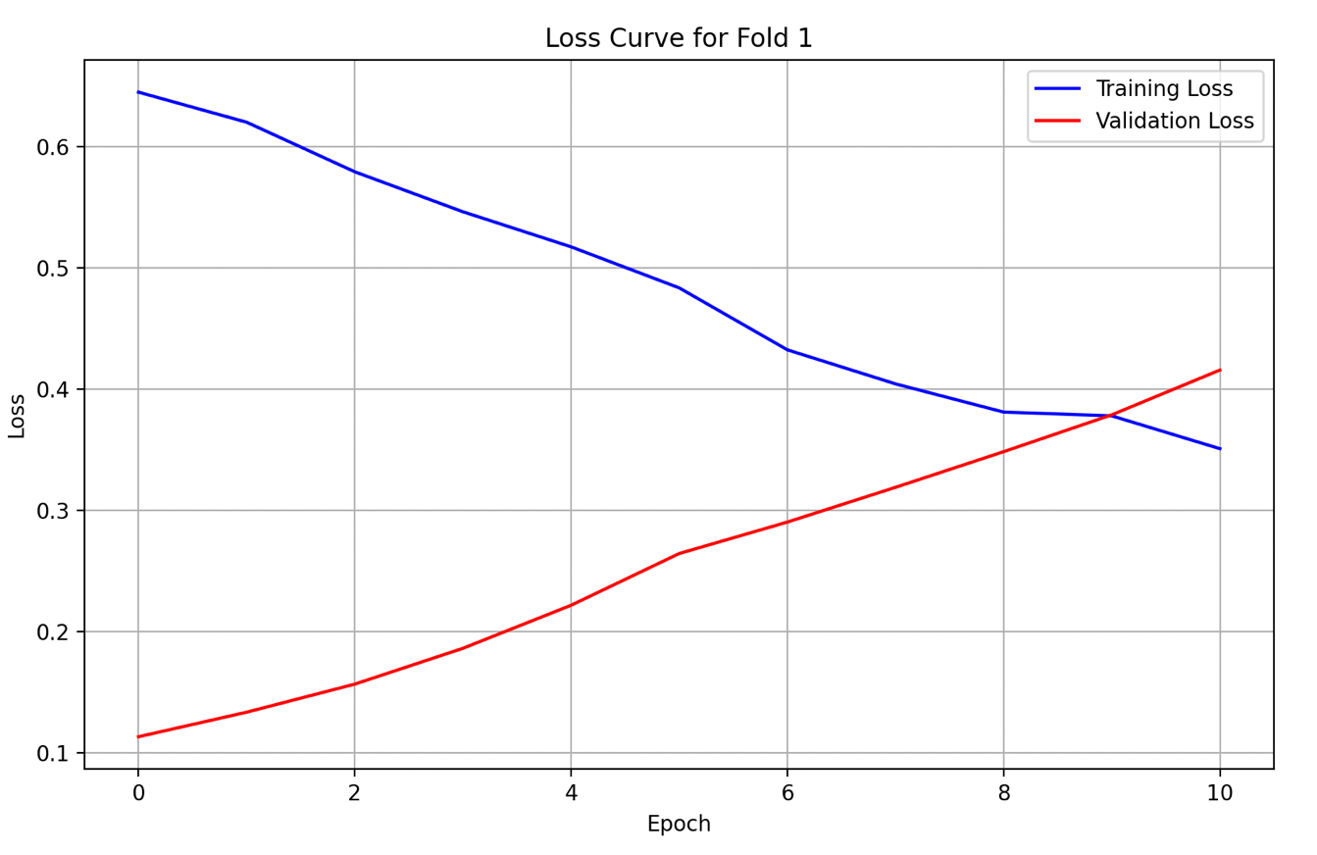

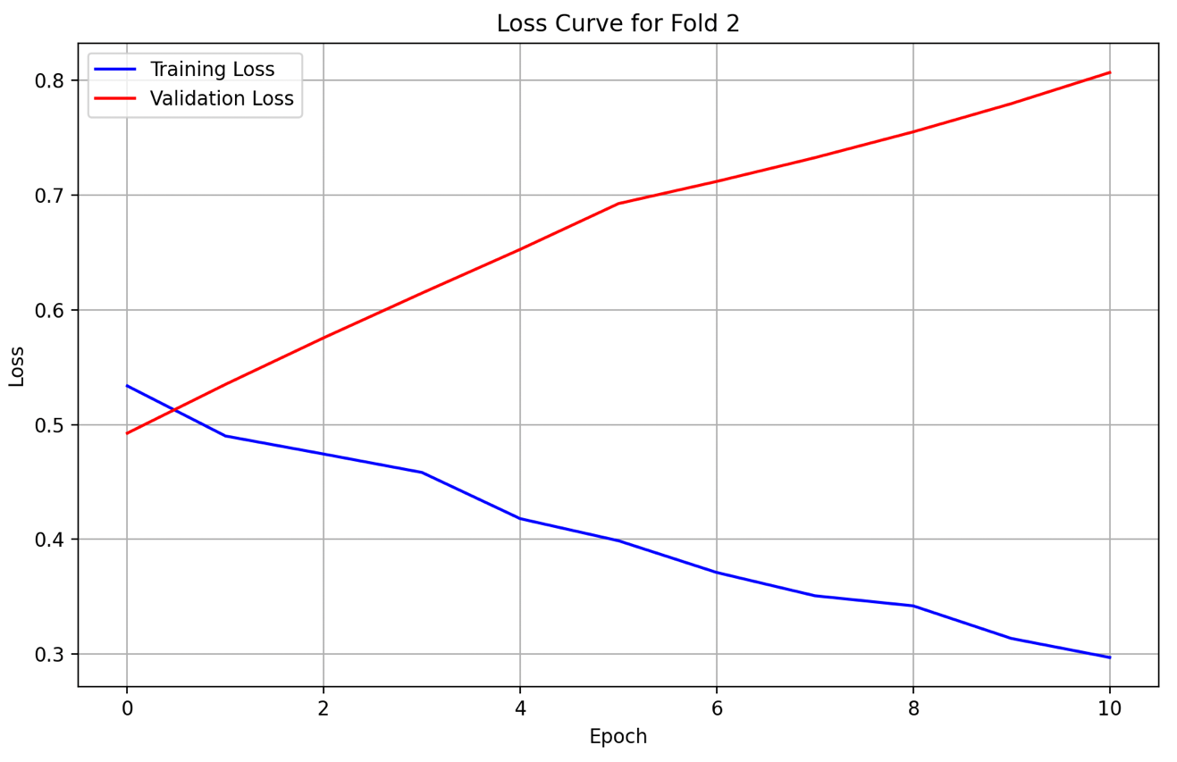

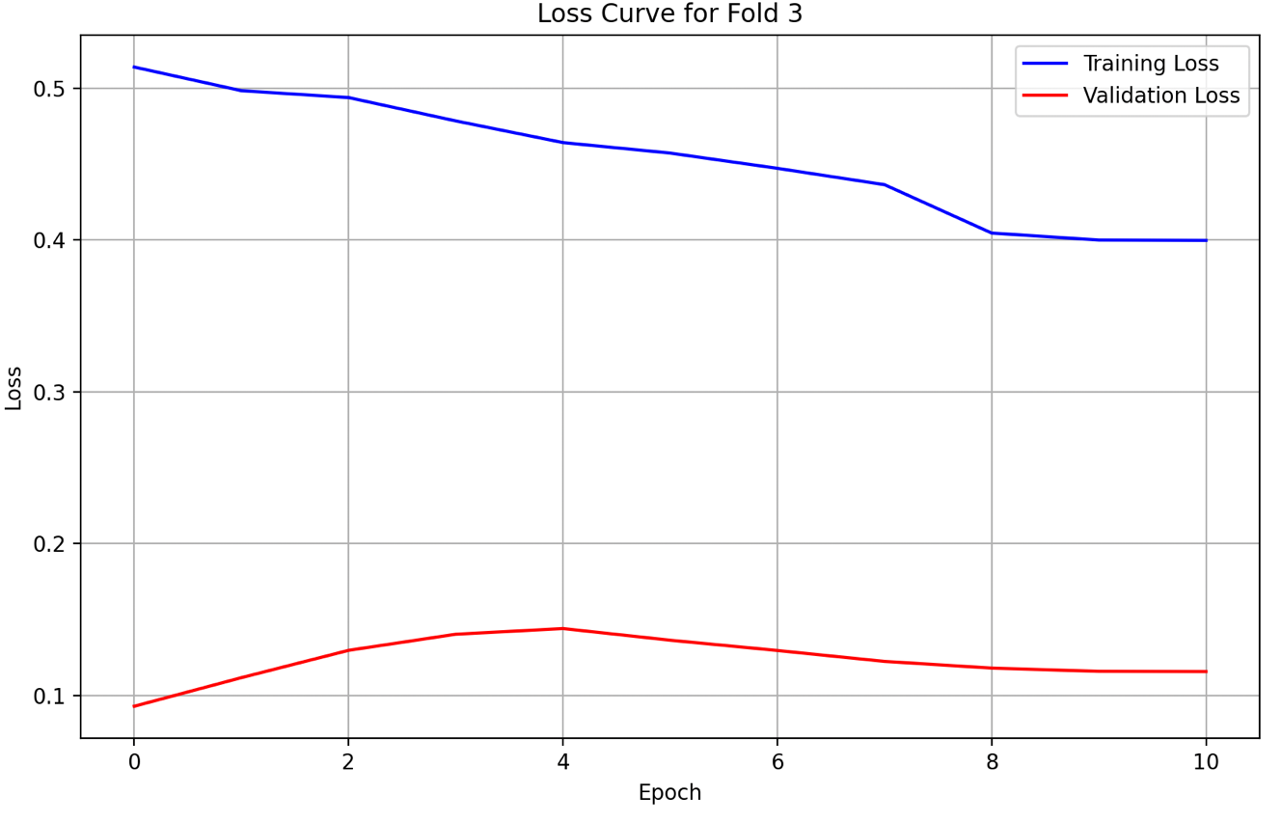

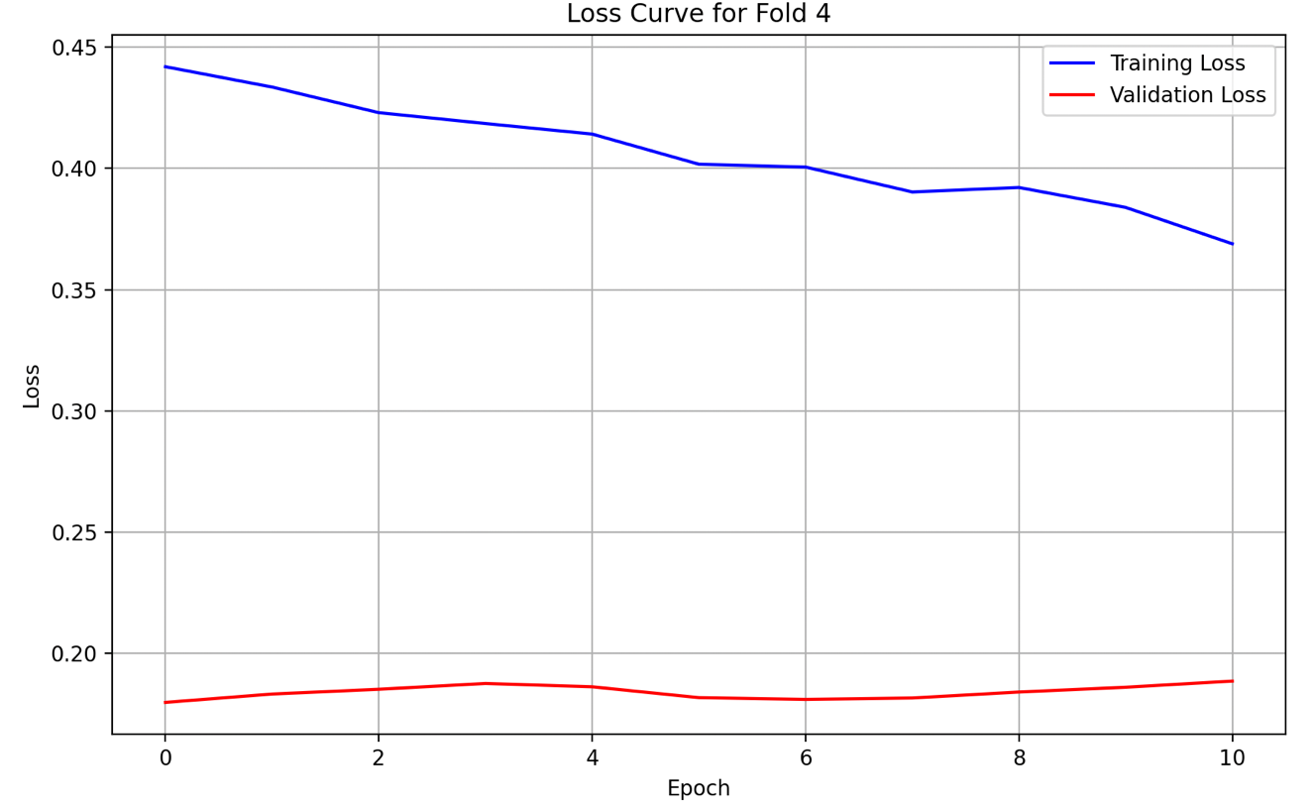

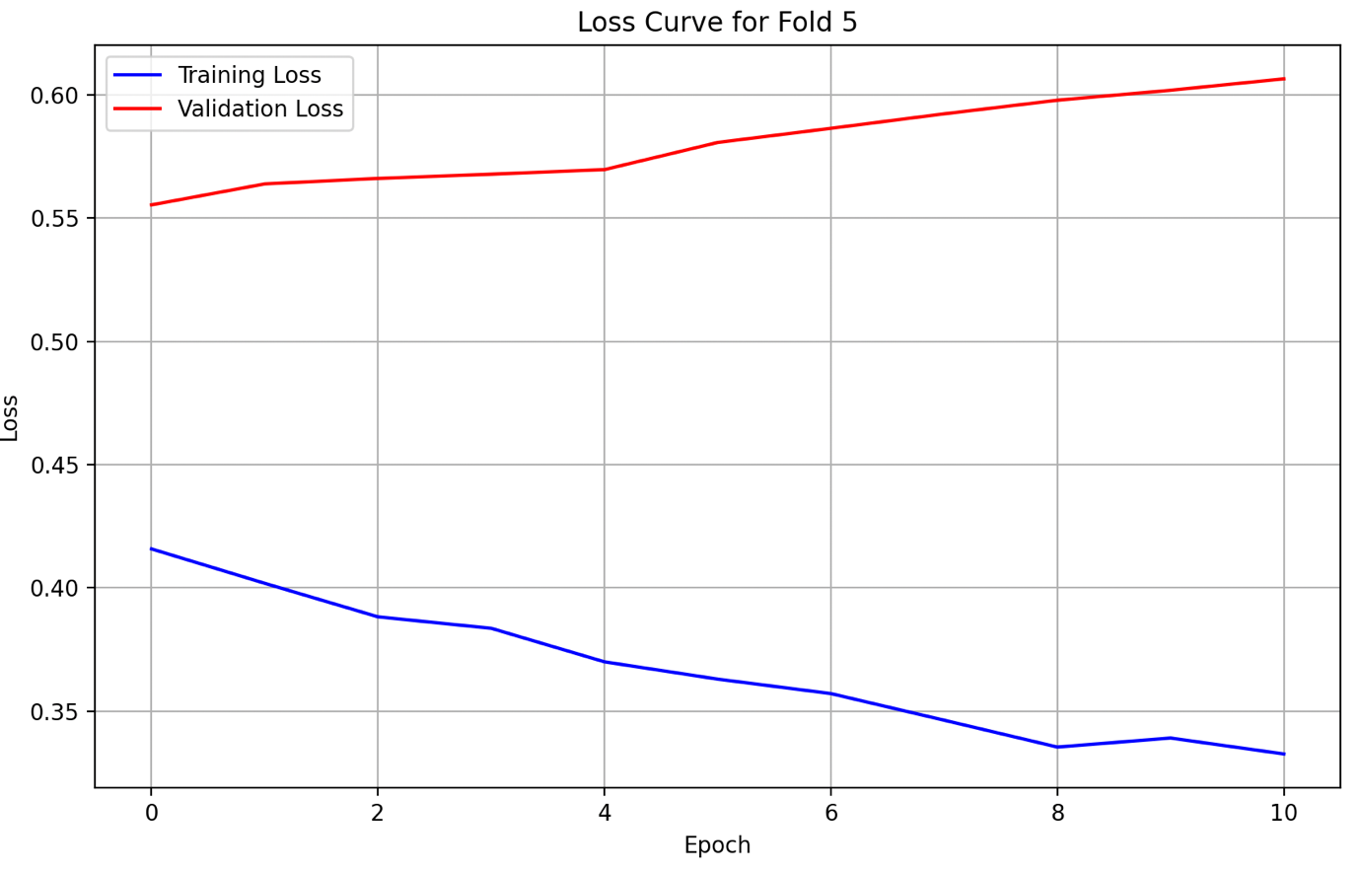

### PA

#### **Plots (Original GRU)**

1. Predicted, Actual and Future Predicted (Prediction Plot)

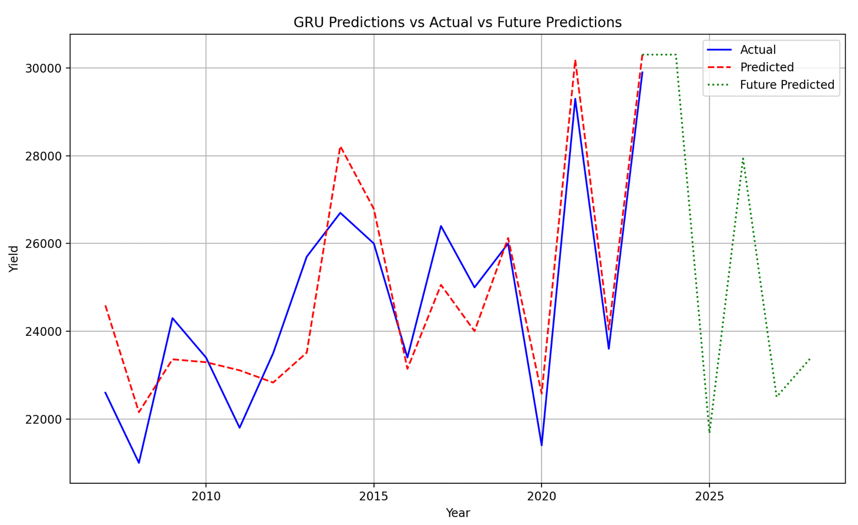

1. Loss Curves

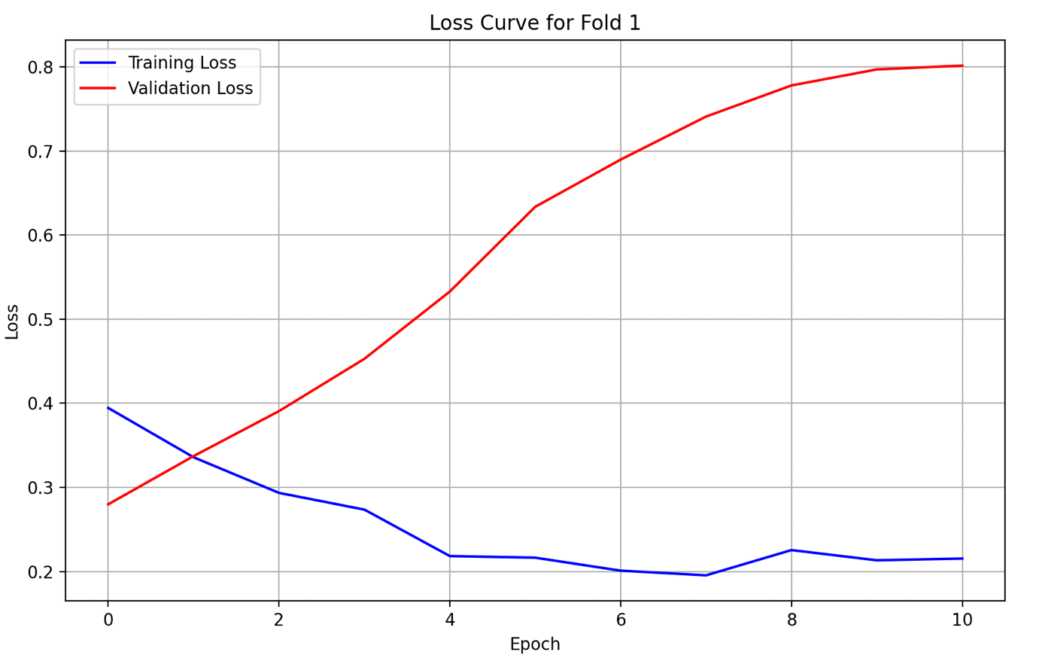

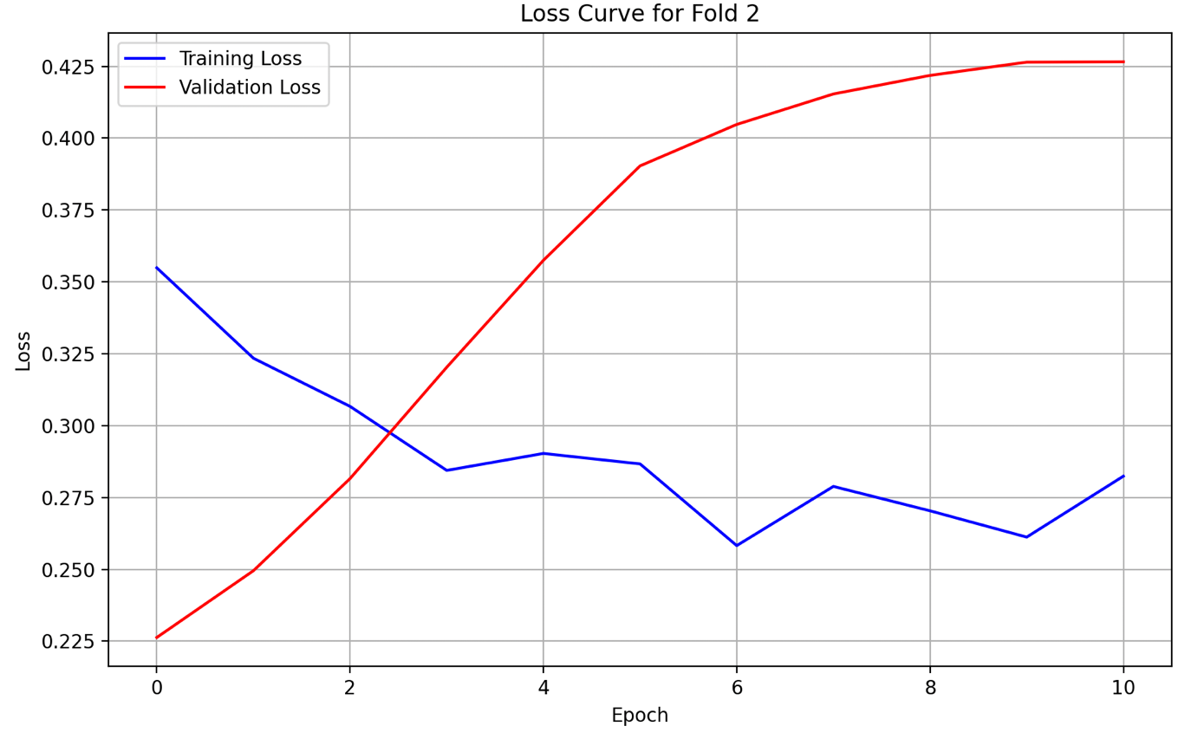

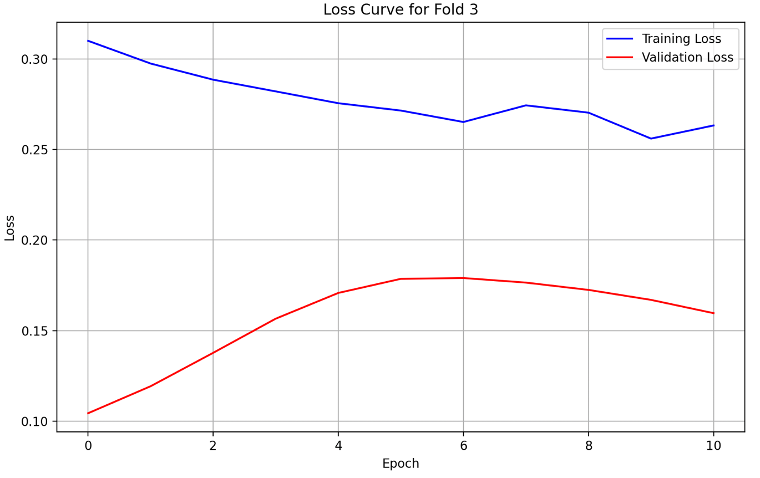

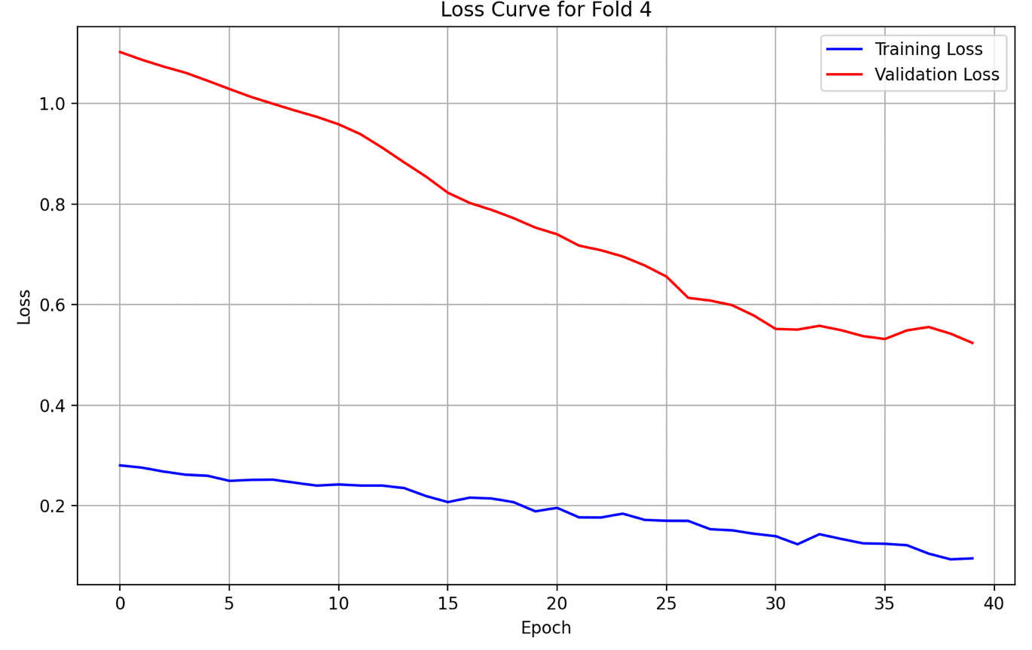

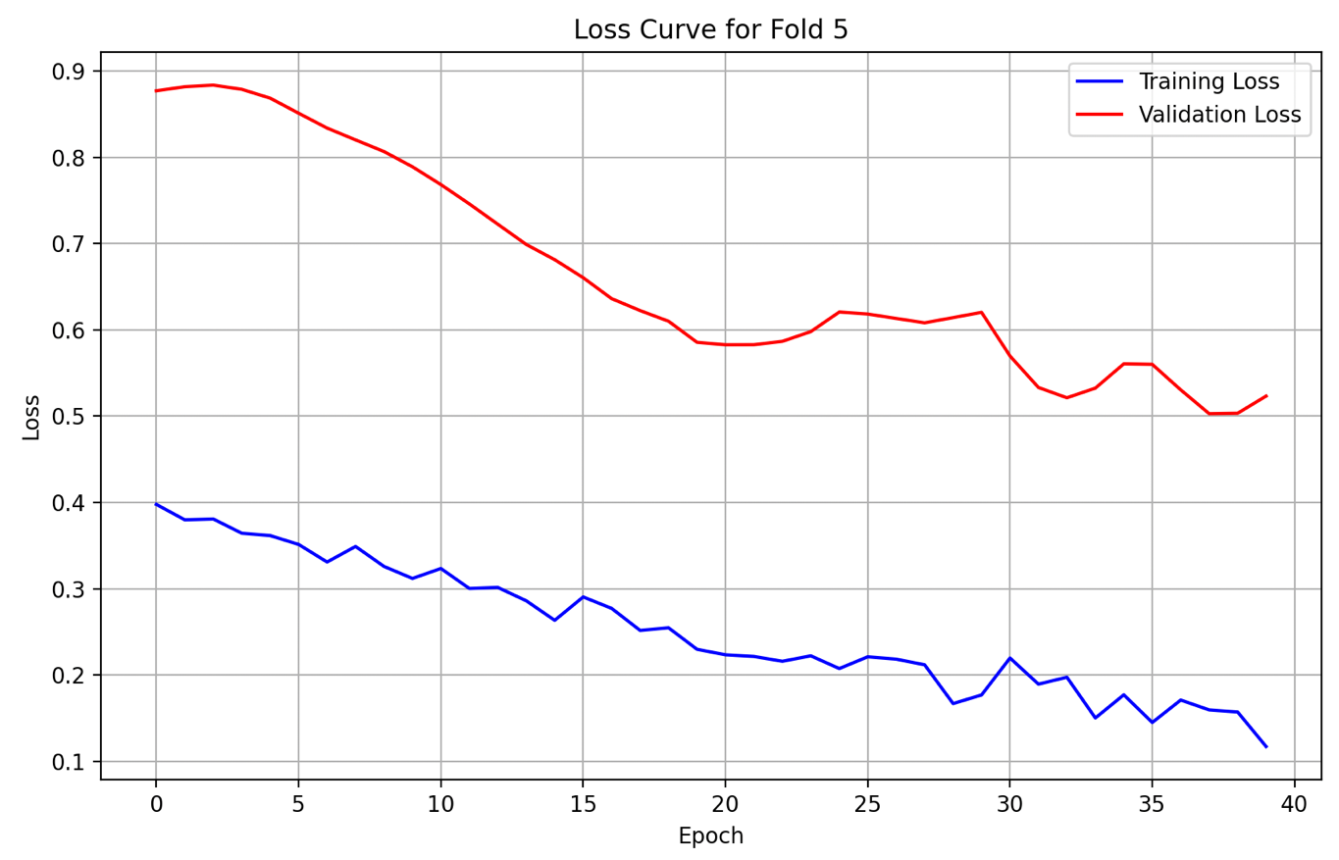

## 1D-CNN

#### **Actual Model Code**

Refer to the Google Drive.

### CA

#### **Plots (Original 1D-CNN)**

1. Predicted, Actual and Future Predicted (Prediction Plot)

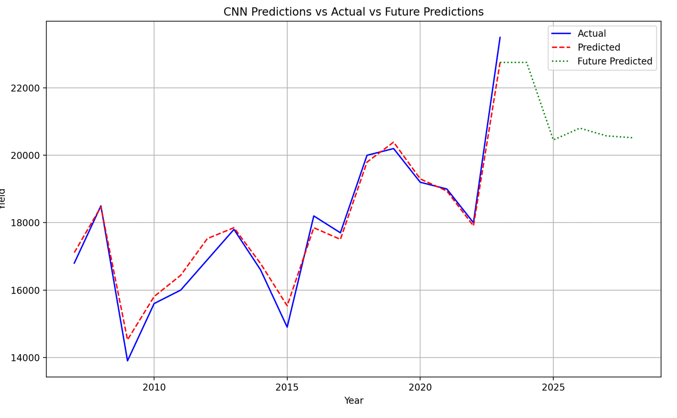

1. Loss Curves

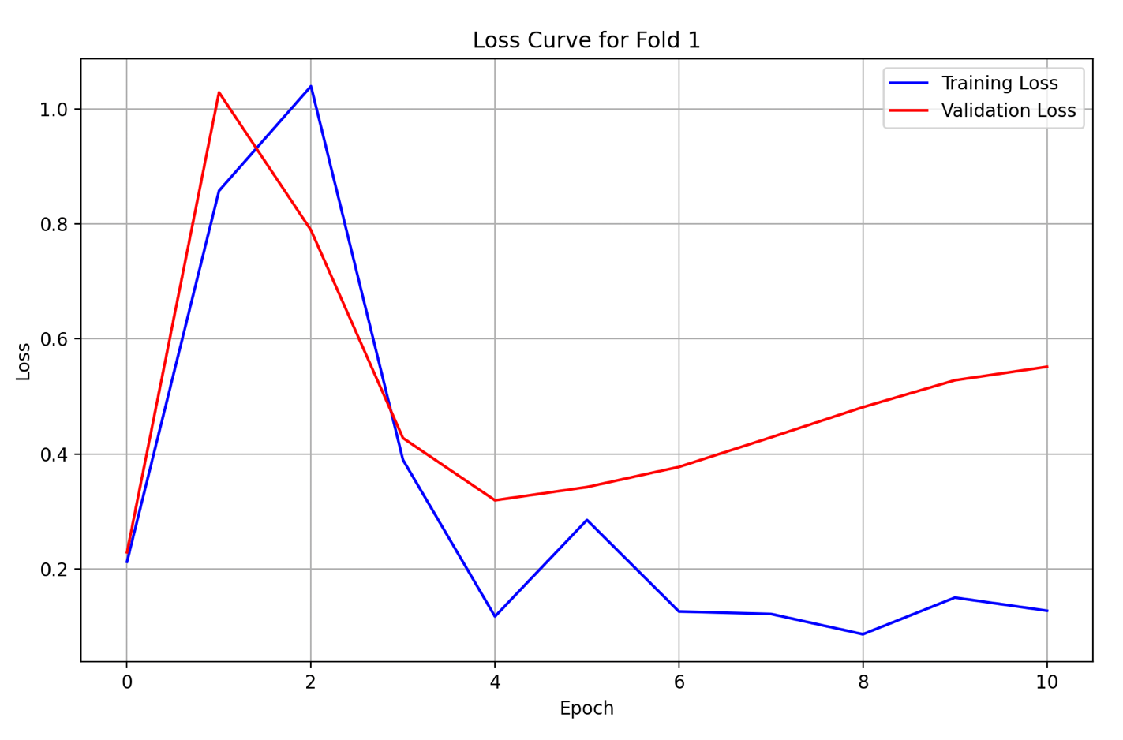

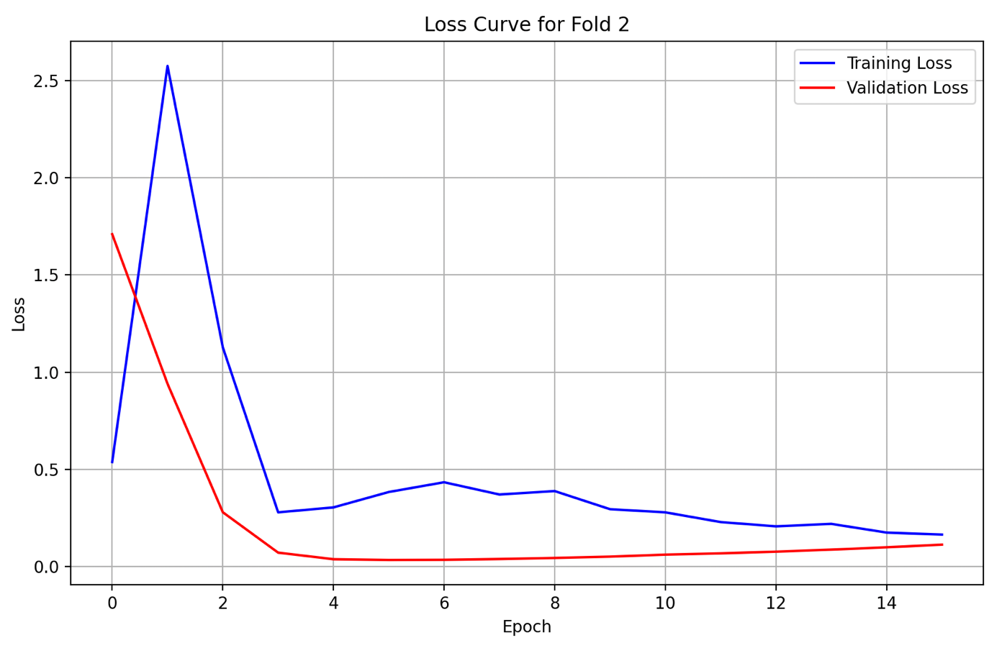

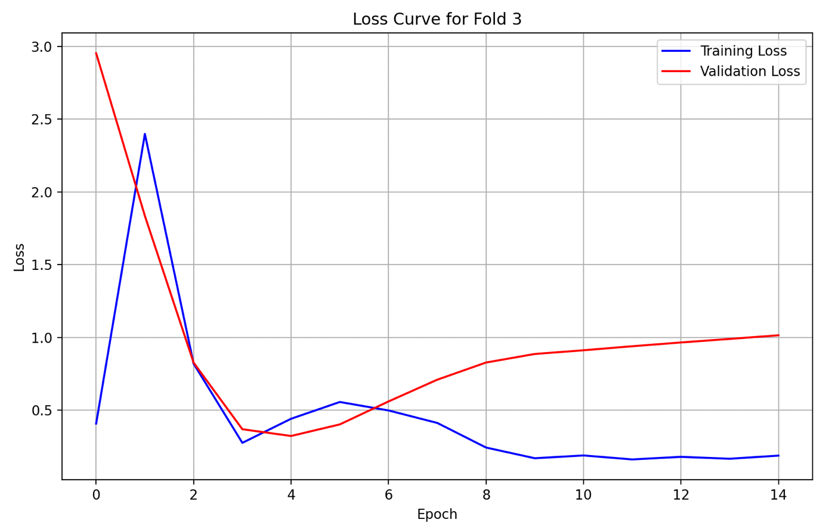

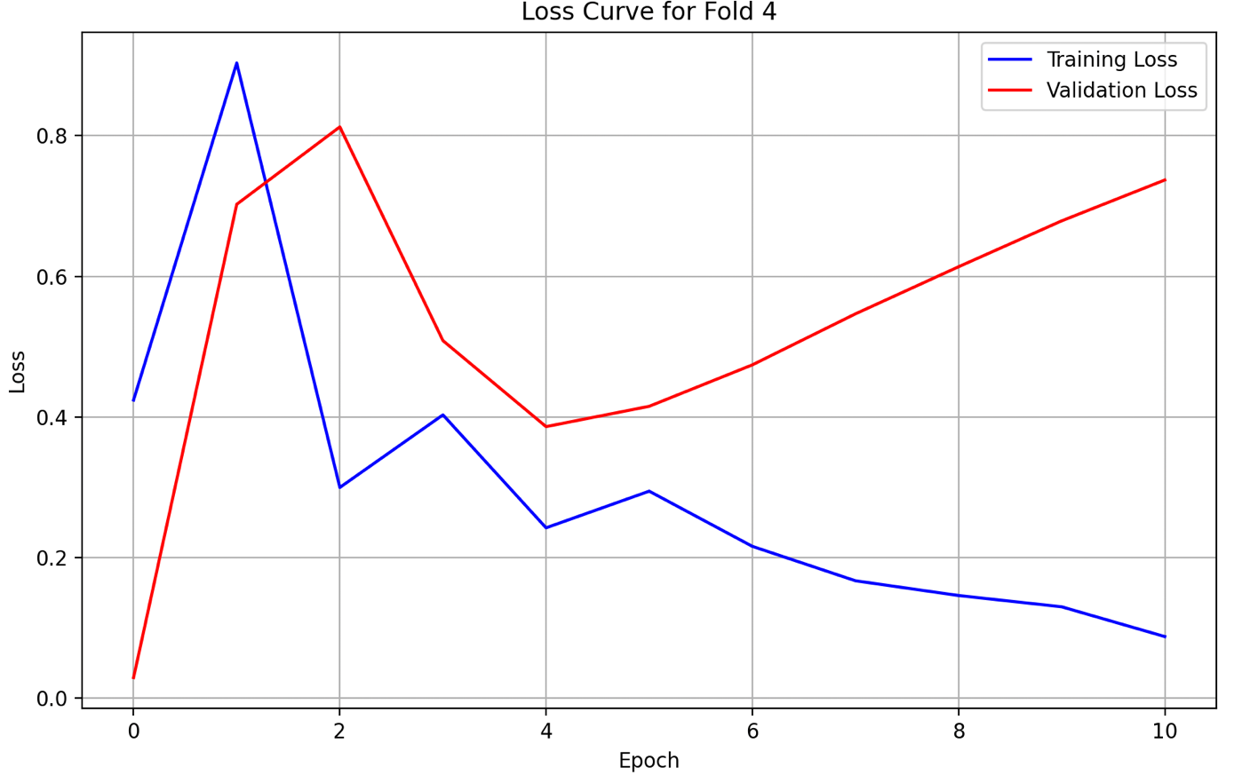

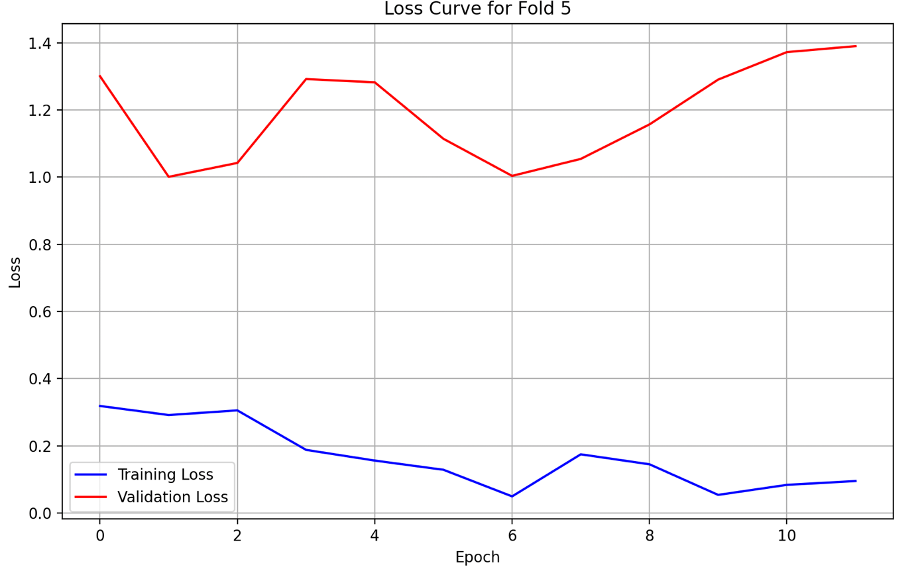

### WA

#### **Plots (Original 1D-CNN)**

1. Predicted, Actual and Future Predicted (Prediction Plot)

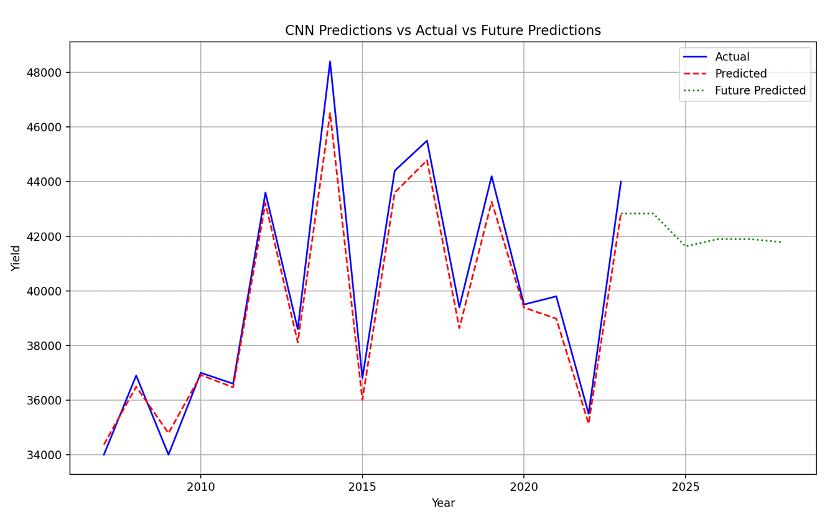

1. Loss Curves

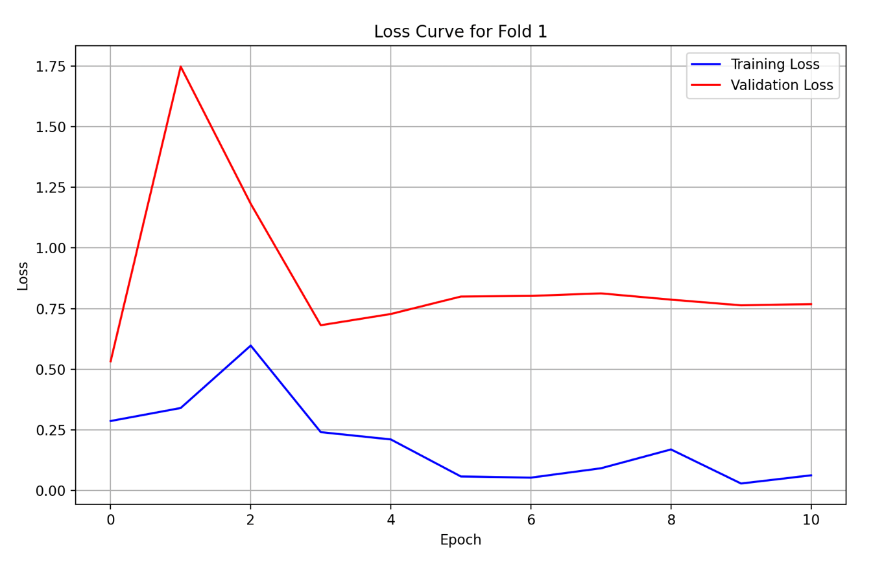

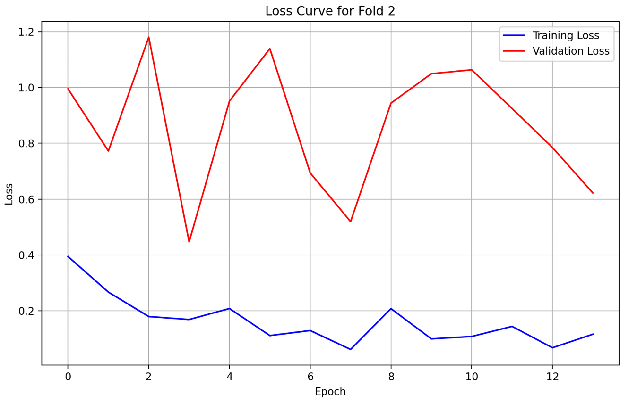

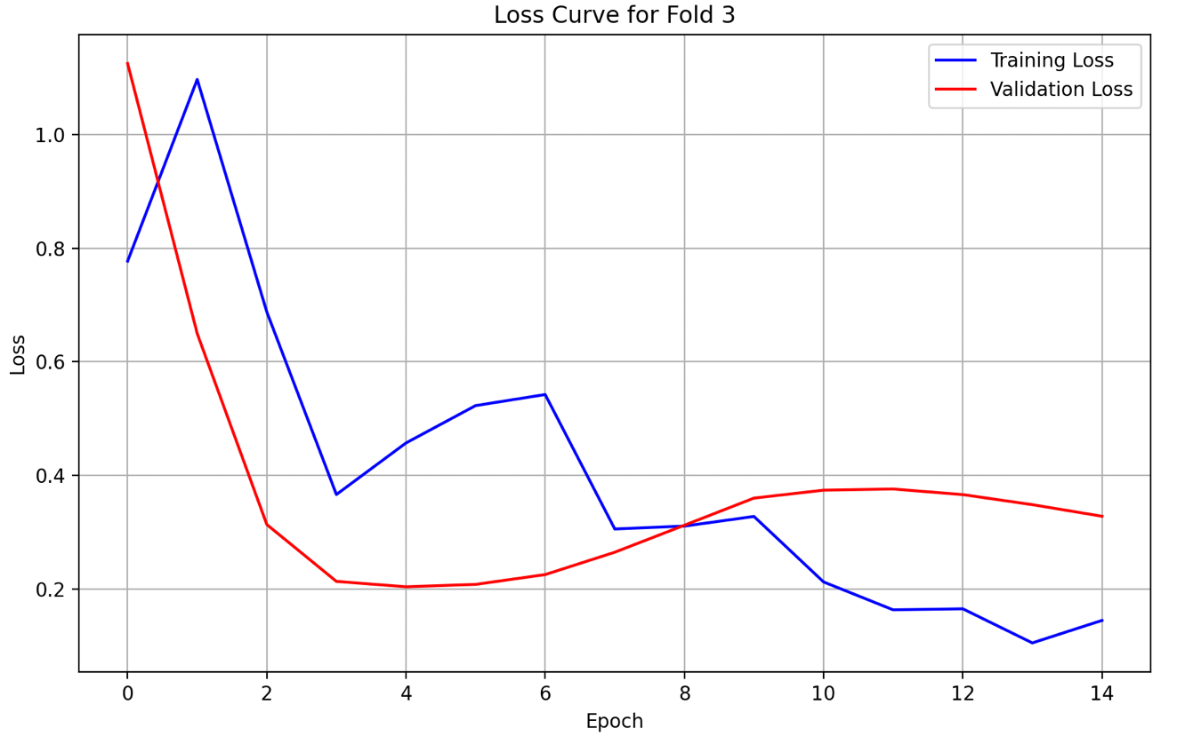

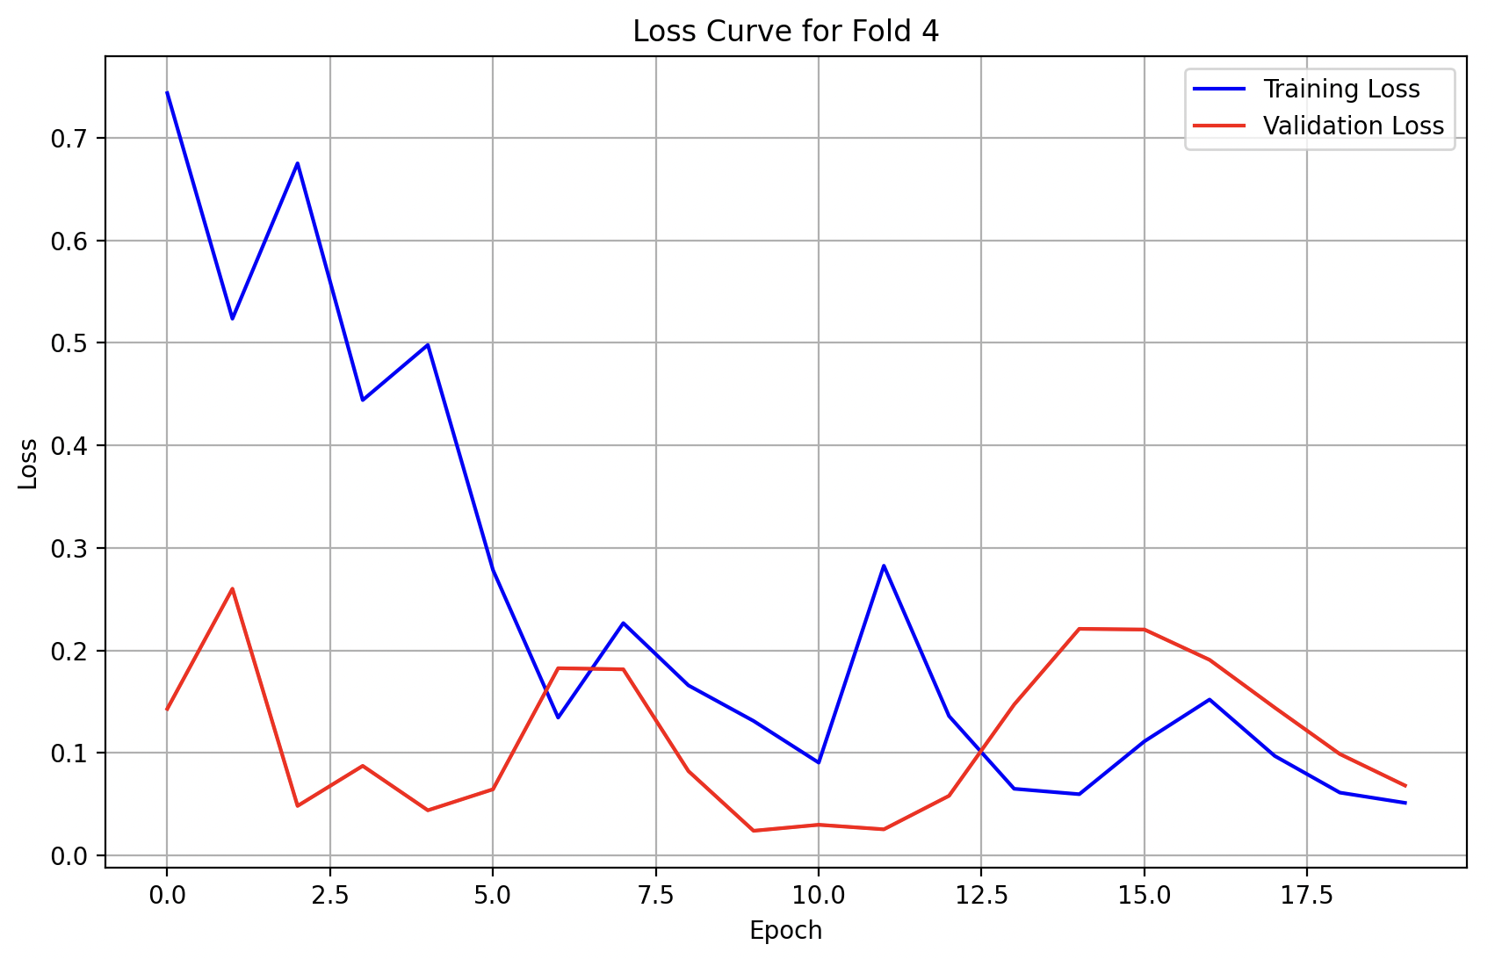

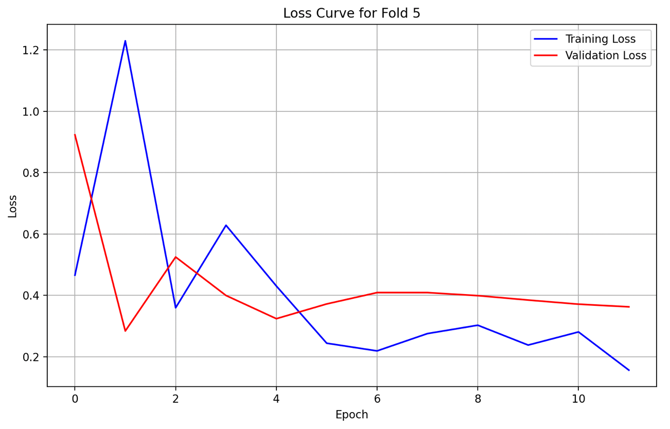

### MI

#### **Plots (Original 1D-CNN)**

1. Predicted, Actual and Future Predicted (Prediction Plot)

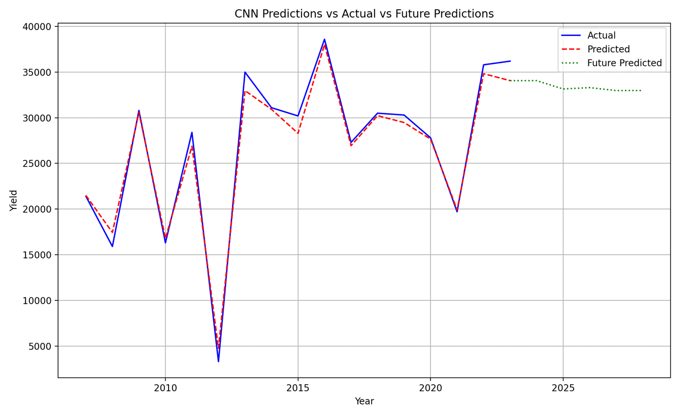

1. Loss Curves

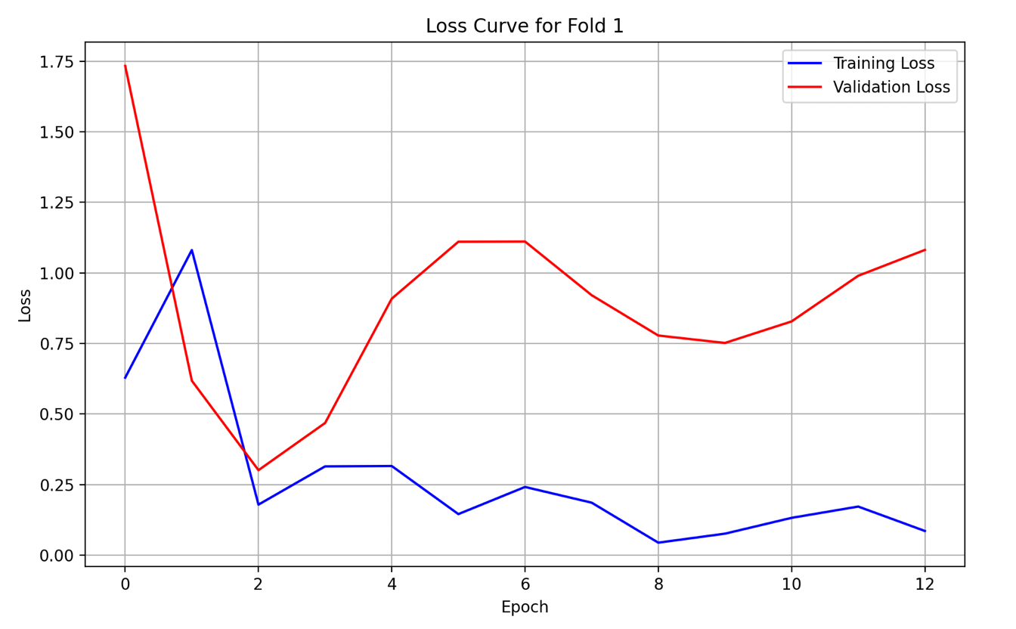

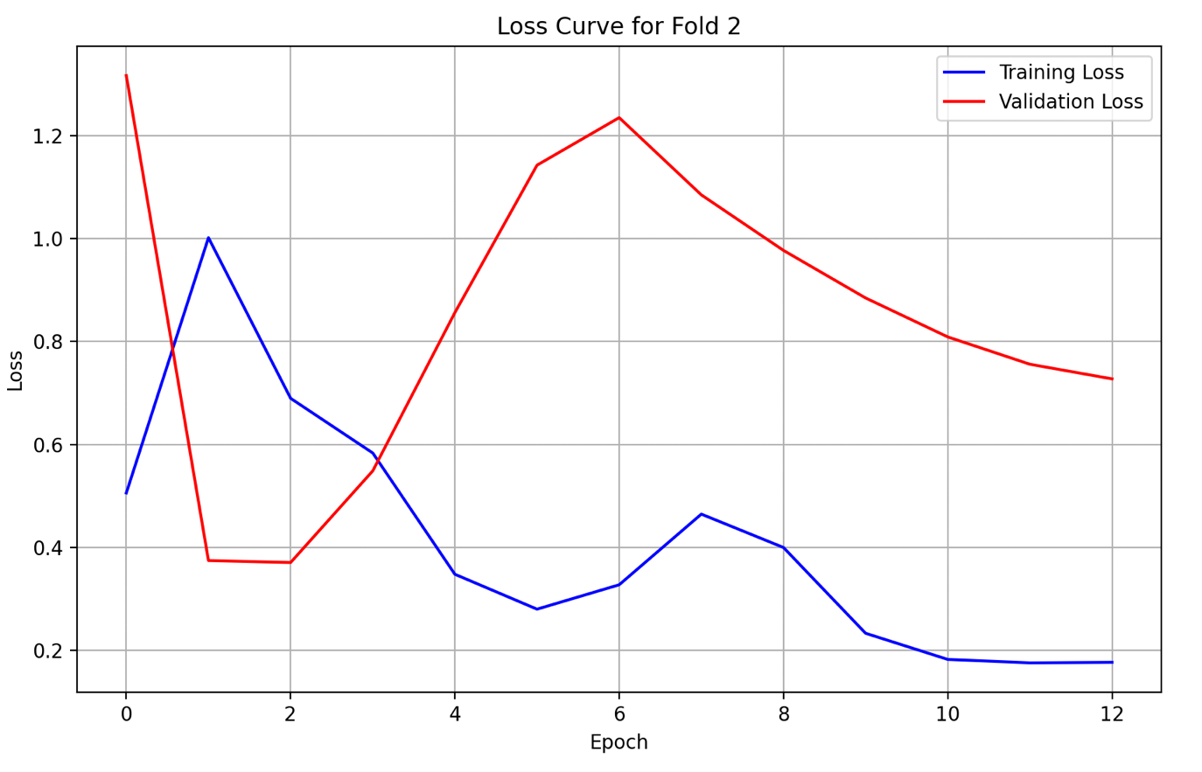

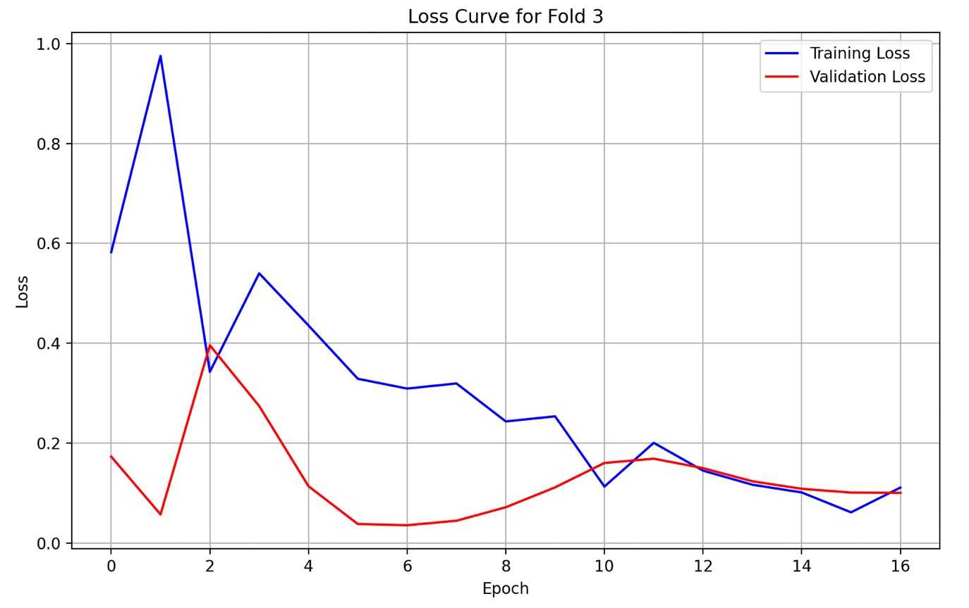

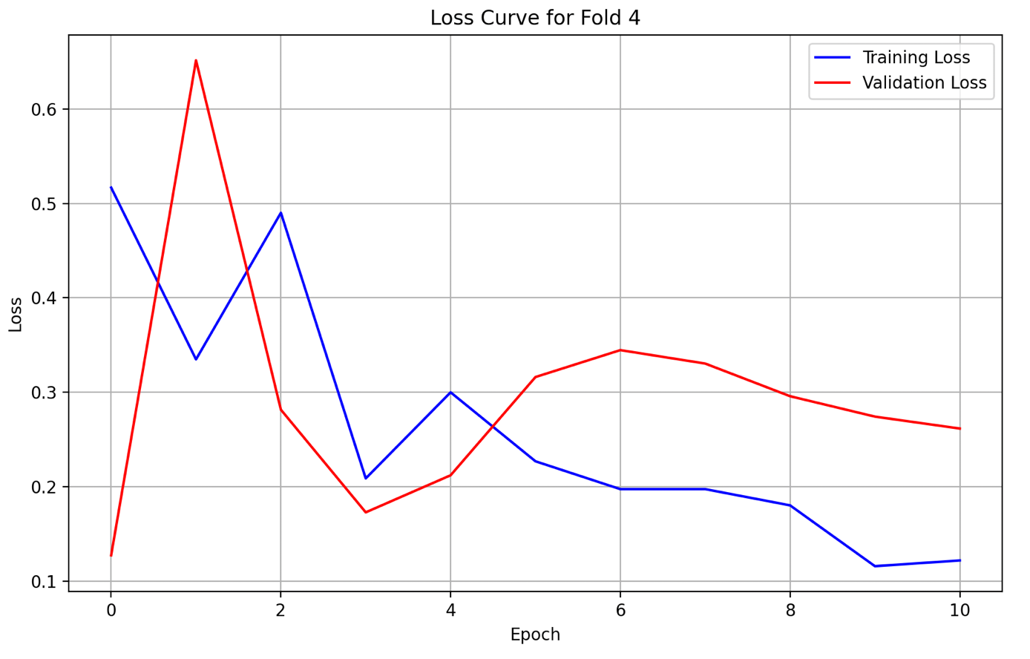

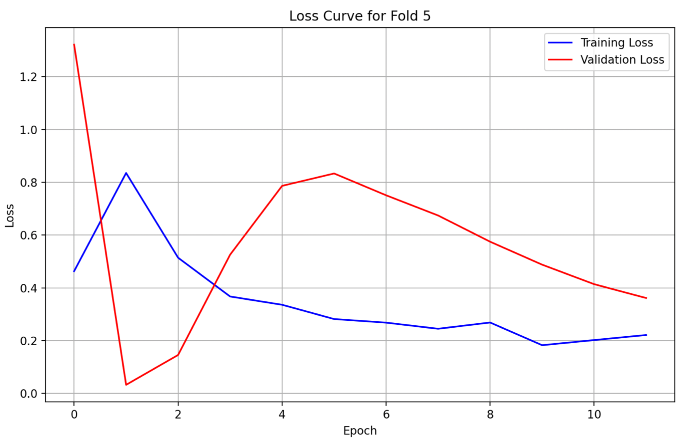

### PA

#### **Plots (Original 1D-CNN)**

1. Predicted, Actual and Future Predicted (Prediction Plot)

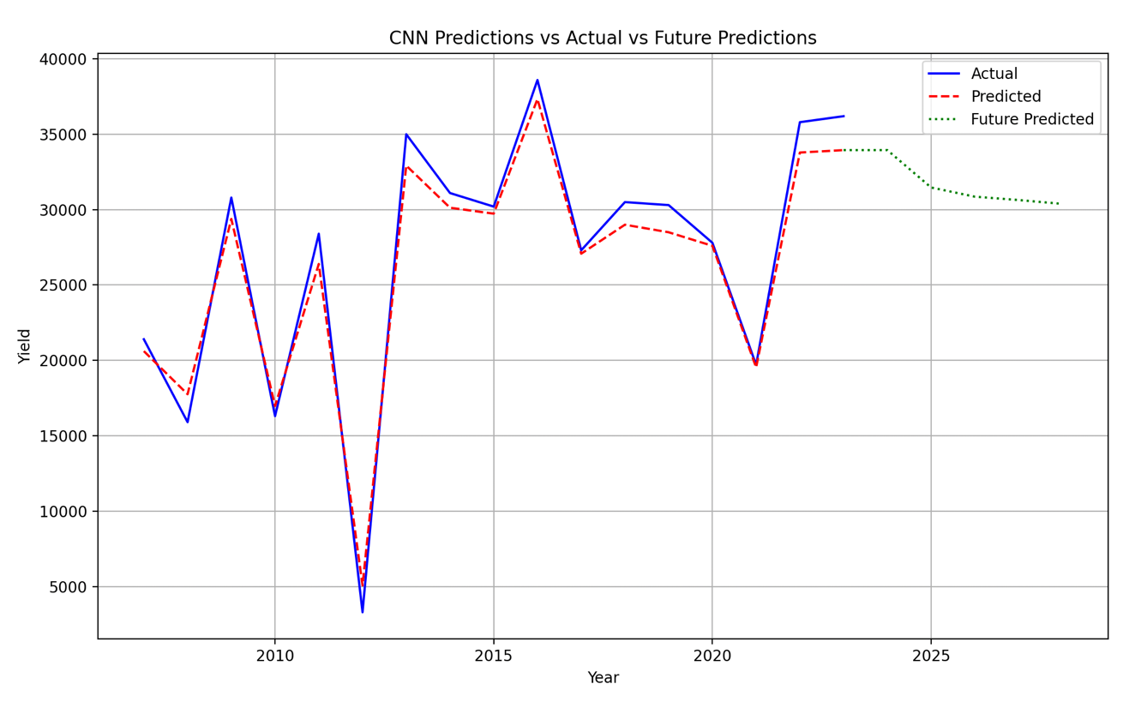

1. Loss Curves

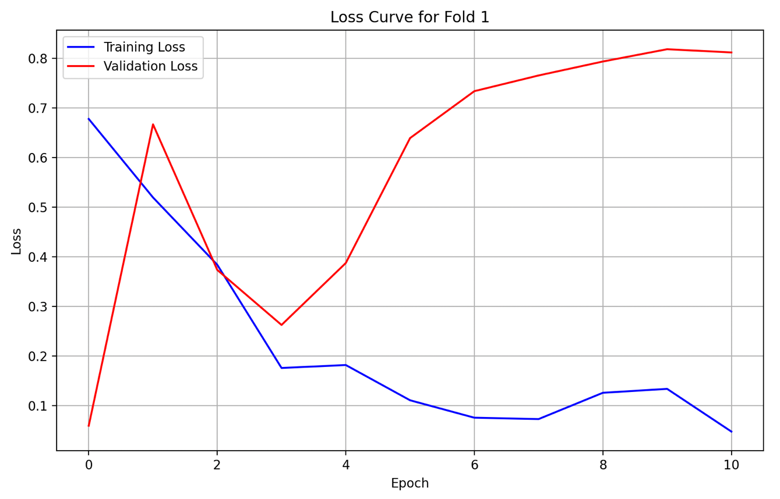

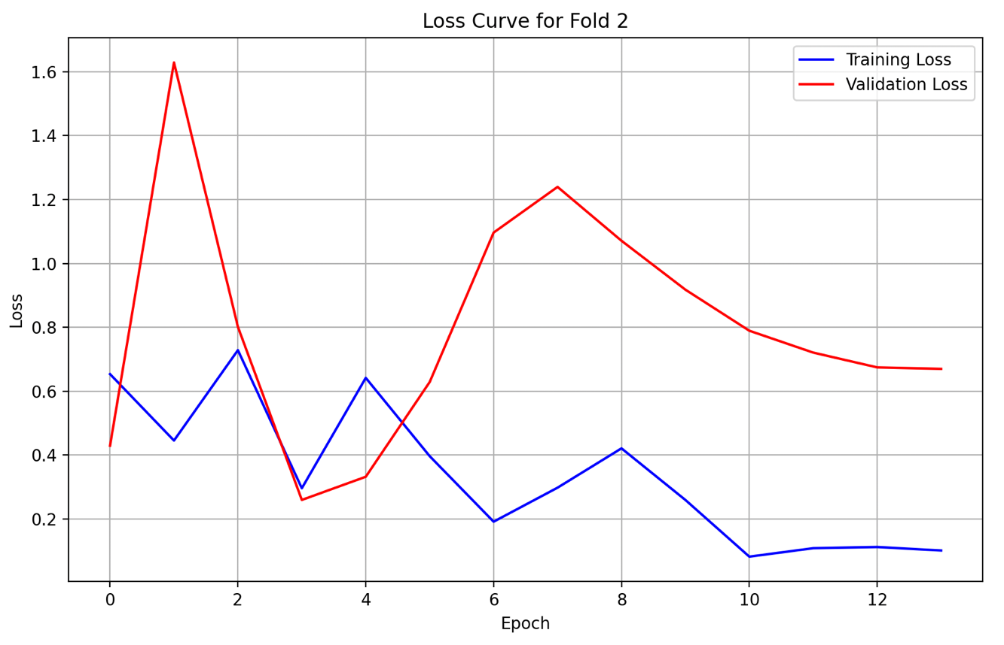

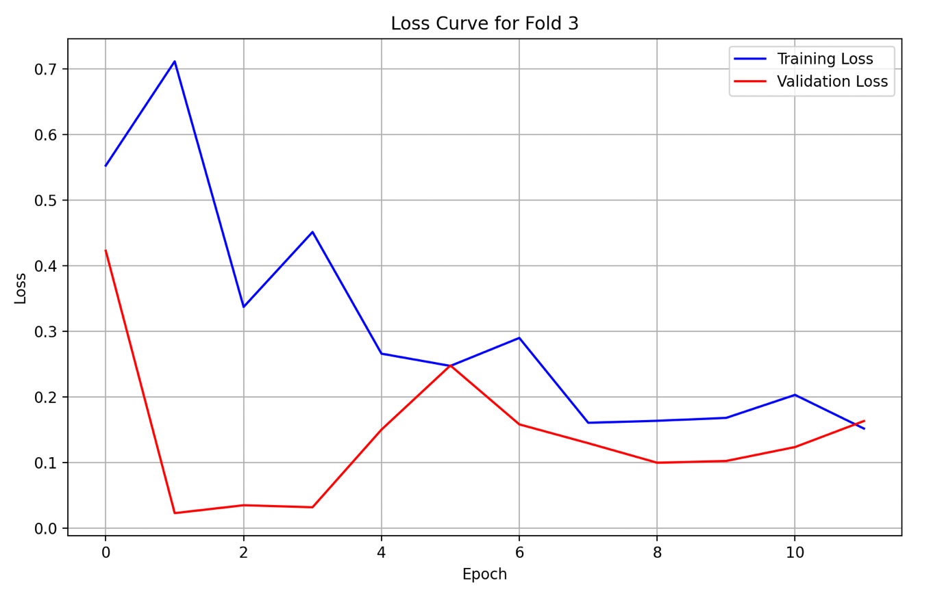

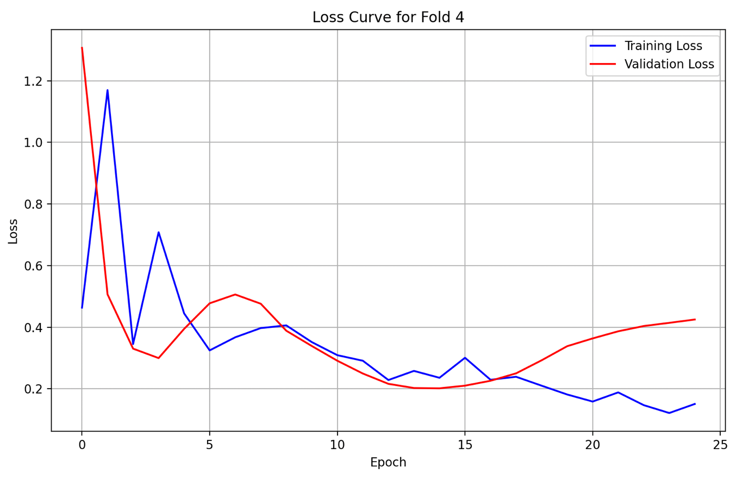

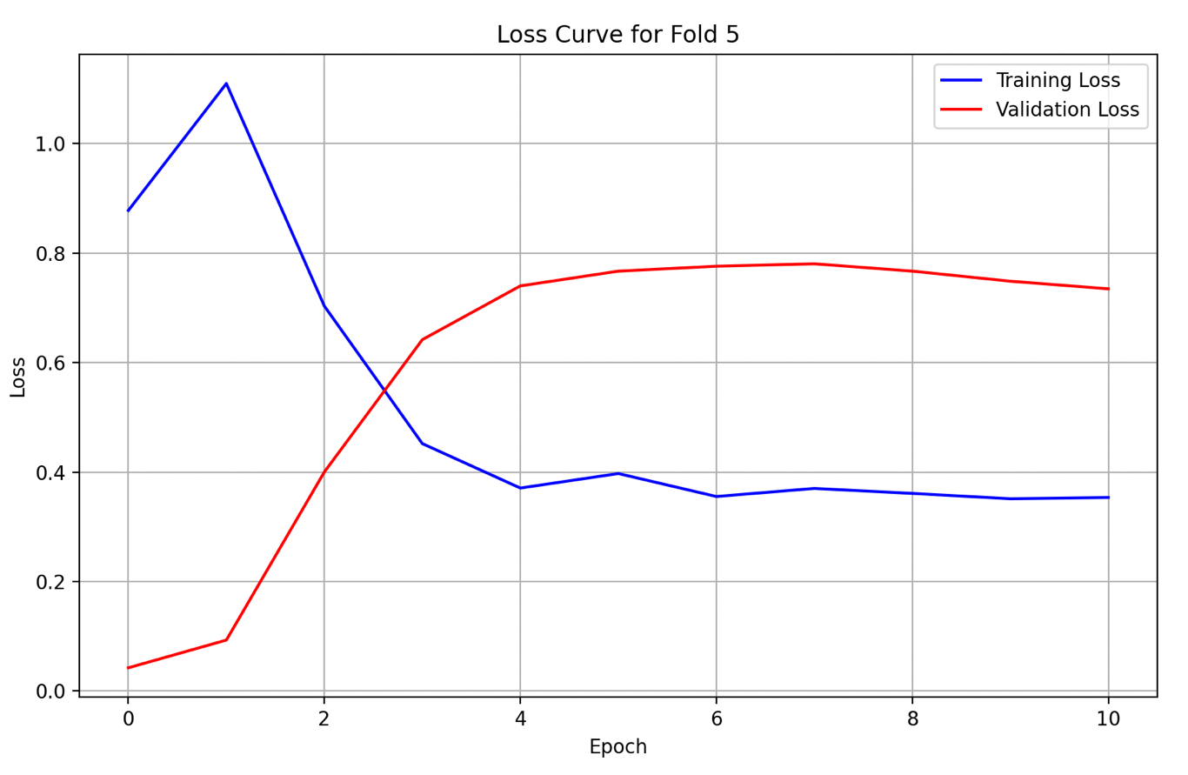

## LSTM (with Attention Layer)

#### **Actual Model Code**

Refer to the Google Drive.

### CA

#### **Plots (Original LSTM with Attention Layer)**

1. Predicted, Actual and Future Predicted (Prediction Plot)

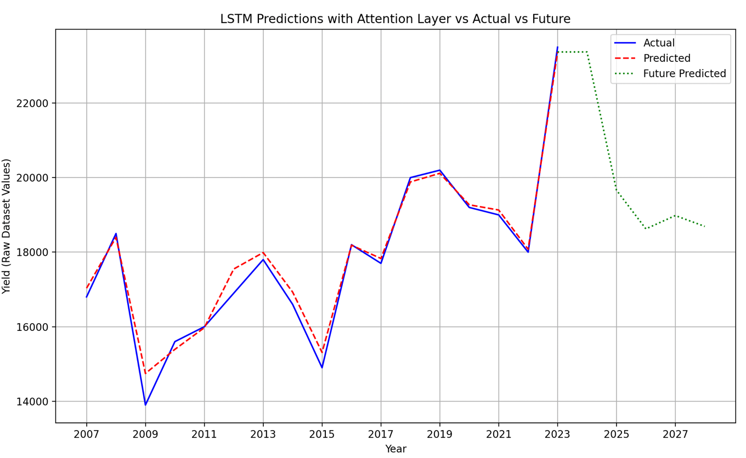

1. Loss Curves

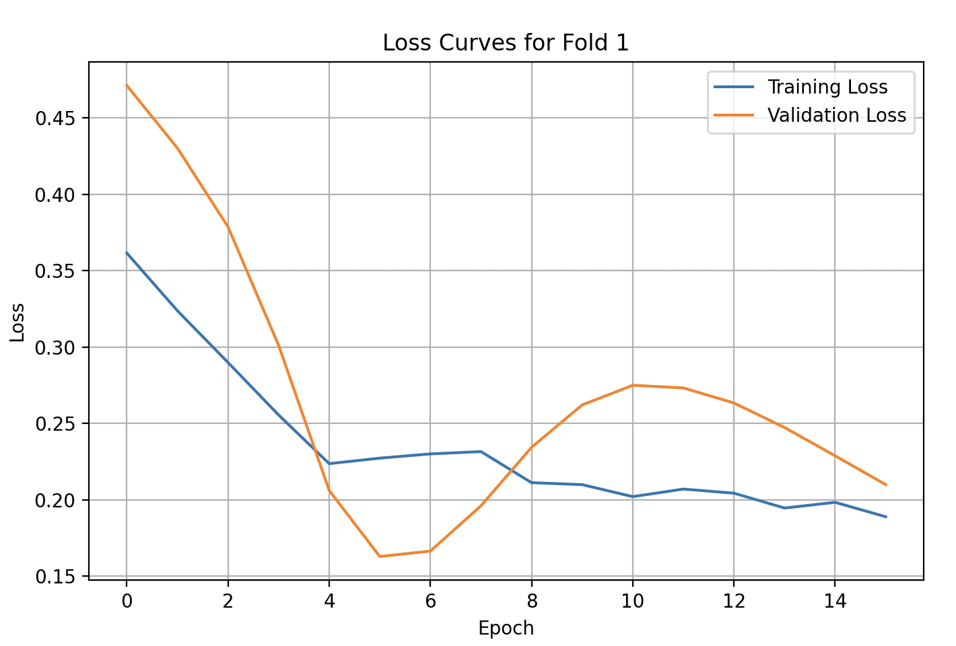

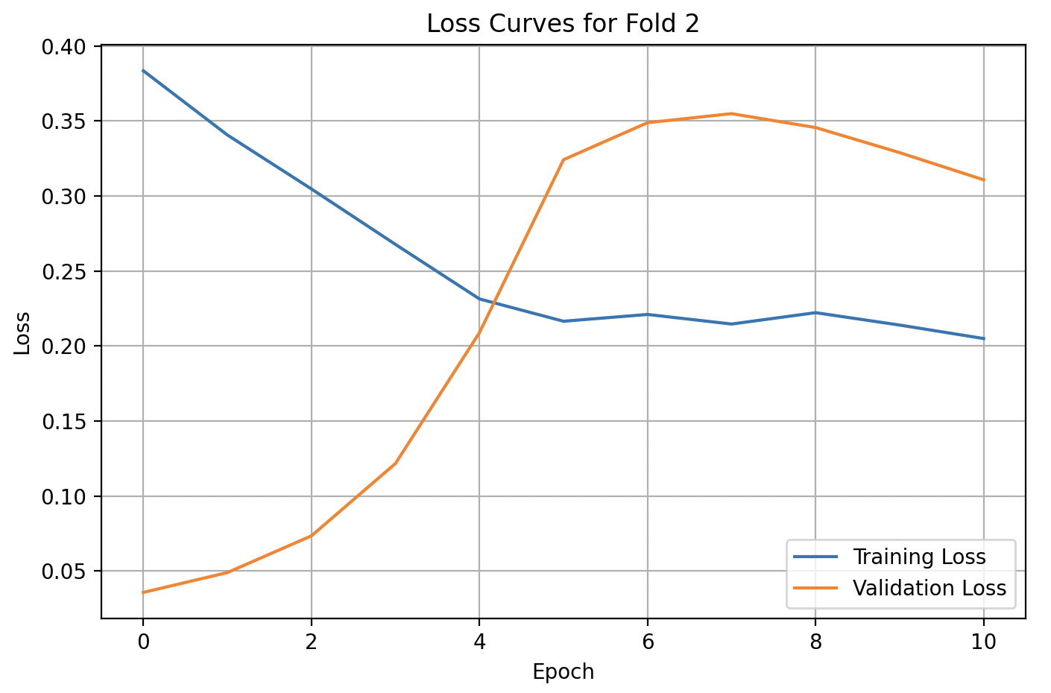

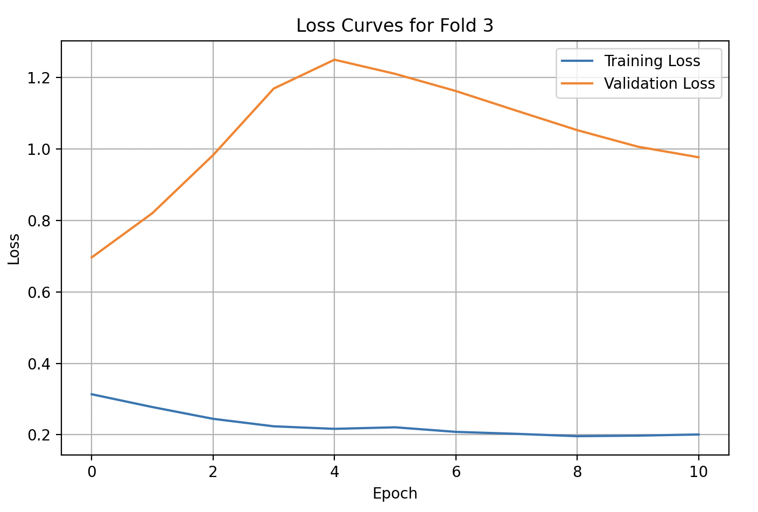

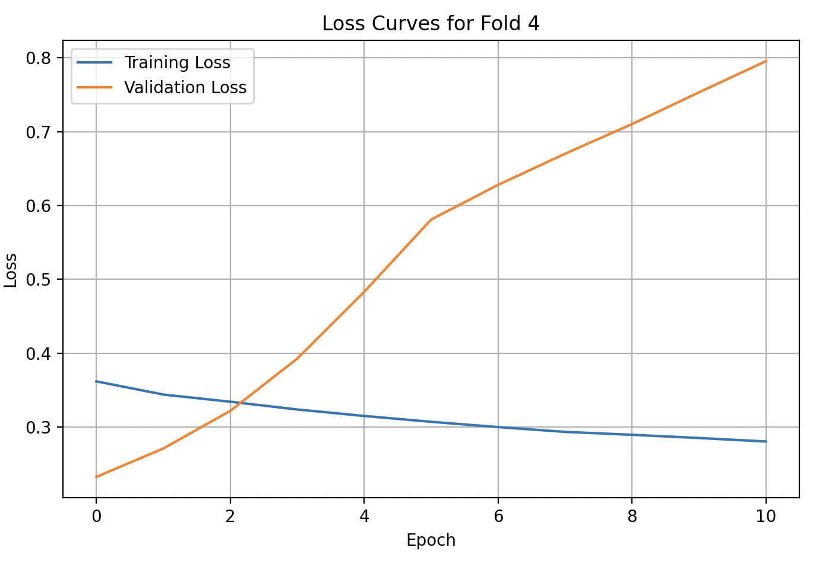

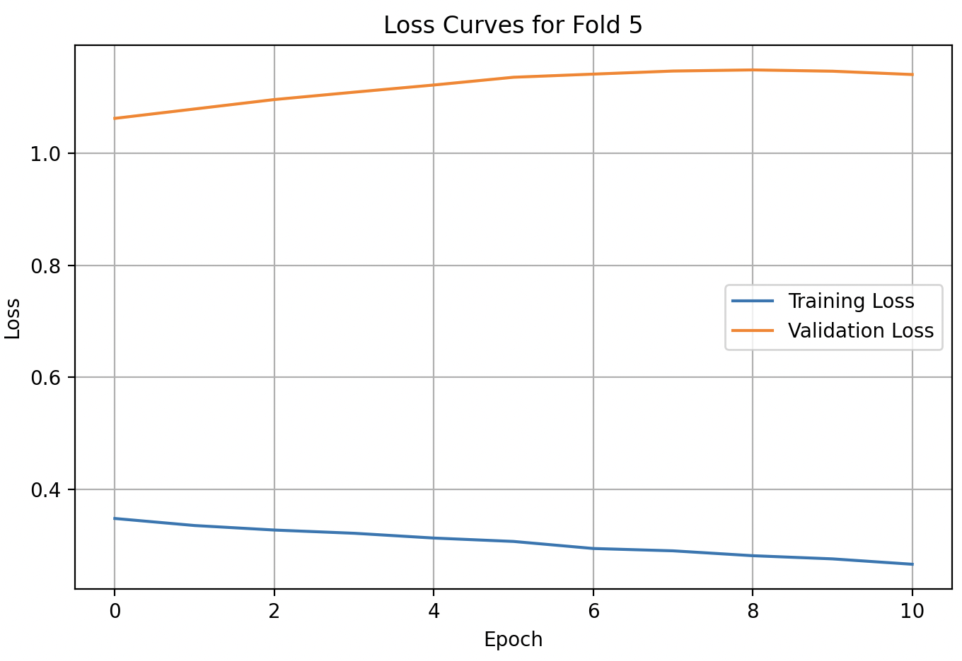

### WA

#### **Plots (Original LSTM with Attention Layer)**

1. Predicted, Actual and Future Predicted (Prediction Plot)

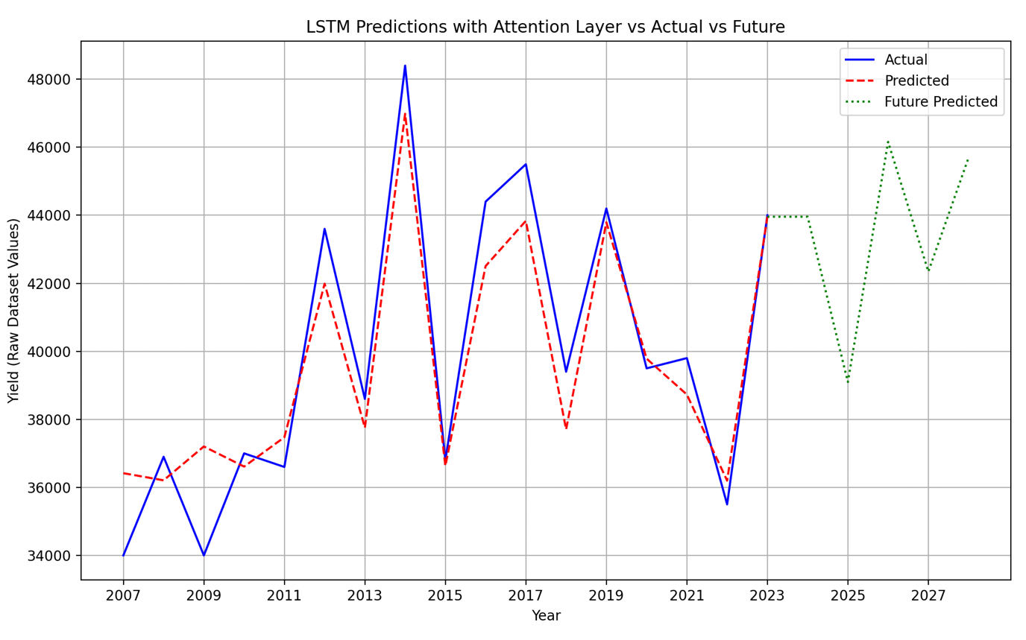

1. Loss Curves

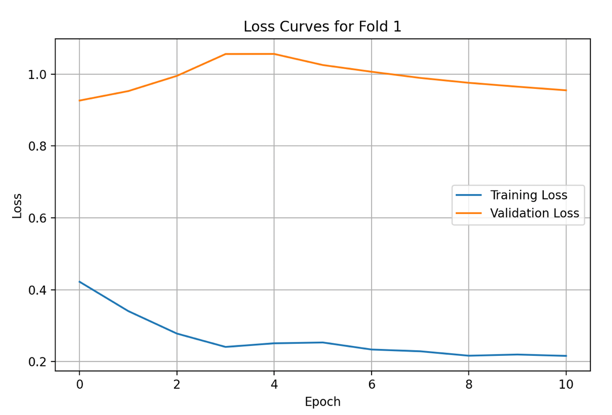

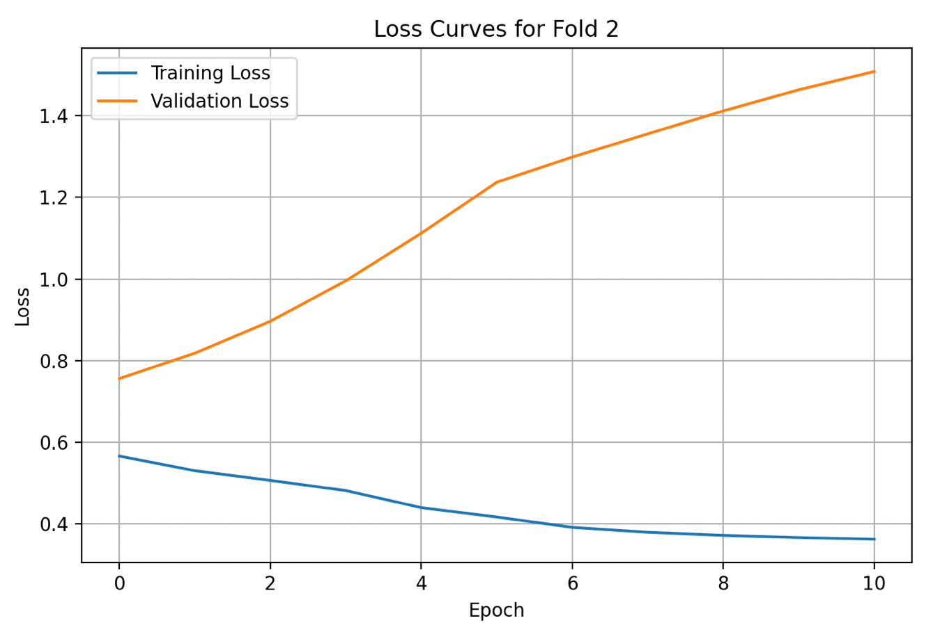

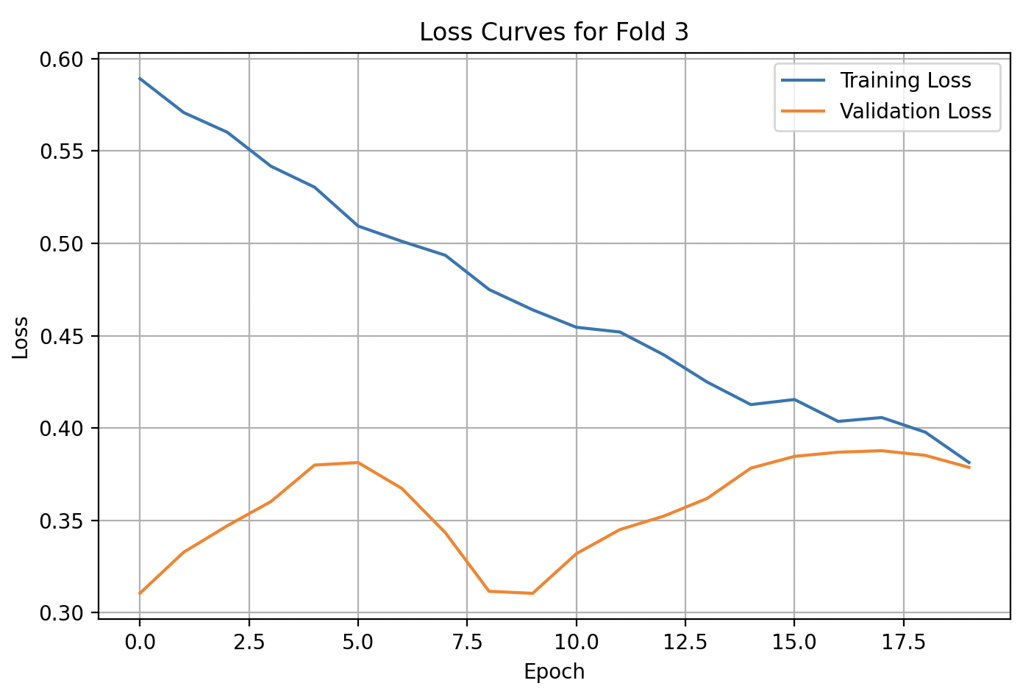

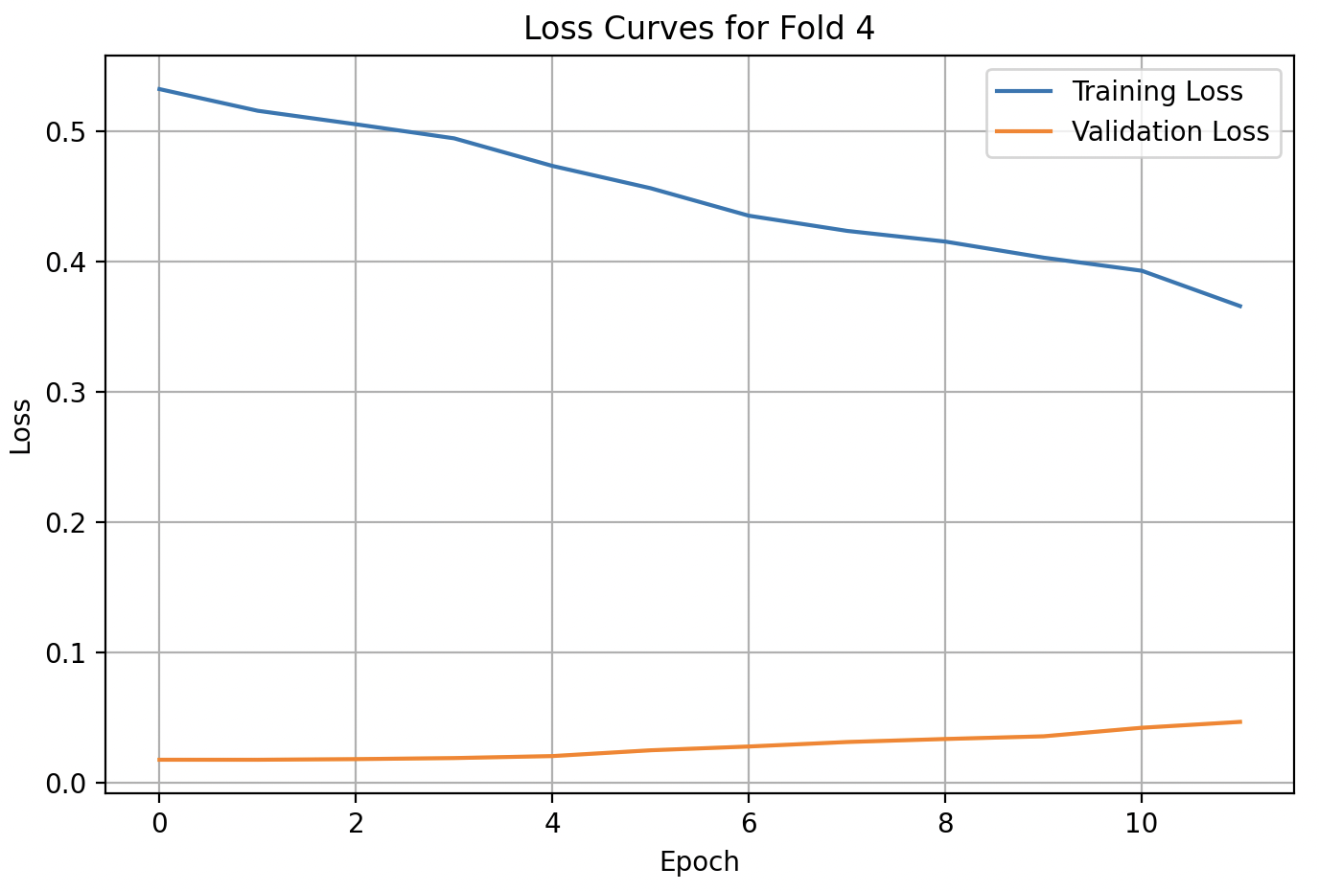

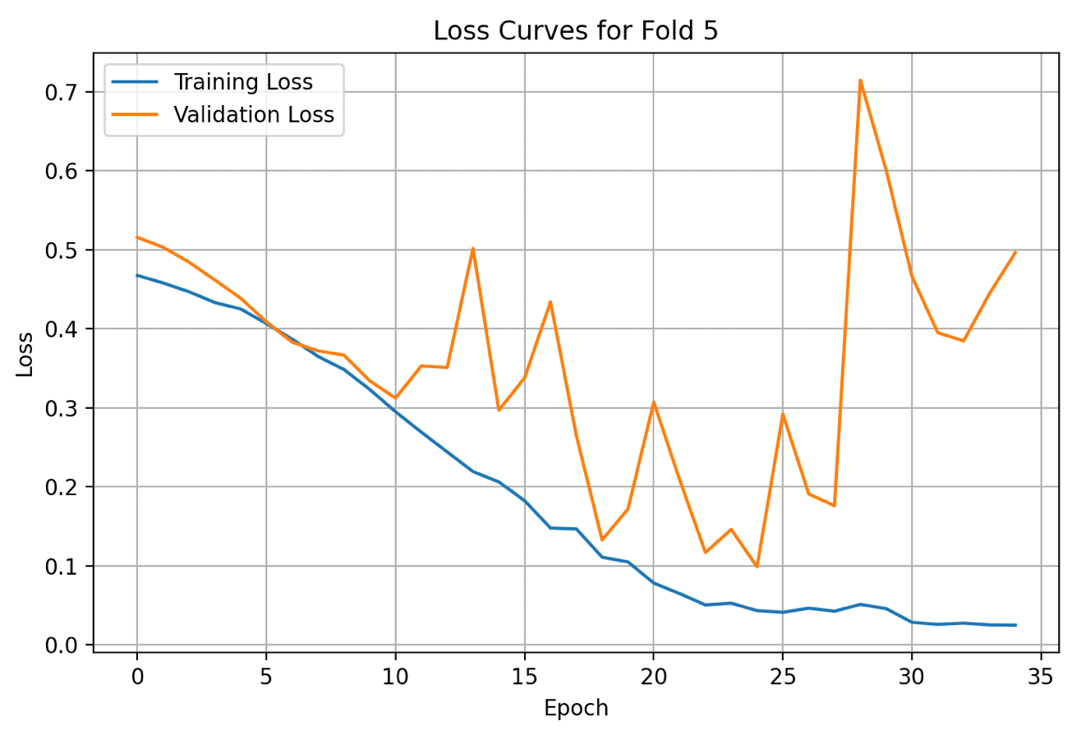

### MI

#### **Plots (Original LSTM with Attention Layer)**

1. Predicted, Actual and Future Predicted (Prediction Plot)

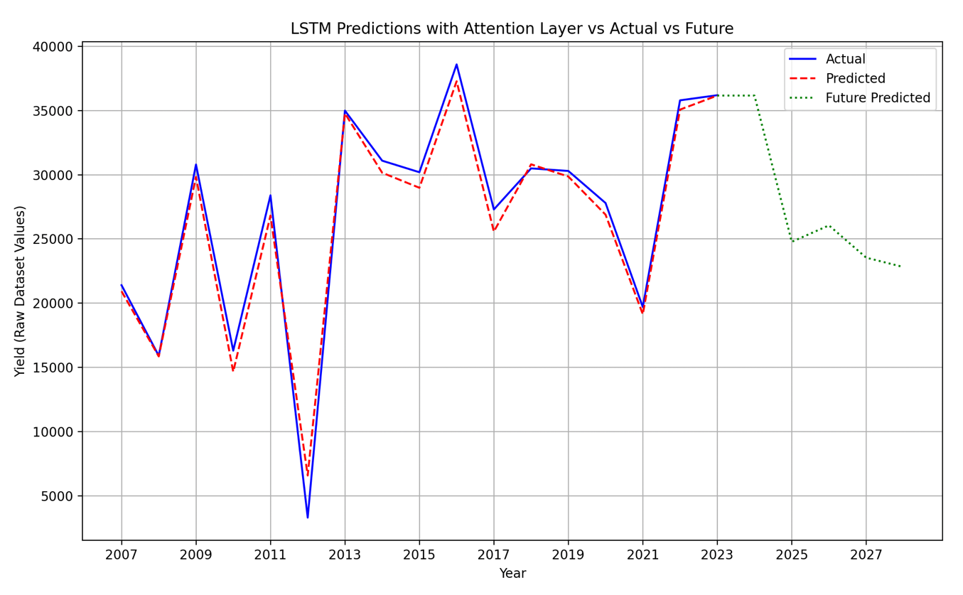

1. Loss Curves

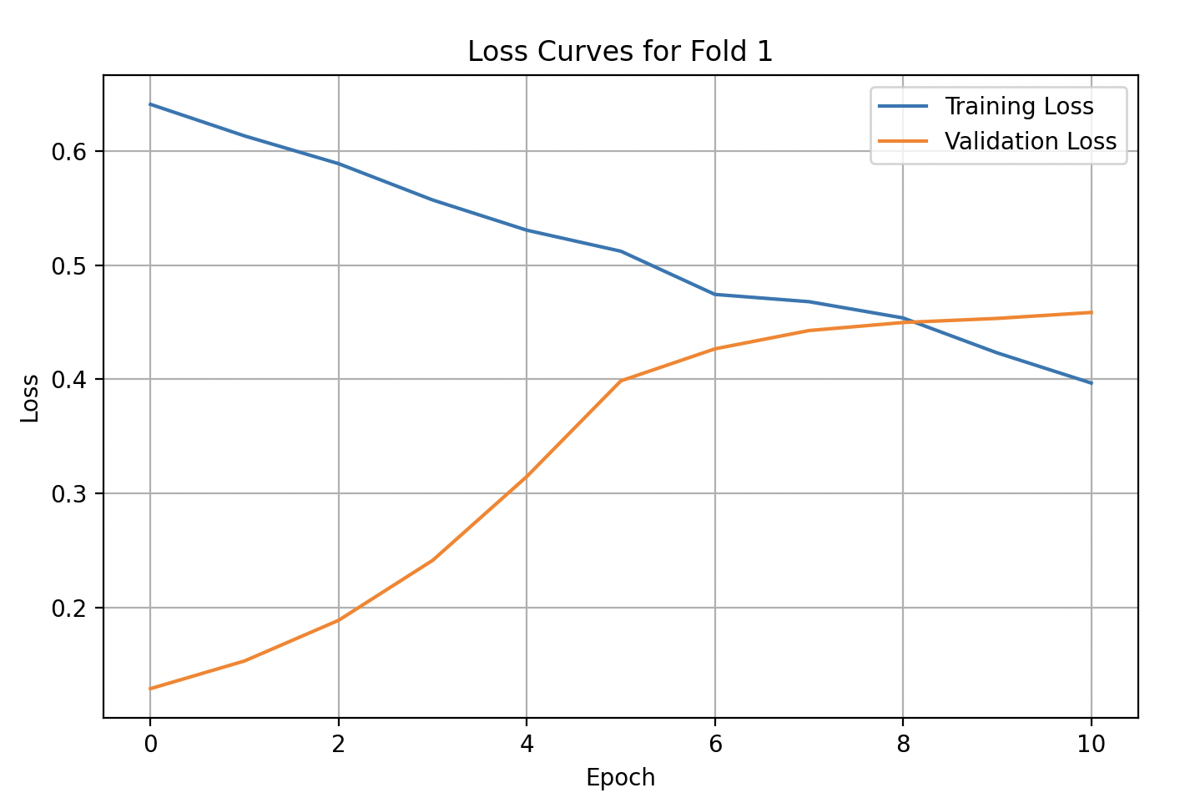

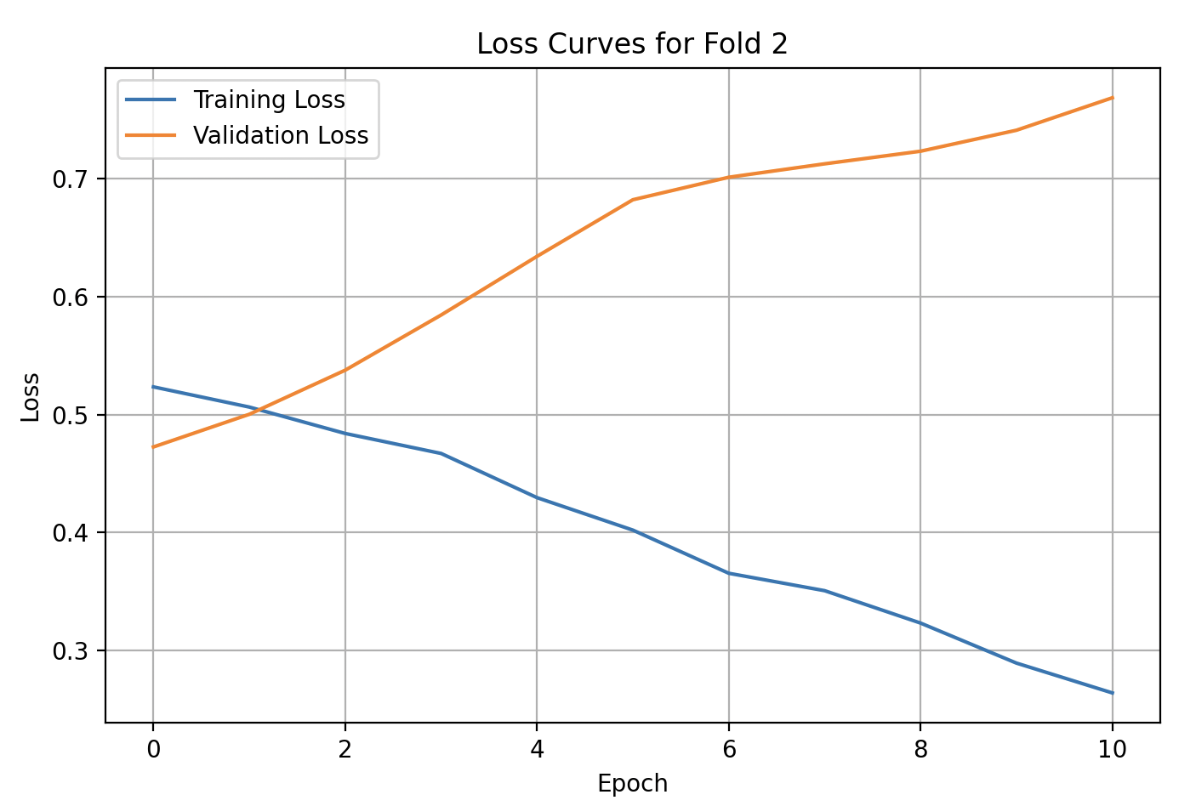

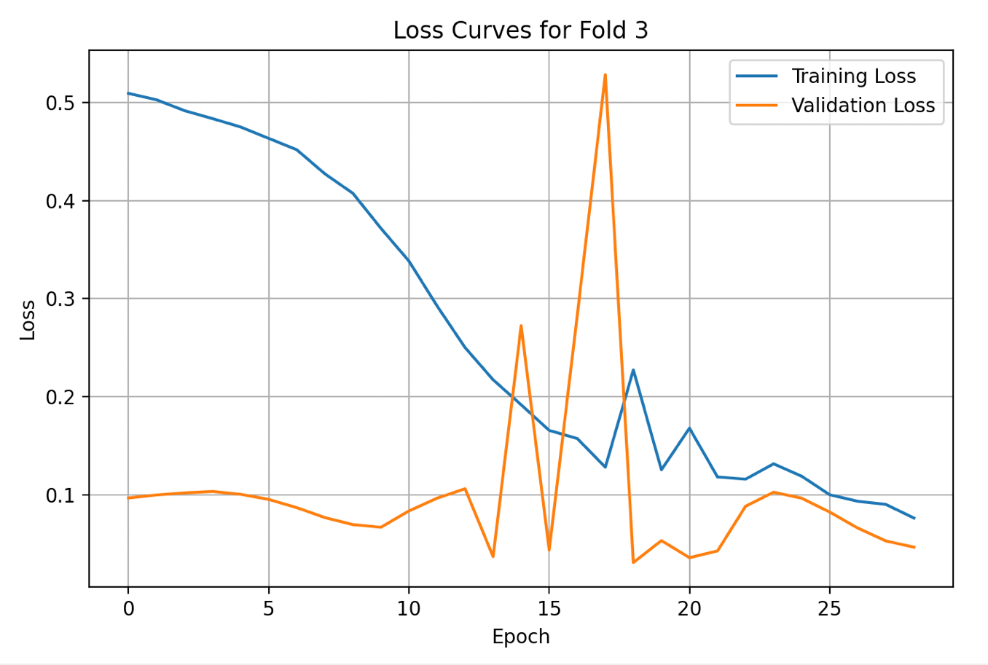

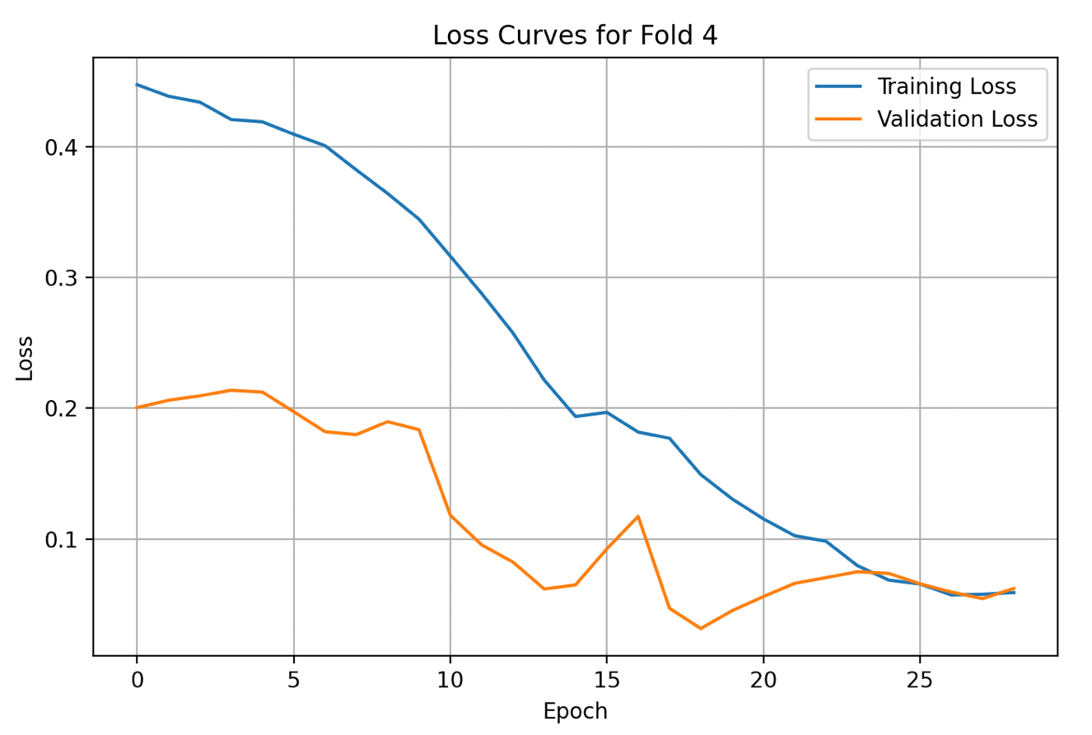

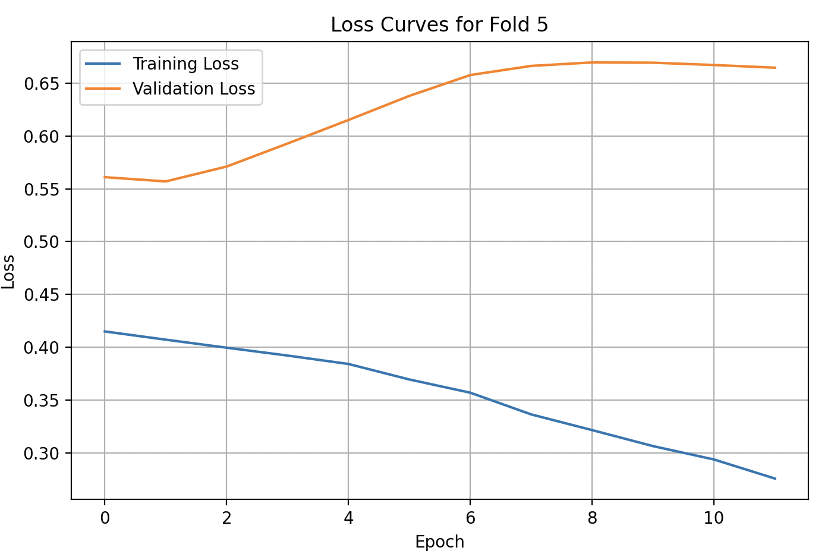

### PA

#### **Plots (Original LSTM with Attention Layer)**

1. Predicted, Actual and Future Predicted (Prediction Plot)

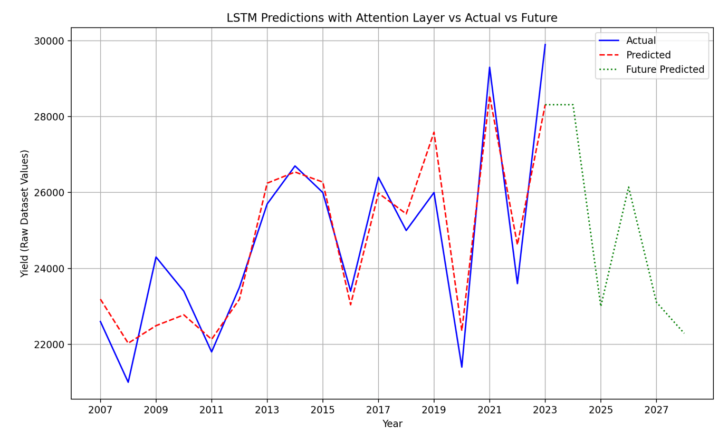

1. Loss Curves

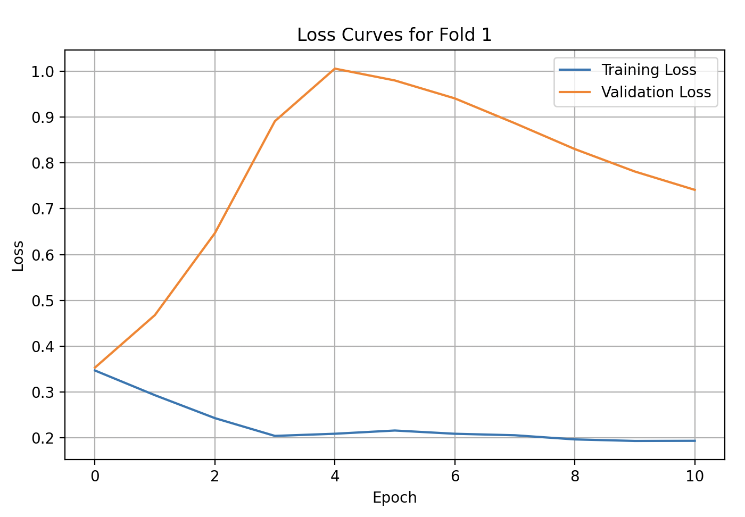

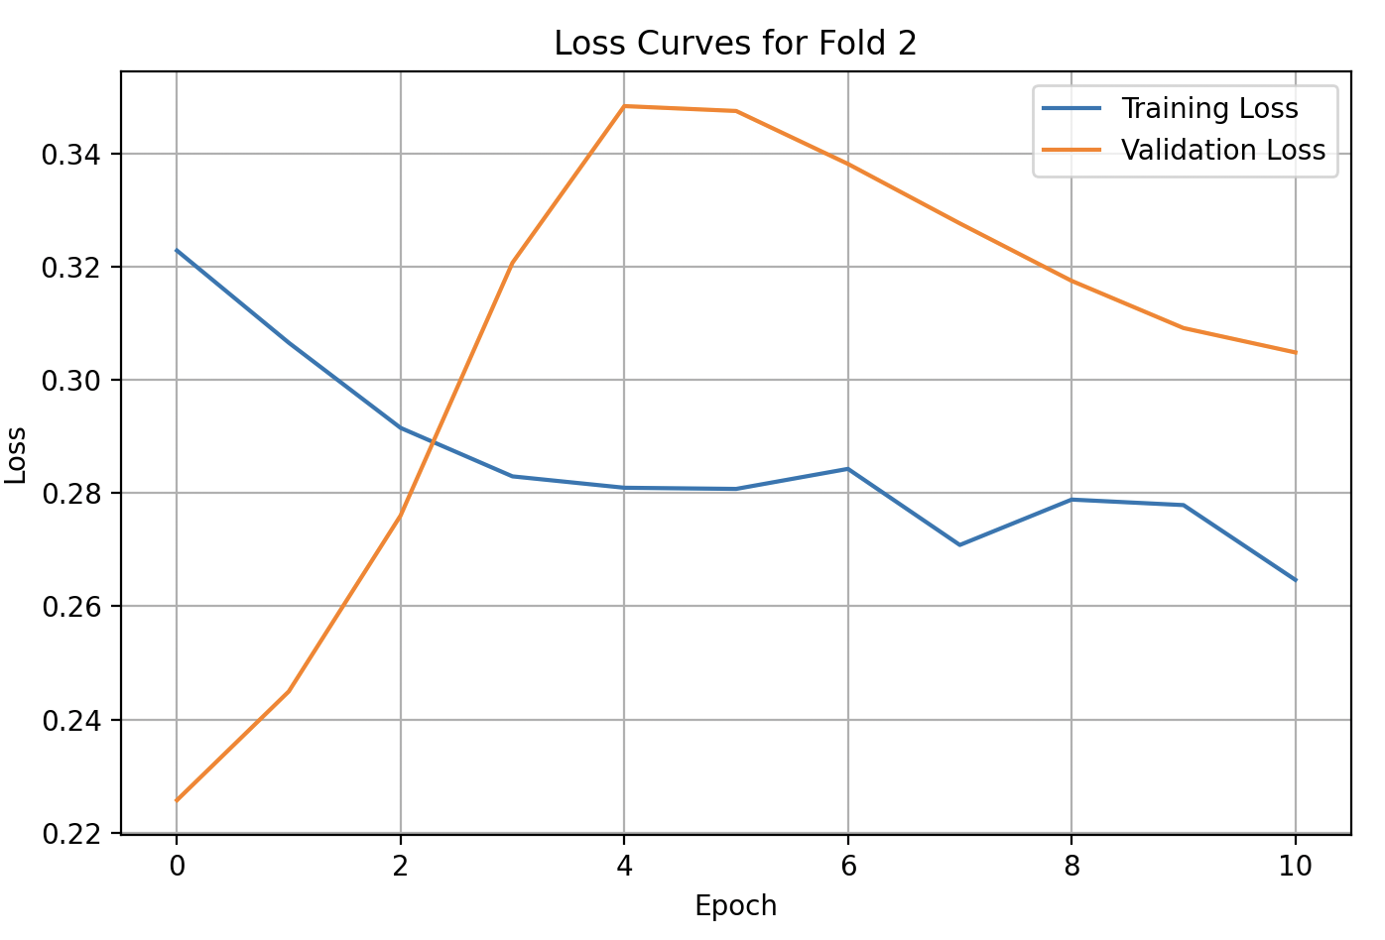

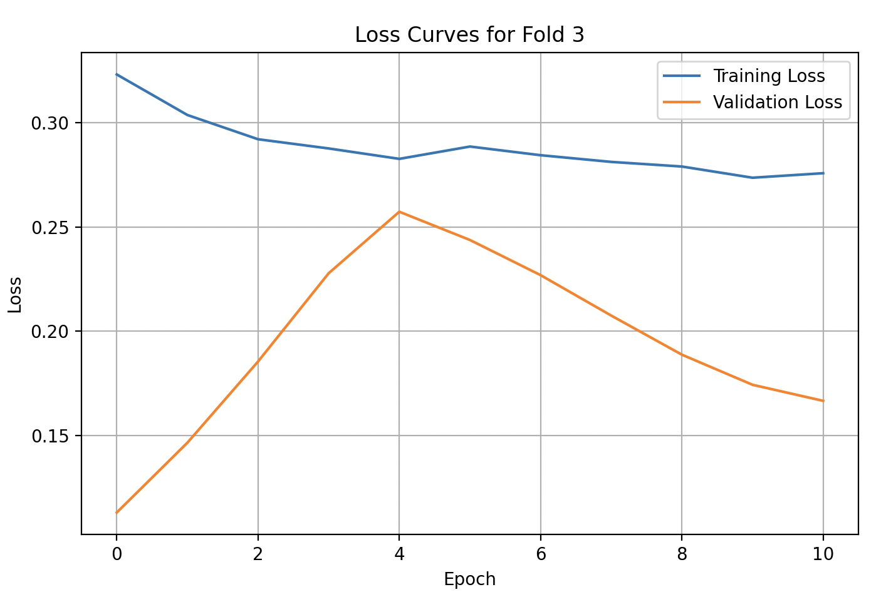

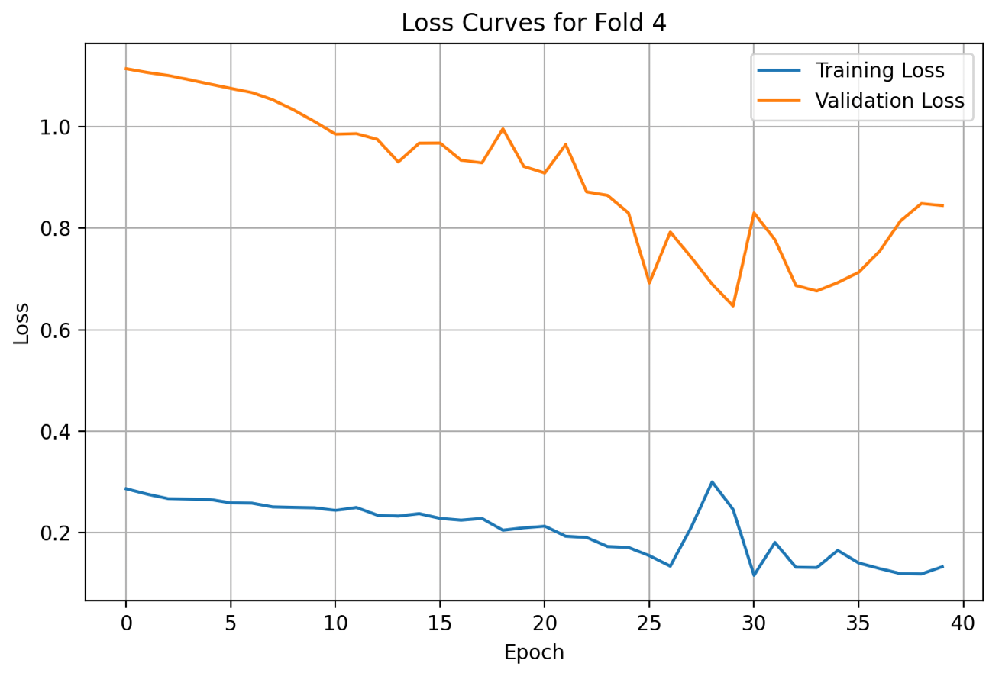

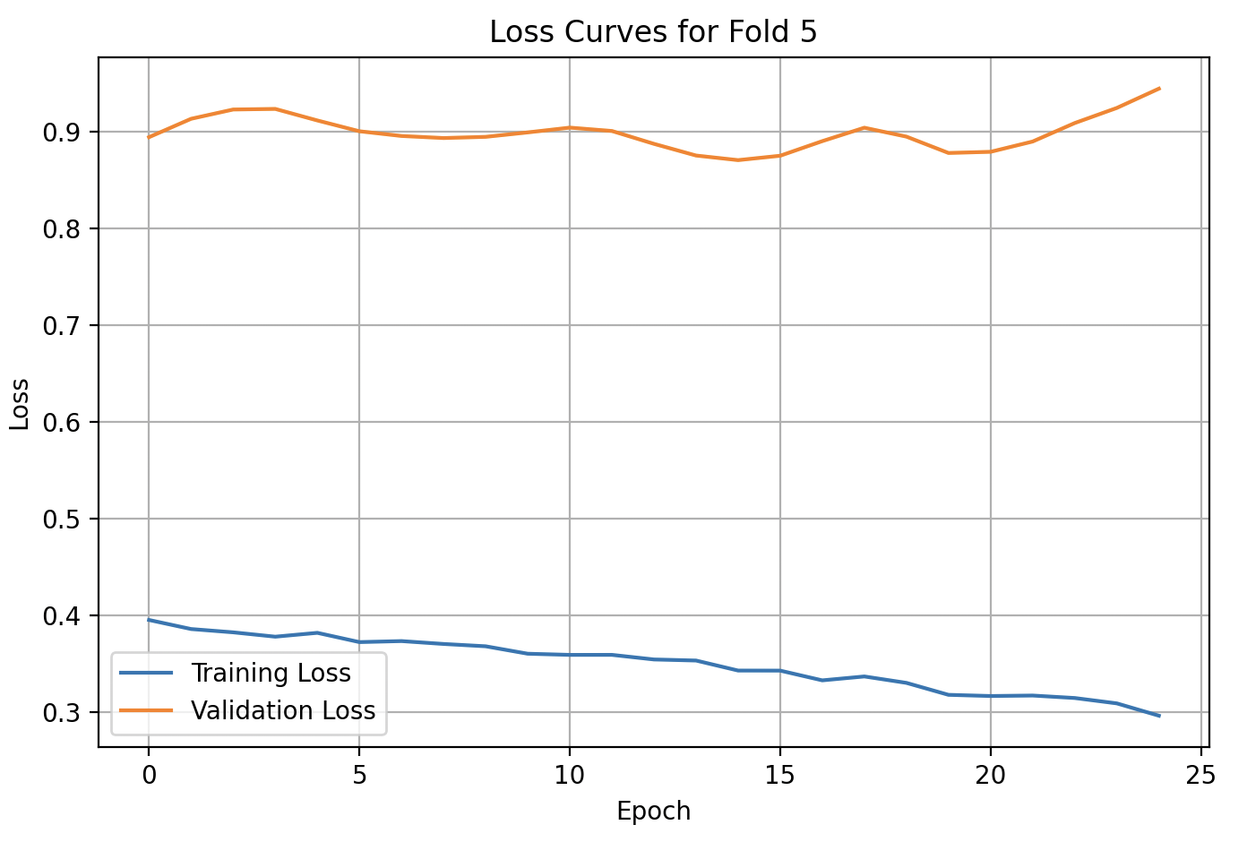

## Comparison Table

### **Accuracies**

| Model/US State | CA | WA | MI | PA |
| --- | --- | --- | --- | --- |
| LSTM | 97.66% (Predicted vs actual on seen data)  86.21% (Predictive power on unseen data) | 95.67% (Predicted vs actual on seen data)  87.86% (Predictive power on unseen data) | 84.66% (Predicted vs actual on seen data)  71.52% (Predictive power on unseen data) | 95.34%  (Predicted vs actual on seen data)  88.38% (Predictive power on unseen data) |
| LSTM (with attention layer) | 98.01% (Predicted vs actual onseen data)  79.50% (Predictive power on unseen data) | 88.75% (Predicted vs actual on seen data)  94.55% (Predictive power on unseen data) | 98.01% (Predicted vs actual on seen data)  87.57% (Predictive power on unseen data) | 86.68% (Predicted vs actual on seen data)  84.95% (Predictive power on unseen data) |
| 1D-CNN | 98.27% (Predicted vs actual on seen data)  86.95% (Predictive power on unseen data) | 98.43% (Predicted vs actual on seen data)  92.60% (Predictive power on unseen data) | 94.54% (Predicted vs actual on seen data)  78.40% (Predictive power on unseen data) | 92.70% (Predicted vs actual on seen data)  86.26% (Predictive power on unseen data) |
| GRU | 96.69% (Predicted vs actual on seen data)  78.66% (Predictive power on unseen data) | 97.52% (Predicted vs actual on seen data)  92.79% (Predictive power on unseen data) | 82.44% (Predicted vs actual on seen data)  66.31% (Predictive power on unseen data) | 96.05% (Predicted vs actual on seen data)  89.25% (Predictive power on unseen data) |

# Interpretation Of Accuracies, Loss Curves, Prediction Plots and Methods | Future Work

From a thorough analysis, some striking details can be unveiled.

Out of all the models provided, the LSTM with attention layer one had the greatest variation in terms of results. The states of CA, WA and PA had the greatest prediction differences, while MI had one of the best prediction lines in terms of its power on unseen data. For the dataset of WA, fold 5 had numerous large spikes in terms of validation loss although it can still be classified as being normal since the training loss is slightly less than the validation and the overall trend is going downwards. Fold 2 is an example where the training loss decreases but validation loss increases, which may suggest problems such as overfitting with too many epochs and a high learning rate, or noisy and inconsistent validation data. It could be seen as being a potential data issue because of unstable training or preprocessing; however it ends on a downward trend, which is what we want to observe. There are folds of epochs where the training loss is higher than the validation loss in multiple models, such as in the graphs for PA and MI. This could just be a result of dropout or batch normalization if the gap is minimal, but it can also be possible data leakage or improper data handling if the gap is significant. Further, MI’s fold 3 has spikes that become present around the middle of the graph. The plotting of the data for fold 1 makes the difference between training and validation minimal at epoch 0 before extending to around 0.8 at the maximum. In terms of the consistency visually, CA seems the most consistent with the least differences between the training and validation loss in each fold. In general, some datasets may lead to better prediction results in terms of the raw and future data due to their structure, balance and trends that indicate seasonality.

The loss curves that were generated from the GRU and base LSTM models look as intended. The ones that were generated using 1D-CNN has a lot of sharp corners, which could indicate instability in training and optimizers, poor weight initialization, or simply a large batch size.

The results that were obtained from the above may also have eventuated from how the attribute ‘Snow’ was omitted in the PA dataset, since it did not exist. It is the only dataset where the attribute did not exist, and the other three had it. A formative assessment of model accuracy powers has also been conducted using the MAPE function. It has been decided to use the GRU model to predict future values for the WA dataset since it has the highest accuracy rates for the predicted on seen and unseen data, with the values all being above 90%. This means that the model is efficient at everything that a machine learning model should be capable of. For machine learning models like these and the project in general, it is still possible that even though aspects such as hyperparameter tuning, EarlyStopping callbacks, L2 Regularization, Adam and Huber functions are used, overfitting or underfitting issues can remain. Further, using MAPE as an evaluation metric can also influence the results outlook since it has bias toward underestimation and is sensitive to small target values. Gradient updates might also be made uneven due to the proportional scaling.

There are still more ways to improve how the machine learning model functions and makes future predictions. They include building hybrid models that combines two distinct models into one, harnessing the benefits of both into one application. Combining the benefits of two machine learning architectures into one can make a larger and more powerful model, and examples of applications include applying a CNN with a LSTM and applying a Generative Adversial Network (GAN) to a LSTM. Bidirectional ConvID is useful for a model to learn patterns in past and future directions since there could be strong dependencies in time-series data and convolutional ConvID for spatial-temporal pattern learning. Also, cosine decay can be useful to alter the learning rate of a machine learning model. The rate will naturally and gradually decrease, following a cosine curve, while also assisting the model to settle into an optimal solution smoothly. Cosine decay can be beneficial to avoid getting stuck in a poor local minima or minimum value, while reducing the chance of overfitting by fine-tuning at the later stages of training. It typically will work better for deep networks such as LSTMs and CNNs.